­

Insight

Services: AWS Application Migration PoC

AWS–Build Documentation

Client: Astellas Pharma Europe Ltd

Contents

3 Contact Information & Document Control 3

3.1 Document Information 3

3.2 Version Control 3

3.3 Document Approval 3

4 Document References 4

4.1 Referenced Documents. 4

4.2 Terminology & Abbreviations 4

5 Introduction 5

5.1 Document Purpose 5

5.2 Intended Audience 6

6 Build 7

6.1 Site Installation Details 7

6.2 AWS Application Migration Service - Deployment Details 7

6.3 AWS End-of-Support Migration Program (EMP) for Windows Server - Deployment Details 9

6.4 VM Import/Export 9

7 Identity & Access Management 11

8 Proposed Migration Strategy 12

Figures

Figure 1 – AWS Application Migration Service 7

# Contact Information & Document Control

The Primary contacts for questions and discussions regarding this document are:

Brian Kavanagh

Senior Consultant

Insight UK

Phone: +44 7920 104063

Email: Brian.Kavanagh@insight.com

## Document Information

|  |  |
| --- | --- |
| Title | AWS Application Migration PoC |
| Insight Reference | Q21239 |
| Version | 0.1 |
| Status | Draft |
| Author | Insight |
| Distribution Date | 22/11/2022 |

## Version Control

|  |  |  |  |
| --- | --- | --- | --- |
| Version Number | Author | Purpose / Change | Date |
| 0.1 | Brian Kavanagh | Draft | 22/11/2022 |
| 0.2 | Alex Bishop | Draft | 08/12/2022 |
| 0.3 | Brian Kavanagh | Client Walkthrough | 09/12/2022 |
| 0.4 | Alex Bishop | Draft | 15/12/2022 |
| 1.0 |  |  |  |

## Document Approval

|  |  |  |
| --- | --- | --- |
| Name | Date | Initial |
|  |  |  |
|  |  |  |
|  |  |  |
|  |  |  |

# Document References

## Referenced Documents.

|  |  |  |  |
| --- | --- | --- | --- |
| Ref | Type | Document Name / URL | Version |
| 1 | Statement of Works | Astellas _ AWS Migration PoC SOW v3.0 docx.docx | 3.0 |
| 2 | Build Sheet | Astellas AWS Application Migration Service Build Sheet.xlsx | 0.1 |
| 3 | Source Server Detail | Source Server Detail & Migration Scenarios.xlsx | 0.1 |
| 4 |  |  |  |
| 5 |  |  |  |
| 6 |  |  |  |

## Terminology & Abbreviations

|  |  |
| --- | --- |
| Abbreviation | Expansion |
| AMS | Application Migration Service |
| AWS | Amazon Web Services |
| EBS | Elastic Block Storage |
| IAM | Identity & Access Management |
| OS | Operating System |
| PoC | Proof of Concept |
| SSM | AWS Systems Manager |
| VM | Virtual Machine |

# Introduction

## Document Purpose

This document describes at a High-Level the design and implementation of 2 AWS Migration Services for use by Astellas:

* The AWS Migration Service (AMS), which will be used to migrate 3 selected Windows 2008 R2 VM’s from the Astellas On Premise environment to their selected AWS environment.
* The VM Import/Export Service, which will be used to migrate any existing Astellas servers with applications installed, but avoid the need for any AWS agents so as to avoid any QA concerns around agent impacts to the applications.

The design has been developed against the Insight Lab environment, which was built, as no access was granted to the existing Astellas Source / Target environments.

Astellas provided the following Server Spec’s which are to be used as part of the PoC

|  |  |  |  |  |
| --- | --- | --- | --- | --- |
| Server Name | Operating System | CPU | Memory | Storage |
| AS041NLME37 | W2008 R2 | 2 | 8 | C:\ - 60GB  D:\ - 50GB |
| AS041NLME41 | W2008 R2 | 1 | 4 | C:\ - 60GB  D:\ - 50GB |
| EUPMPPPLAP050 | W2008 R2 | 12 | 8 | C:\ - 40GB  D:\ - 40GB  E:\ - 50GB  F:\ - 40GB  G:\ - 15GB |

Development for both the AWS AMS and VM Import/Export options were carried out in the Insight Lab environment was against the EUPMPPPLAP050 server spec, with an example Bitanami application installed.

Upon successful completion of the Migration Phase of the Project a Post Migration phase will look to integrate the migrated servers with existing Services within the Astellas AWS environment listed below, Insight will provide any Consultancy / Advisory input as requested during this phase:

* + Cloudwatch / Cloudwatch Logs
  + Cloudtrail
  + Security Hub / Patch Manager
  + Control Tower / SSO
  + Anti Virus
  + AWS Backup
  + AWS DRS

Blueprints for the AWS Service detailed within this document will be provided within a Build Sheet document [2] which will allow Astellas to recreate the design configuration within their own environment as required.

Astellas have confirmed that all of the networking is in place between their AWS and On Premise environments and that the target AWS account networking is configured as required.

## Intended Audience

This document is aimed at an IT technical audience that has some understanding of AWS, Server Admin & config, and a broad awareness of the current Astellas IT infrastructure estate.

# Build

## Site Installation Details

**AWS Environment**

|  |  |
| --- | --- |
| AWS Account – Astellas | Not Provided |

## AWS Application Migration Service - Deployment Details

The Application Migration Service is and AWS service which provides the capability to migrate all of the Servers identified as part of the Astellas PoC project, the 2 Operating System only Servers identified will only require the use of AMS, however the 3rd of the Servers in scope, EUPMPPPLAP050, has a Legacy application installed with no application media available and will require further activity detailed in Section 6.3 – End-of-Support Migration Program

The AWS Application Migration Service is Region specific so the 1st confirmation should be to ensure that the correct AWS region has been selected and showing when AMS is launched.



Figure 1 – AWS Application Migration Service

Prior to configuring any source servers with the AMS Replication Agent the AMS Replication Template should be configured along with Launch Template and Post Launch Templates if these are required.

As part of the AMS Setup a Replication Agent and Install script is generated, these were copied to the Source Server and the install script ran to initiate the Replication Agent install process.

### Replication Template Settings

Replication Template Settings determine the Target staging area for the Replicated Servers.

The following parameters can be configured, with details provided within the Blueprint document [2].

* Target Subnet – Subnet into which the Replicated Servers will be staged.
* Instance Type – Instance Type for Replicated Servers.
* EBS Volume Type – The Storage type for Disks attached to the Replicated Servers.
* EBS Encryption – Default or Custom Encryption settings.
* Security Groups – Which Security Groups to attach to the Replicated Servers.
* Data Routing & Throttling – Public / Private IP allocation and whether to Throttle the network for migration traffic.
* Resource Tags – Tags to be attached to Replicated Servers.

### EC2 Launch Template

The Application Migration Service creates an EC2 Launch Template as part of the migration process. This details the configuration of the Migrated server to be hosted in AWS. The following parameters were configured as part of the lab environment, with details provided within the Blueprint document [2].

* Template Name – Provides a meaningful name to the Template
* Target Description – A short description of the Templates purpose
* Source Template – Option to select the Launch Template created by AMS
* Source Template Version – Selected the latest (Default) version.
* Amazon Machine Image – determines the OS of the image to launch. *Note AMS itself is not capable of performing upgrades as part of the migration process. The automated Windows Upgrade Process is detailed in Appendix E.*
* Instance Type – Select the Manual Instance type which is identified by AMS.
* Network Settings – Select the Subnet into which to deploy EC2’s.
* Additional Network Interfaces – If required.
* Security Groups – Add any that are required or create new.
* EBS Volumes
  + Device Name
  + EBS Type
  + Delete on termination
  + Encryption
* Resource Tags – Tags to be attached to Replicated Servers.

When launching the Migration confirmation should be undertaken to ensure that the correct Launch Template and Version is being used.

## AWS End-of-Support Migration Program (EMP) for Windows Server - Deployment Details

The AWS EMP will be used to migrate the more complex of the Servers identified as part of the Astellas PoC project, EUPMPPPLAP050, which has no available media to be able to launch on fresh instances.

It has been requested that Astellas provide a current server image of EUPMPPPLAP050 so Insight can build out the design for EMP based on this image. At present no image has been provided so the EMP design has been put together by deploying a free 3 Tier Web Application for testing purposes and may change based on any deployment within the Astellas environment.

### Guided Reverse Packaging (GRP)

EMP provides 2 models, Standard Packaging (used when the media is available) and Guided Reserve Packaging (used when media is unavailable). GRP will be used for EUPMPPPLAP050. The full runbook configuration for EMP install is detailed in Appendix F.

## VM Import/Export

The VM Import/Export Service will be used to migrate an existing VMWare image into an EC2 AMI within AWS.

The solution will involve the copy of the existing source VMWare OVA or VMDK file into an AWS S3 Bucket.

* *astellas-poc-migration-vmimport-export-bucket*

Once the source file is stored within S3 depending on the number of disks one of the following AWS CLI commands would be run:

**Single Disk**

*aws ec2 import-image --description "<server Name>" --disk-containers* *file://C:\import\containers.json*

**Multiple Disk**

*aws ec2 import-image --description "<Server Name>" --disk-containers "file://C:\import\containers.json"*

The following command can then be used to monitor the import:

*aws ec2 describe-import-image-tasks --import-task-ids <import-ami-id>*

Once the import is complete then the AMI is available to launch EC2’s.

Note that this migration path will not automatically select the instance type to match the server. This will be manually selected on instance launch.

### VM Import/Export Pre-requisites

There are several considerations to be aware of before performing a VM Import/Export operation. Astellas should pay particular attention paid to the VM Modifications item below to ensure none of the actions would concern the internal QA team :

* System Requirements – <https://docs.aws.amazon.com/vm-import/latest/userguide/prerequisites.html>
* Licensing Options - <https://docs.aws.amazon.com/vm-import/latest/userguide/licensing.html>
* Limitations - <https://docs.aws.amazon.com/vm-import/latest/userguide/limitations-image.html>
* Permissions - <https://docs.aws.amazon.com/vm-import/latest/userguide/required-permissions.html>
* Export Requirements - <https://docs.aws.amazon.com/vm-import/latest/userguide/prepare-vm-image.html>
* VM Modifications - <https://docs.aws.amazon.com/vm-import/latest/userguide/import-modify-vm.html>

The Permissions item requirement above is detailed in Section 7 of this document and the Build Config / Blueprint document [2]

# **Identity & Access Management**

**Application Migration Service**

As part of the AWS AMS setup an IAM User account is created with its Access Keys configured within the install script used to launch the Replication Install Agent on the Source Server.

**Systems Manager**

Attach the relevant IAM Role to the EC2’s which will allow AWS SSM access. As part of the Lab environment the following AWS Provided IAM Role was attached

* SSM_EC2Role

To allow the launch of the Tool to deploy the AWS EPM Deployment tool, an IAM Policy is required to Execute API’s. This Policy was created and attached to the above Role as an Inline Policy. The policy is detailed in the blueprint document [2]

**VM Import/Export**

VM Import/Export requires a role to perform certain operations. A service role named **vmimport** with a trust relationship policy document that allows VM Import/Export to assume the role, and you must attach an IAM policy to the role. The policies for the role are detailed in the build config / blueprint document [2]. Note, depending on the options required, ie licensing, encryption etc updates may be required to the policy.

# **Proposed Migration Strategy**

The proposed migration strategy for the 3 Servers [3] which are in scope for the PoC is as follows:

1. For the 2 Base Windows 2008 R2 Servers a straight migration to an AWS Windows 2008 R2 EC2 is suggested for any applications that require to be hosted on Windows 2008 R2. This migration path was tested in the PoC lab with no issues. This configuration is detailed within the Blueprint document, with the required Operating System Option being configured. There is nothing to suggest that if an Astellas hardened Windows 2008 R2 base server image was provided that it would have any issues following this method. However this would need to be confirmed by testing.
2. The 3rd server in the PoC List [3] which has the Legacy Application installed should follow the process below:

* Perform an Option 1 migration path
* Testing the migrated server and application within AWS
* Run the AWS EMP GPR process to decouple the application from the Operating System to produce a Legacy Application package.
* Launch an AWS EC2 from a Windows 2008 AMI in AWS and attempt an install of the newly created Legacy Package.
  + If the Application Deploy fails then investigation is required and revisit the EMP GPR step to try repacking based on investigative results.
* Assuming the package has deployed then Test the application functionality.
* Update the Windows 2008 R2 to Windows 2019 / 2022 and retest the application.

1. For scenarios where existing VM’s fully loaded with Applications need to be migrated without any agent installs to ensure QA compliance then the use of the AWS VM Import / Export Service should be considered.
2. **AMS Migration: Windows 2008 R2 to Windows 2008 R2 EC2 Instance**

This appendix illustrates how to perform a straight migration from Base Windows 2008 R2 Servers to AWS Windows 2008 R2 EC2 instances.

Once these steps are completed for one server, perform the exact same steps, and run the agent on the second and third server.

Starting with the first Base Windows 2008 R2 server. Connect to the AWS Application Migration Service Console.

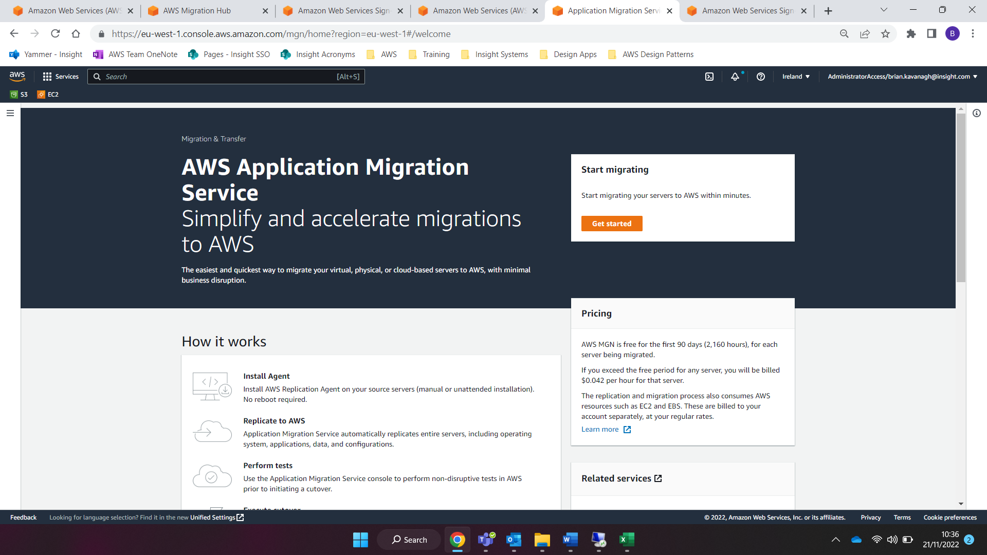

Select “Get started” on the right-hand side of the screen. (If you do not see the option to ‘Get started’ then expand the menu by clicking on the three lines on the left-hand side of the Application Migration Service).

If you are not automatically directed to the “AWS Replication Agent installation” screen, then select *Actions > Add servers* and proceed.

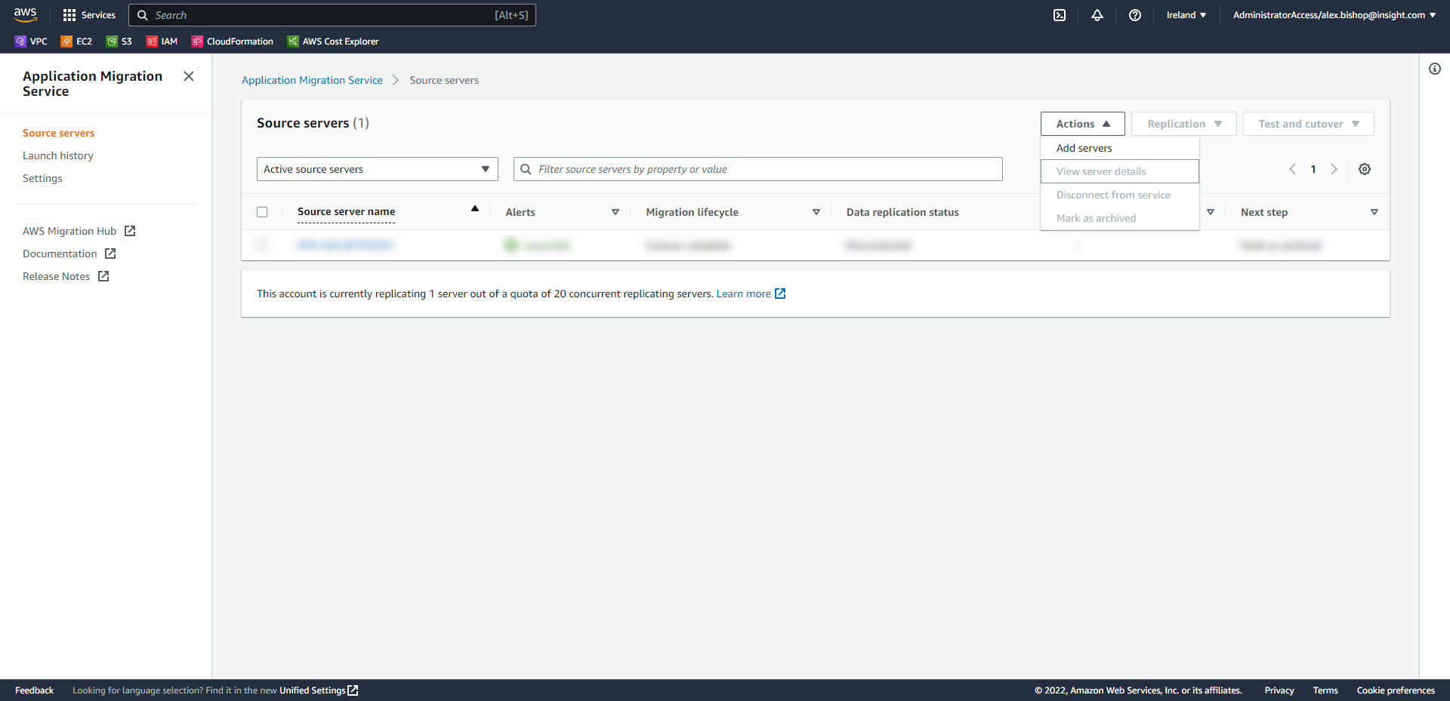

Once on the AWS Replication Agent installation screen, choose *Windows* under “Select your operating system”. Also deselect the check box for “Legacy OS: Windows Server 2003 or Windows Server 2008” as we are migrating from Windows Server 2008 R2.

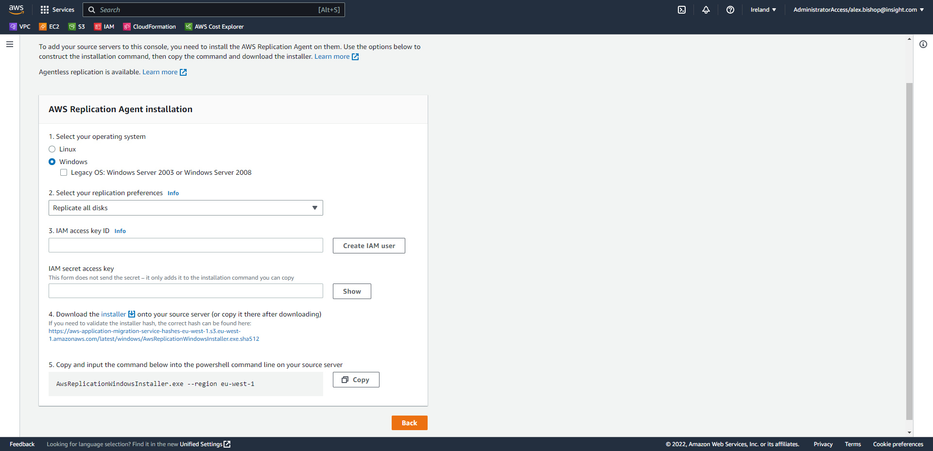

Choose the option to **Replicate all disks** from the “Select your replication preferences” drop-down menu.

Select “Create IAM User”

Follow the on screen instructions to enter a name for the IAM user you will use for installing the agent and choose Go.

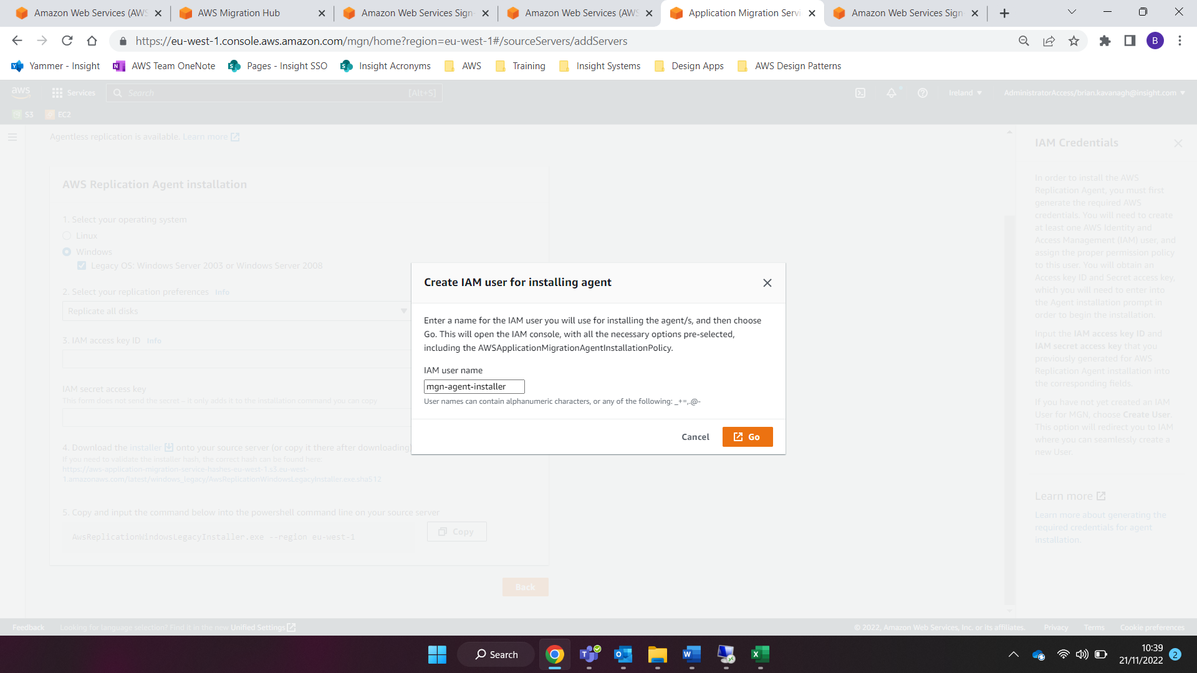

This will automatically open the IAM “Add user” page with all entries pre-populated. The username will be displayed, and the AWS access type is set to “Programmatic access – with an access key”. Select Create user.

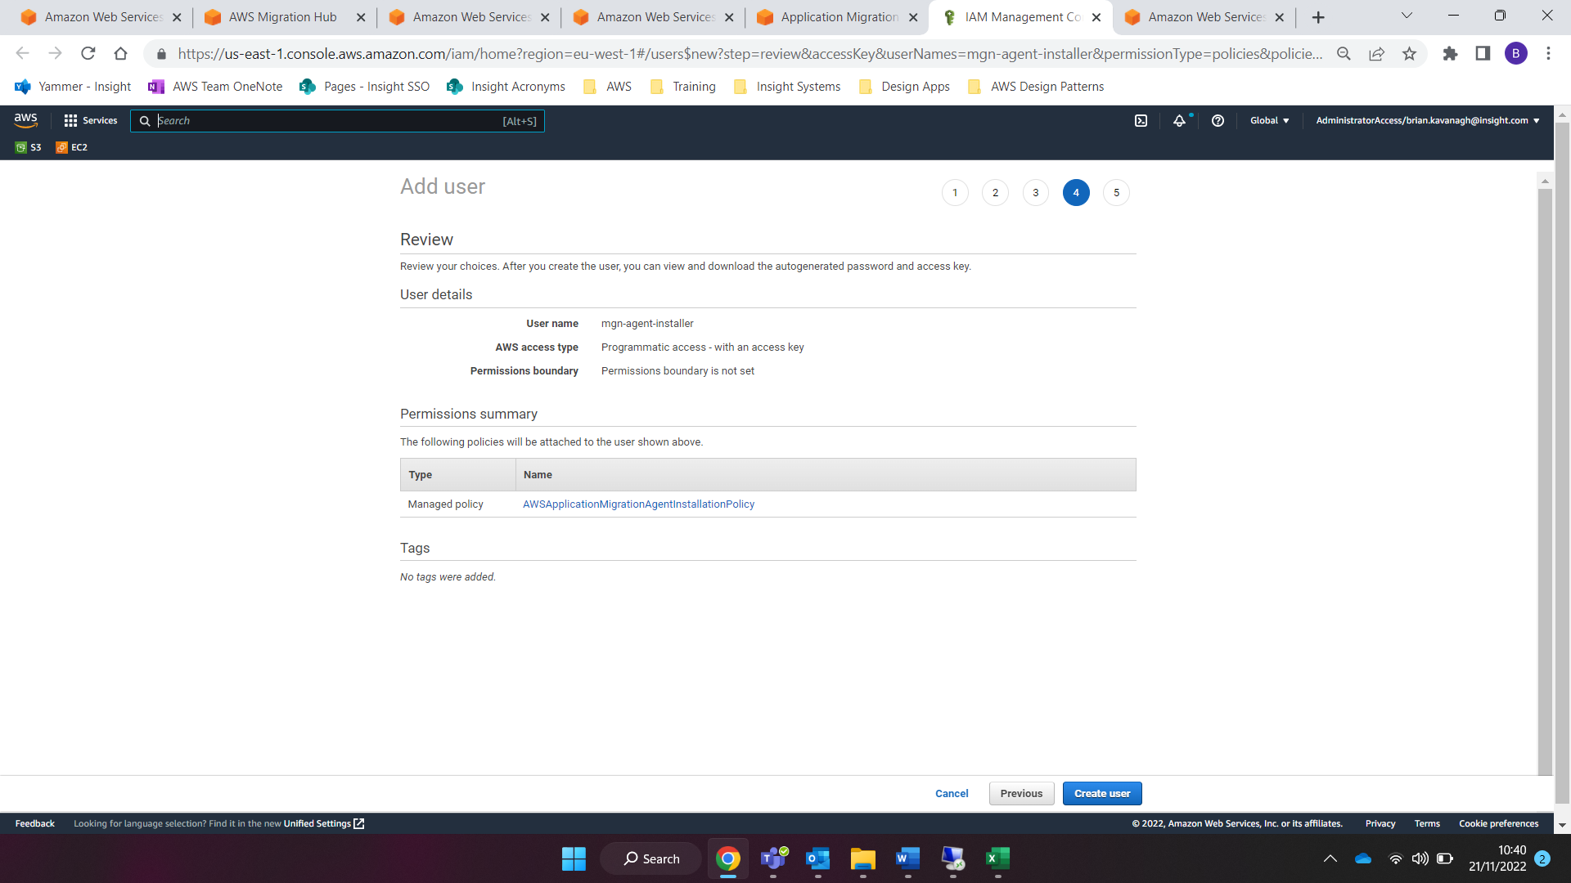

Click “Download .csv” to download the Access Key ID and the Secret Access Key for the user account.

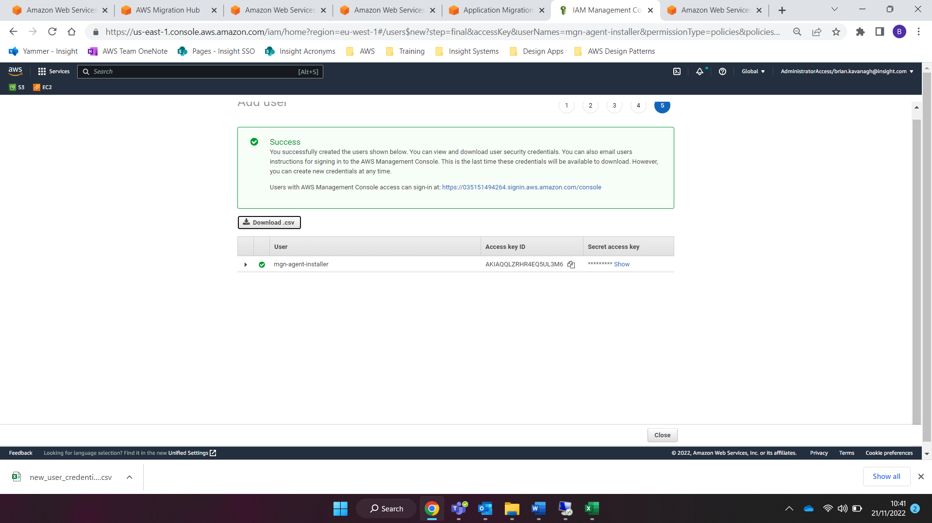

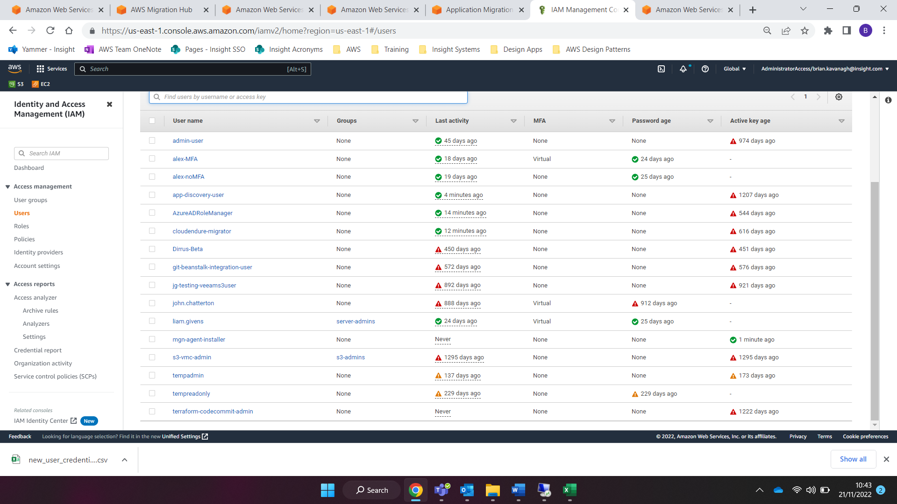

Click Close at the bottom of the page and navigate back to the Application Migration Service console.

Using the “new_user_credentials” file which was downloaded paste in the Access Key and Secret Access Details as required.



Ensure that .NET 4.8 is installed on the Sever. Browse to

<https://dotnet.microsoft.com/en-us/download/dotnet-framework/net48>. Select “Download .NET Framework 4.8 Runtime”

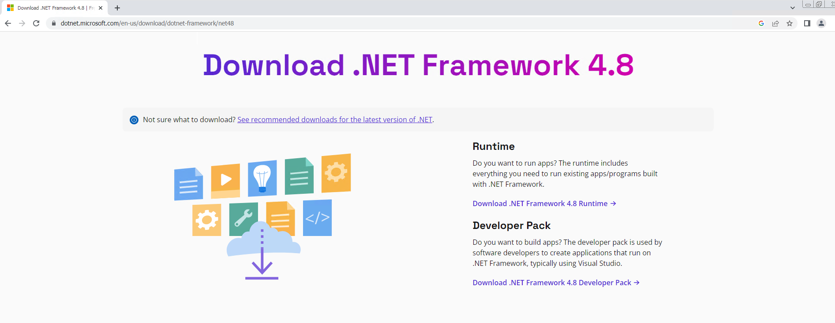

Double click the “ndp-48-web” file from you downloads folder to run the application.

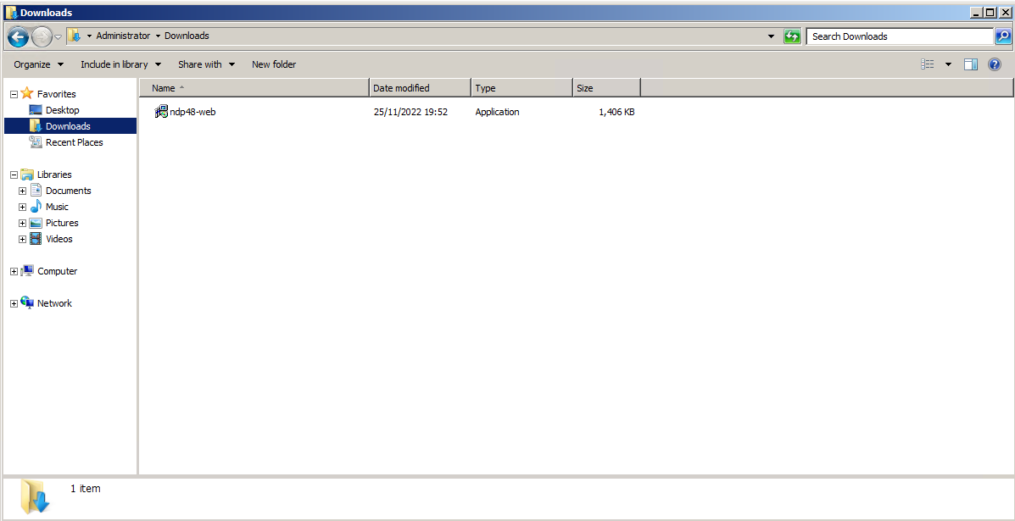

Click Run to start the installation.

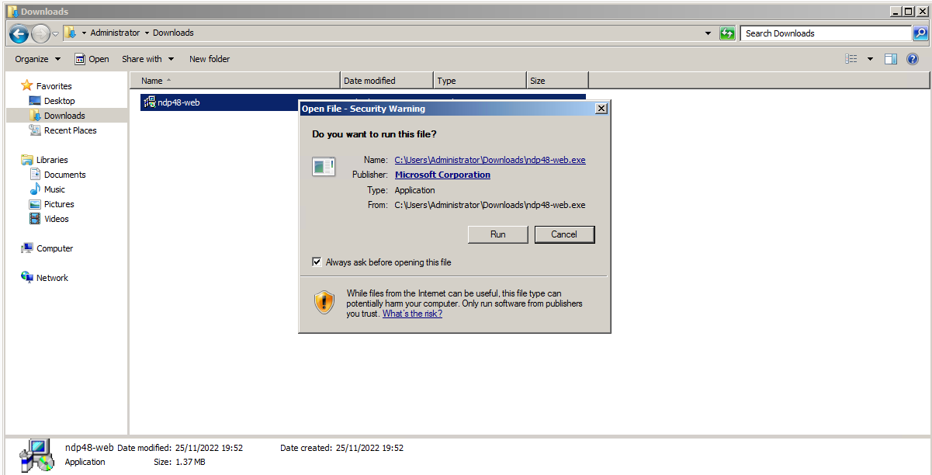

Your installation will be complete. If you see the following screen, then .NET4.8 has already been installed on this machine. Click Cancel if you see this screen.

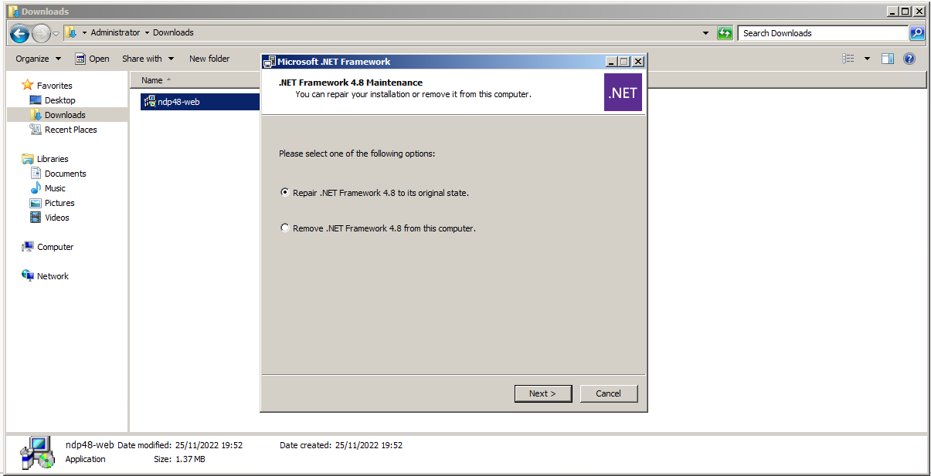

Back on the Application Migration Service console, click the link to Download the Installer file (step 4. of the AWS Replication Agent installation), which will be used to install the agent onto the source servers.

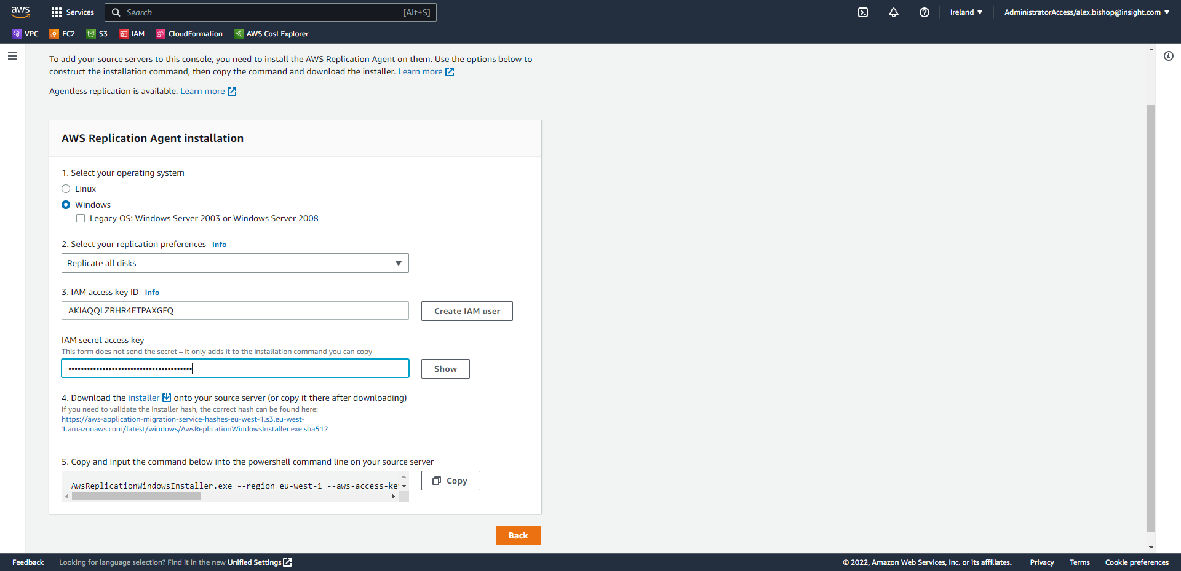

Now, copy and paste the installer command shown in step 5. of the AWS Replication Agent installation into a text file name the file “input_command” and save the file in a memorable location.

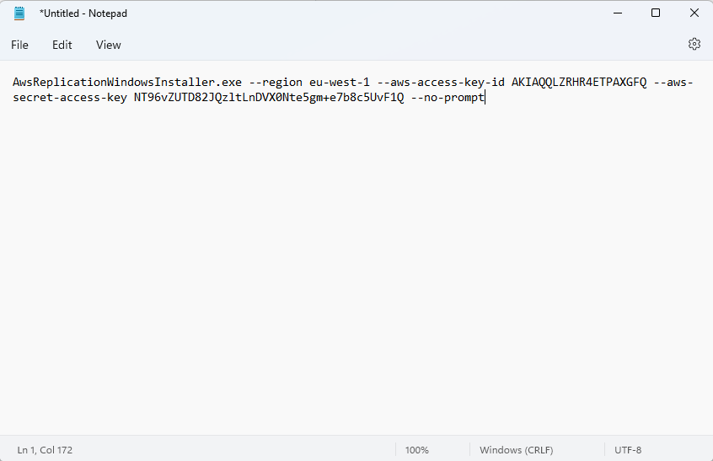

Copy both the installer file and the installer input command text file to a memorable location on the source server.

Run the installer input command from a Command Prompt window (change directory the same location in which the files were copied)

Upon successful completion the following message will be displayed: “The AWS Replication Agent was successfully installed”.

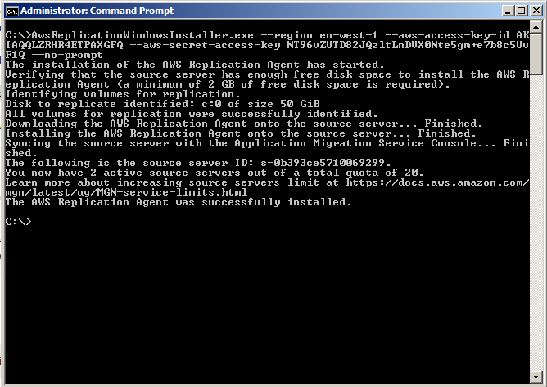

Open the Application Migration Service Console and you will observe that the replication sync has begun.

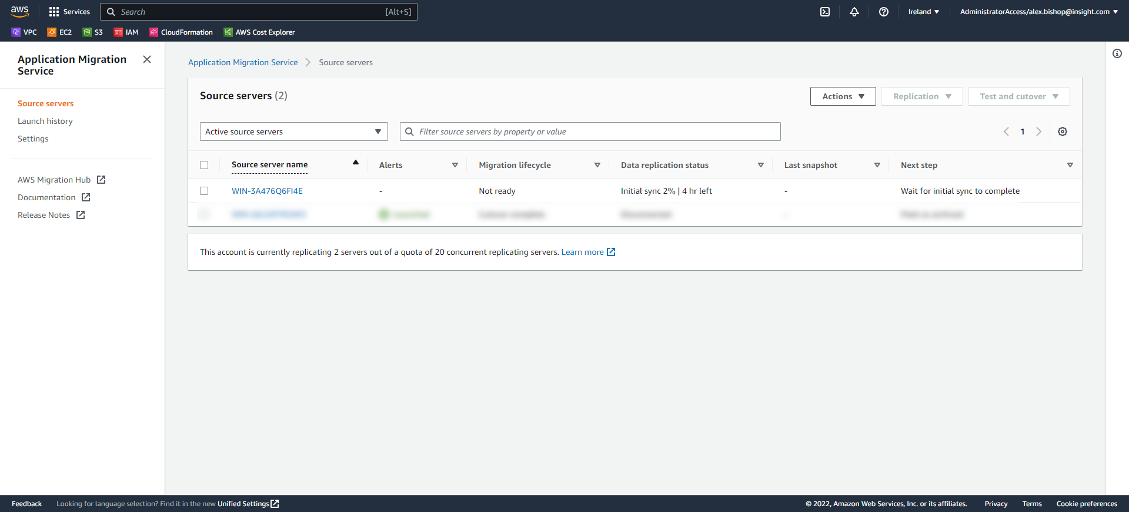

Once Replication has completed the console will indicate the server is healthy and ready for testing.

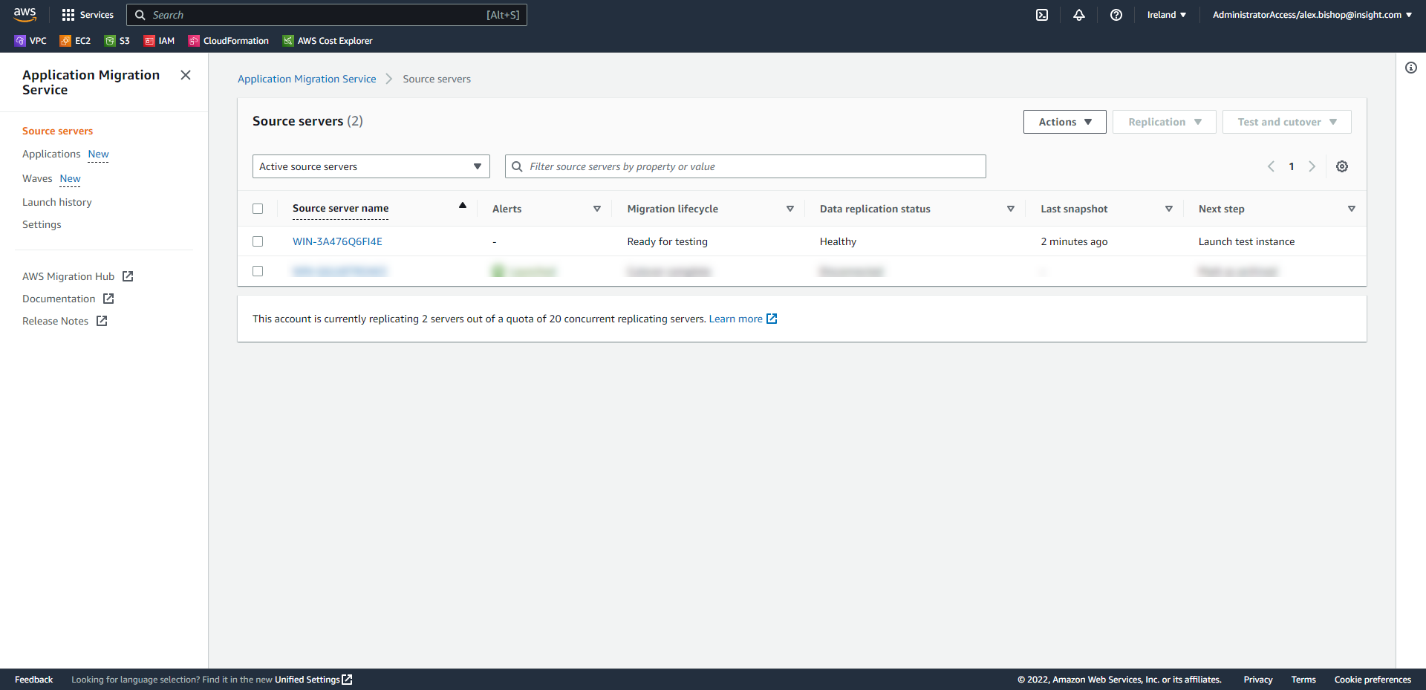

Click onto the source server name and you will see the Migration Dashboard which displays the current state in the Migration Lifecycle.

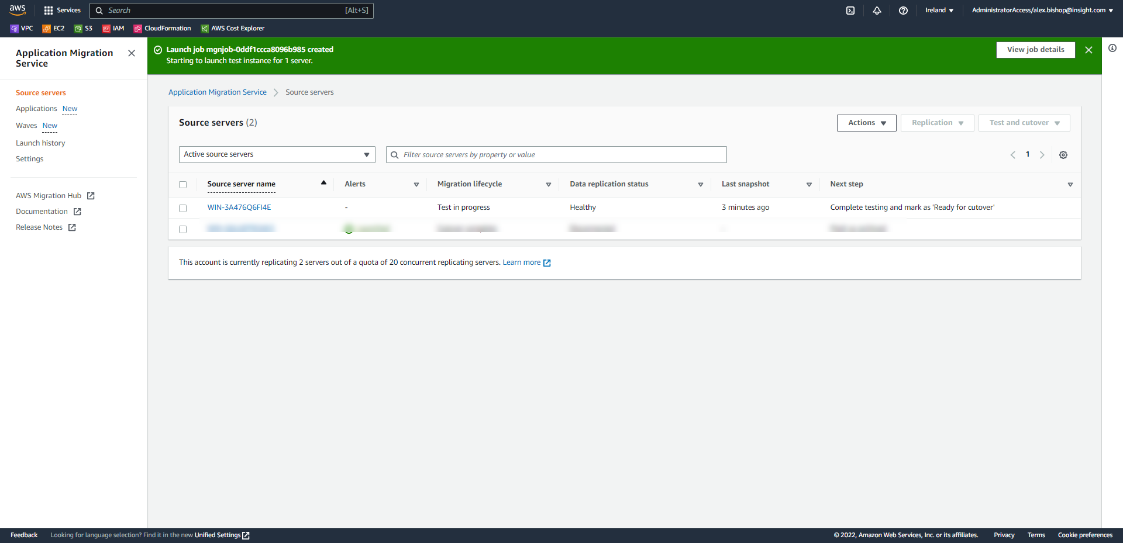

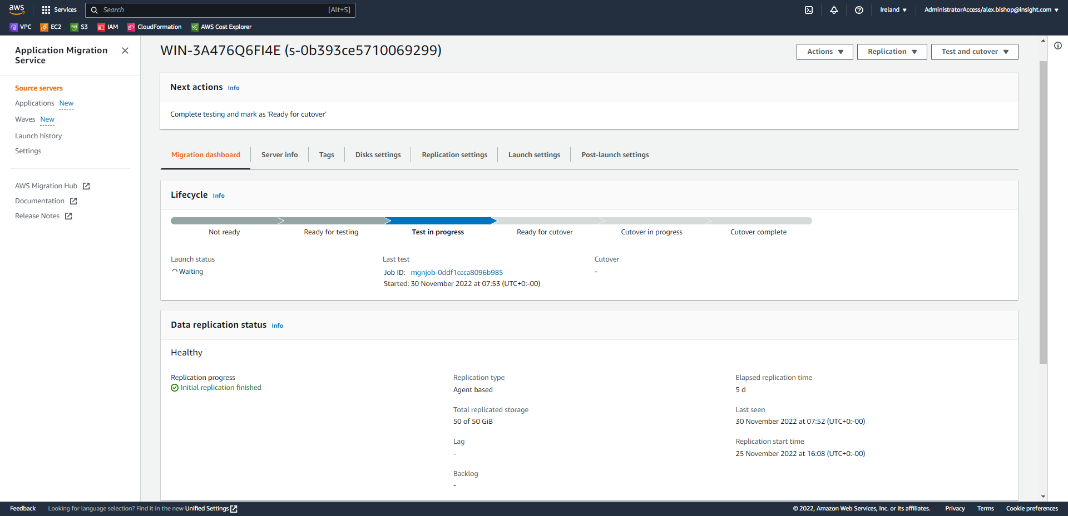

The test will fail at this stage as we need to edit the Launch Template created by the Application Migration Service to update the networking config, adding a private subnet, an instance profile for SSM and tags for the instance.

To do this, click the “Launch settings” tab, scroll down to EC2 Launch Template and click “Modify”:

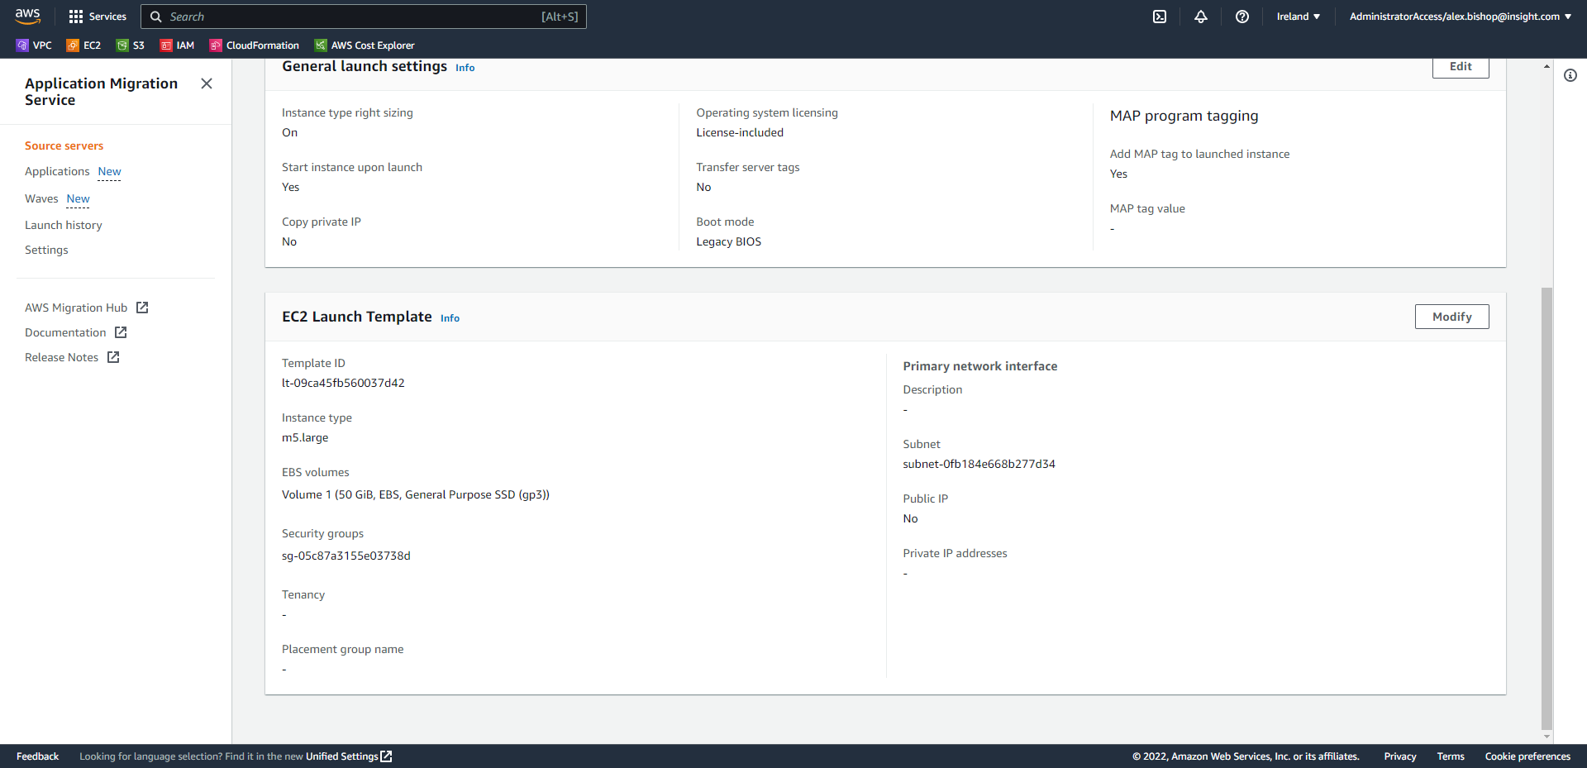

Again, click Modify.

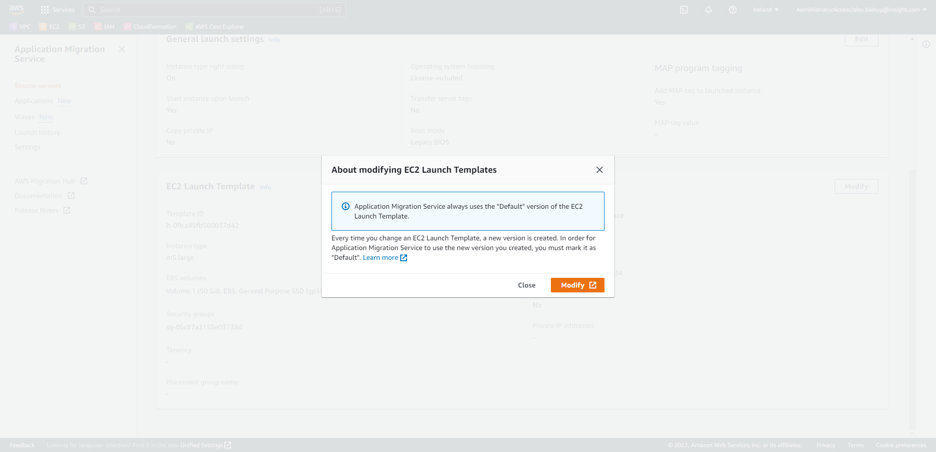

Under “Application and OS Images (Amazon Machine Image)”, select Quick Start and choose “Don’t include in launch template”.

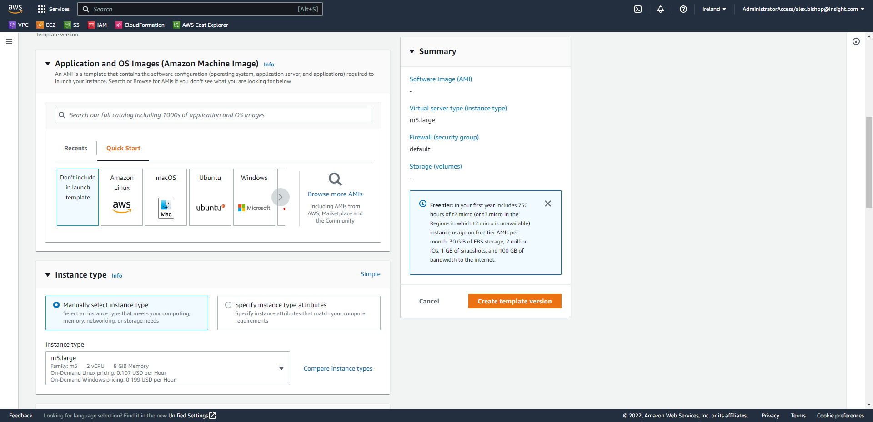

Scroll down to the “Network settings” and choose the private subnet where you wish to deploy your server. Also, either select a Security Group or create a Security Group which has Inbound rules for HTTPS Port 443 from “0.0.0.0/0”. The Security Group in the example is named “SSM-Endpoint”.

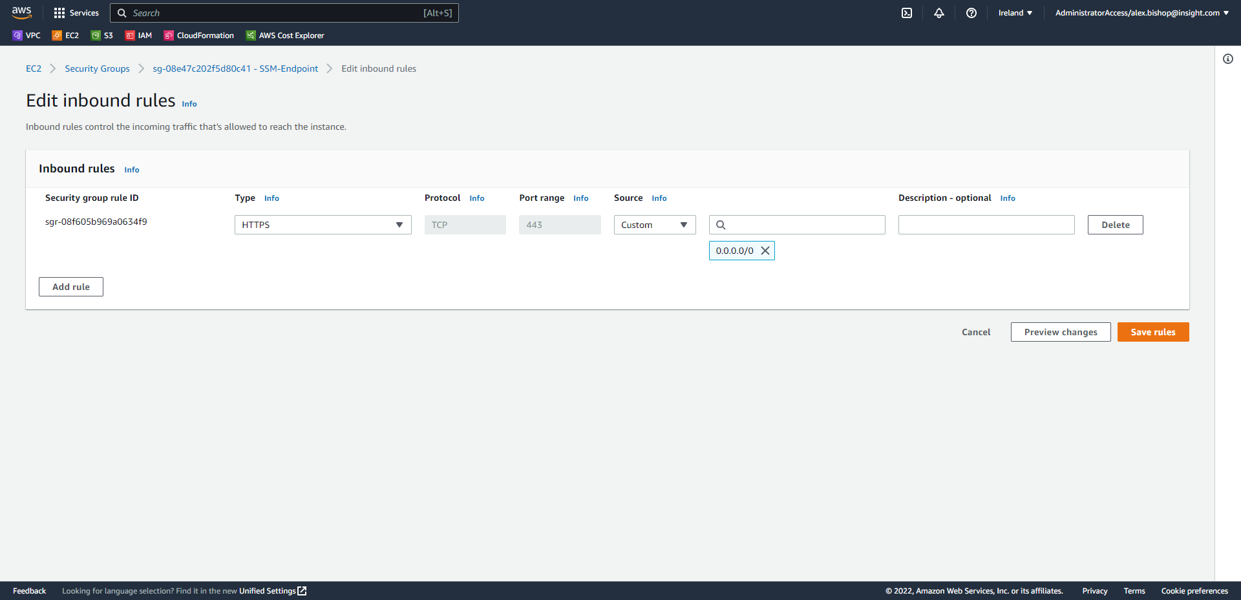

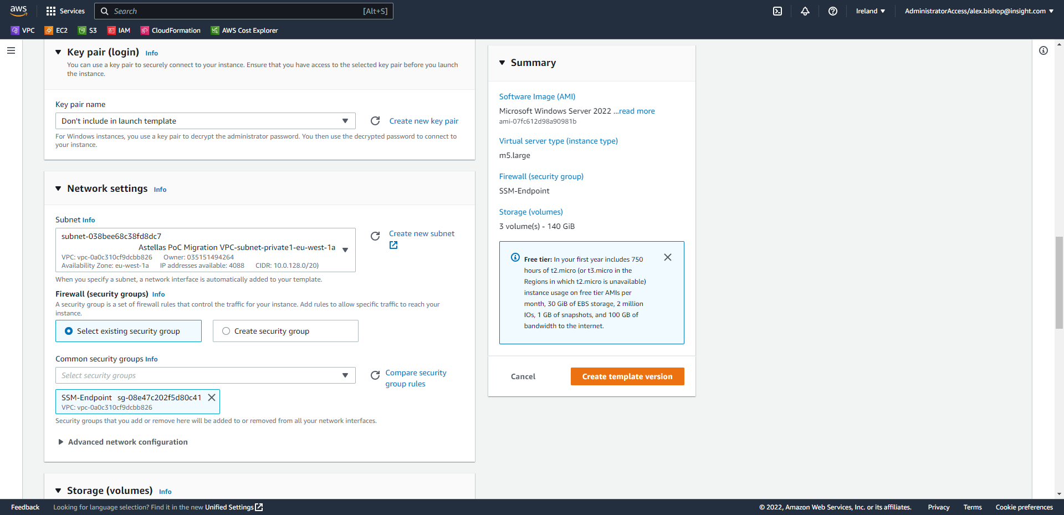

Scroll down and assign Resource tags as appropriate. This example uses the defaults and includes *Key:* “ssm” and *Value:* “true”. Which will be used in a later step to add the instances to Systems Manager for RDP access over the private network.

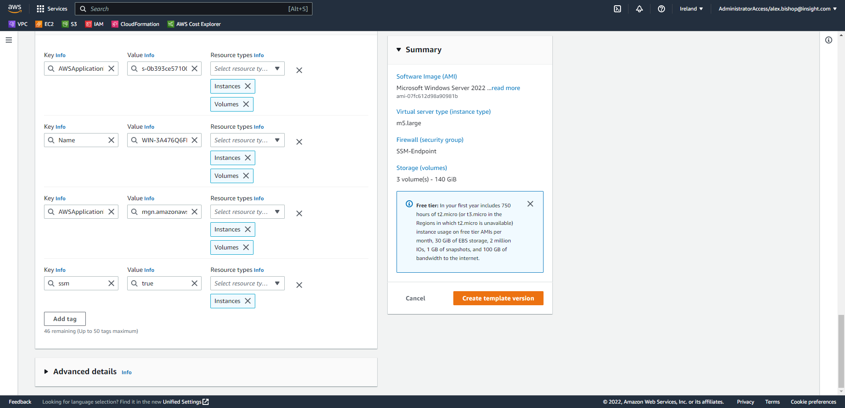

One thing to remember is that we need the SSM agent running on each EC2 instance so that we can RDP to the instances through the AWS Management Console. To do this we need to grant access to SSM by creating and adding an instance profile in the IAM console and adding this to the Launch Template.

Scroll down and open the “Advanced details” menu. If there is a role for SSM already present, then select the role. If not, then select “Create new IAM profile” on the left-hand side which will open a link to Create a new IAM role.

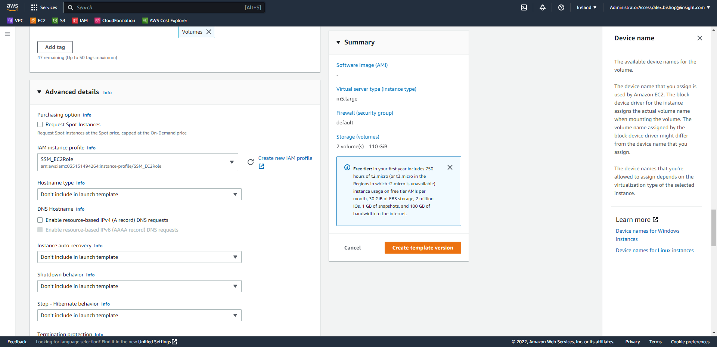

Click “Create role”.

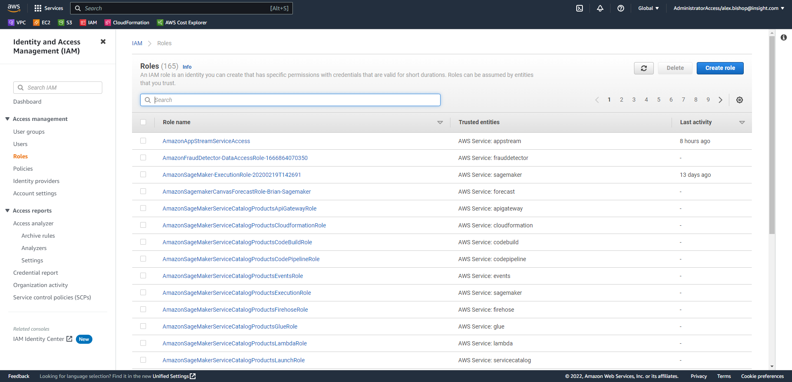

Choose “AWS service” under “Trusted entity type” and select EC2 for the Use case.

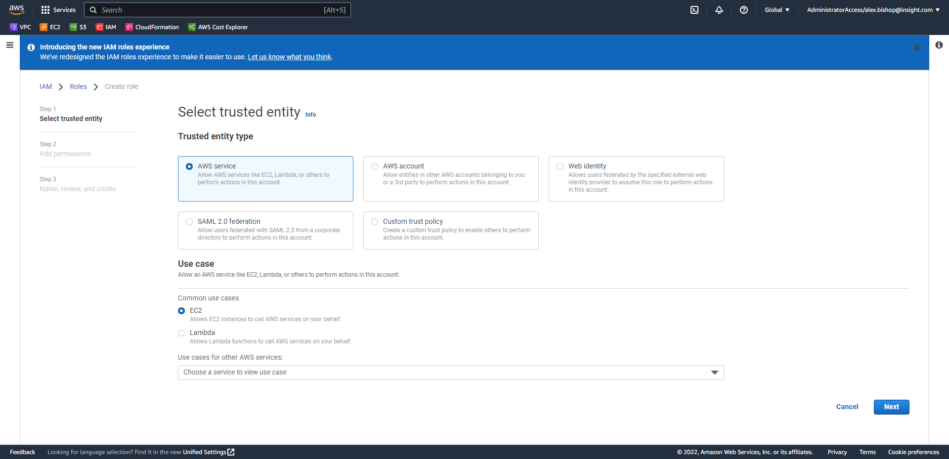

Click Next.

Enter “SSM” into the filter search box to filter the policies. Select “AmazonSSMManagedInstanceCore” to grant all Systems Manager permissions and click Next again.

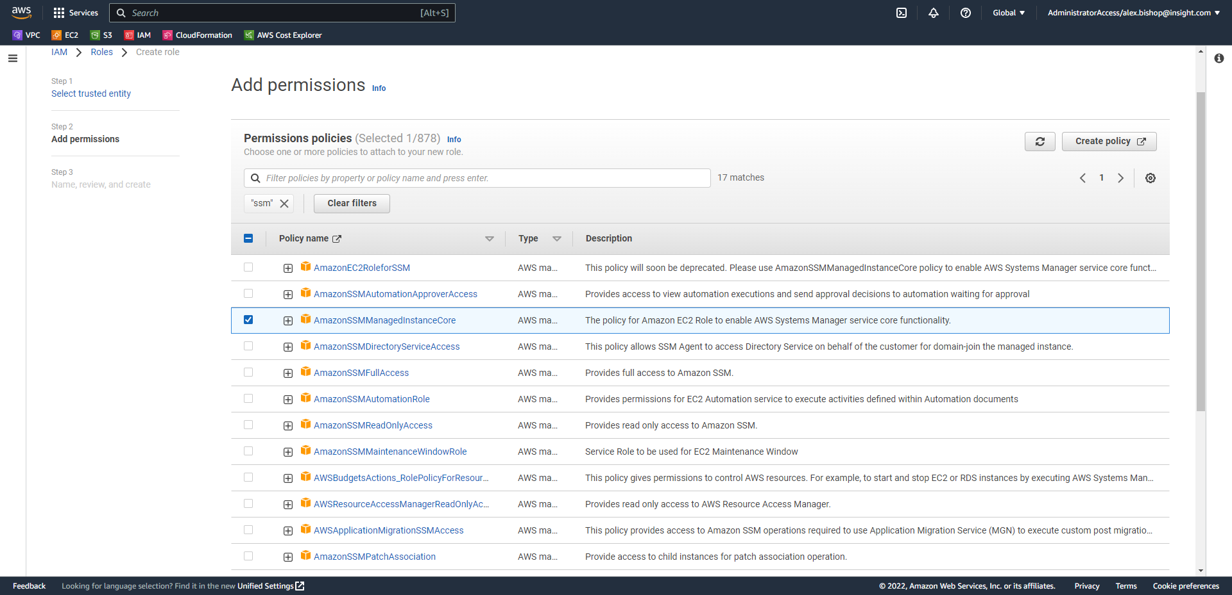

Name the role “SSM_EC2Role” and click Create role.

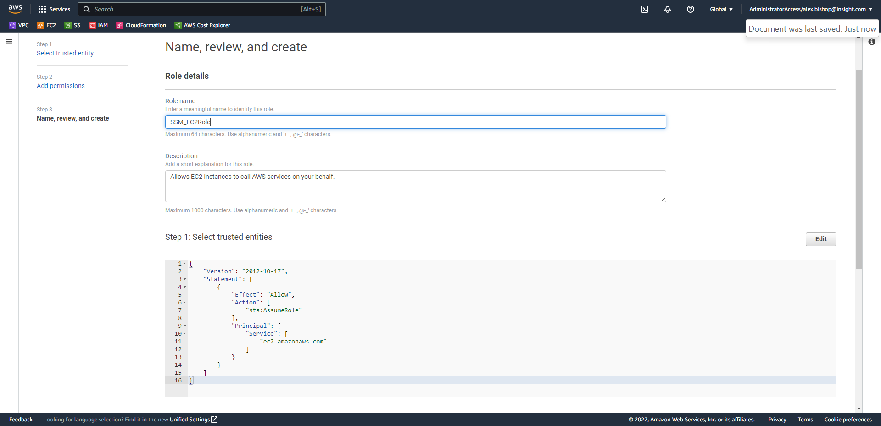

Go back to the Launch template modification page and click the refresh button next to “Create new IAM profile” so that the newly created role will appear.

Select the role from the list (SSM_EC2Role in this case).

Finally, click “Create template version”



Select “View launch templates”.

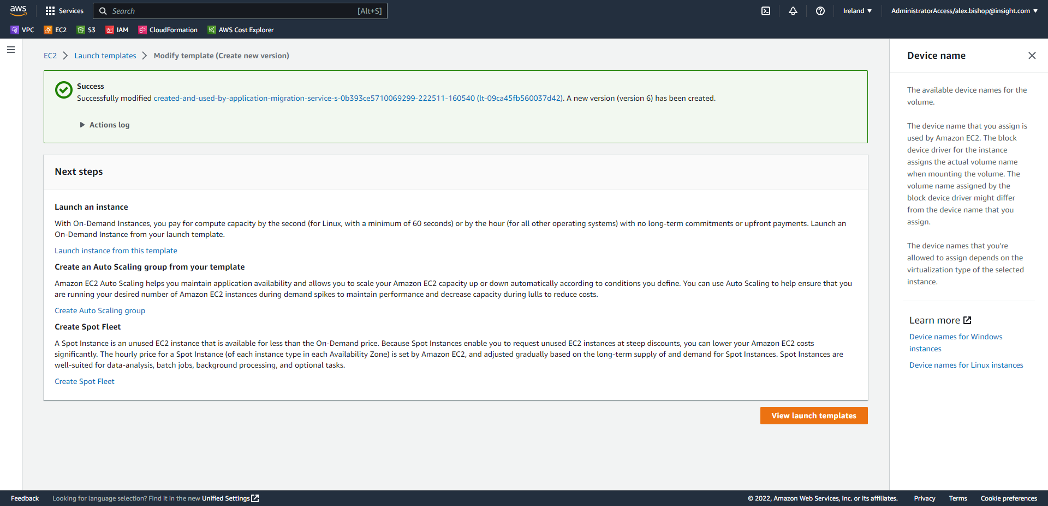

Select the radio button next to your new template ID. Click “Actions > Set default version”

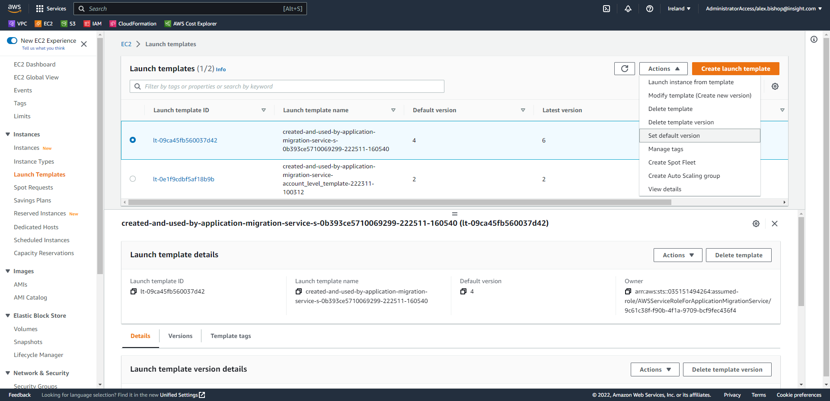

Choose the latest template version from the list and click “Set as default version”.

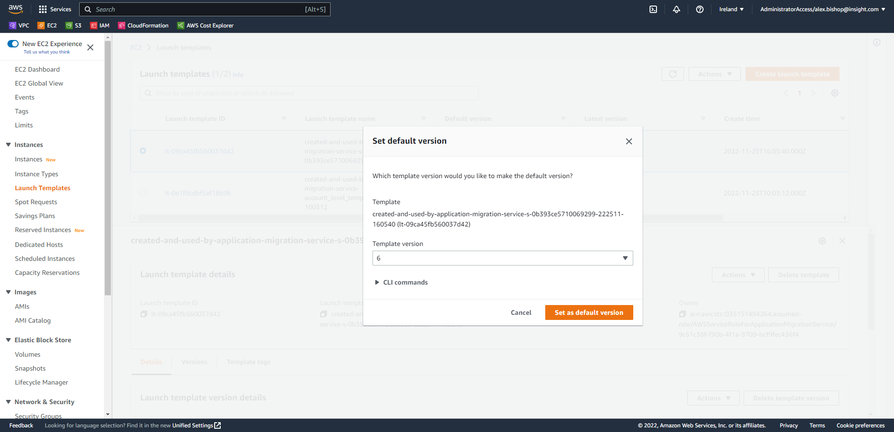

1. **Configuring SSM**

Now that the server has been migrated SSM needs to be configured in the account to RDP into the servers while in a private subnet.

Open the VPC Console and select Endpoints in the left-hand navigation menu. We need to add two VPC Interface Endpoints, one for SSM and one for SSM Messages to use RDP with Systems Manager for an instance in a private subnet.

Click Create endpoint.

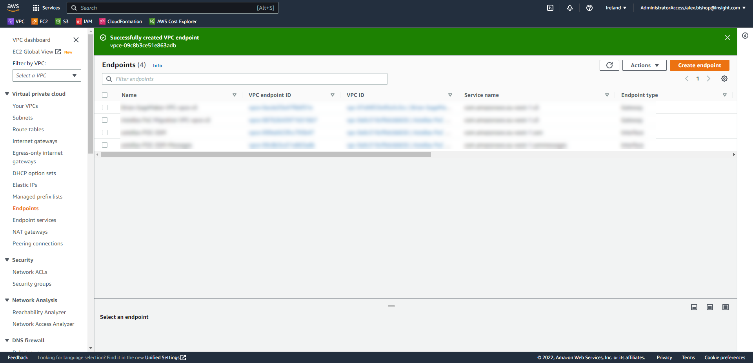

Name the endpoint astellas-POC-SSM and select AWS services for the Service category.

Under Services filter the services to “ssm” and select the Interface of *“com.amazonaws.eu-west-1.ssm”*

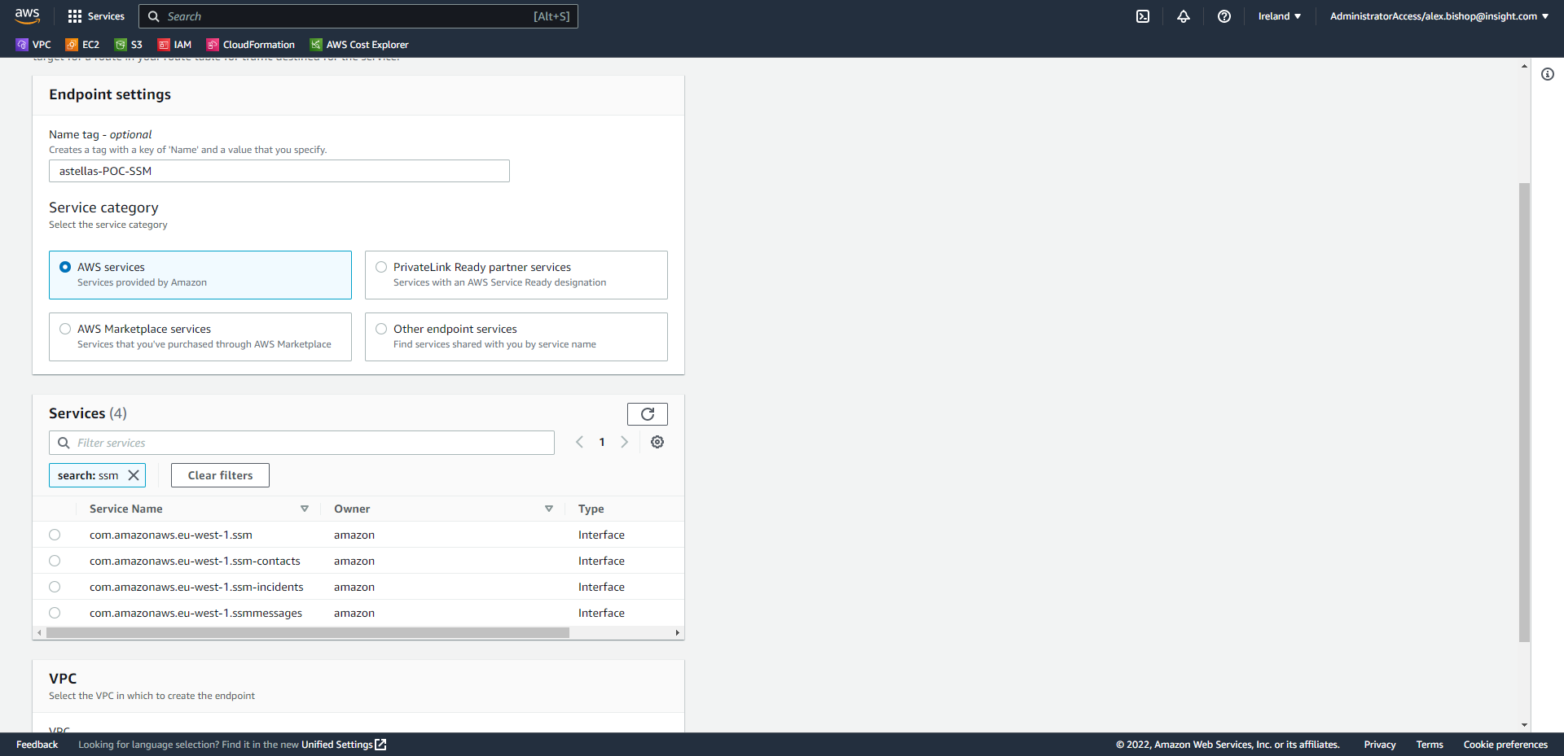

Select the same VPC and private subnet that hosts your server (this scenario selects all private subnets in the VPC). Choose the IPv4 IP address type and select the SSM-Endpoint Security Group.

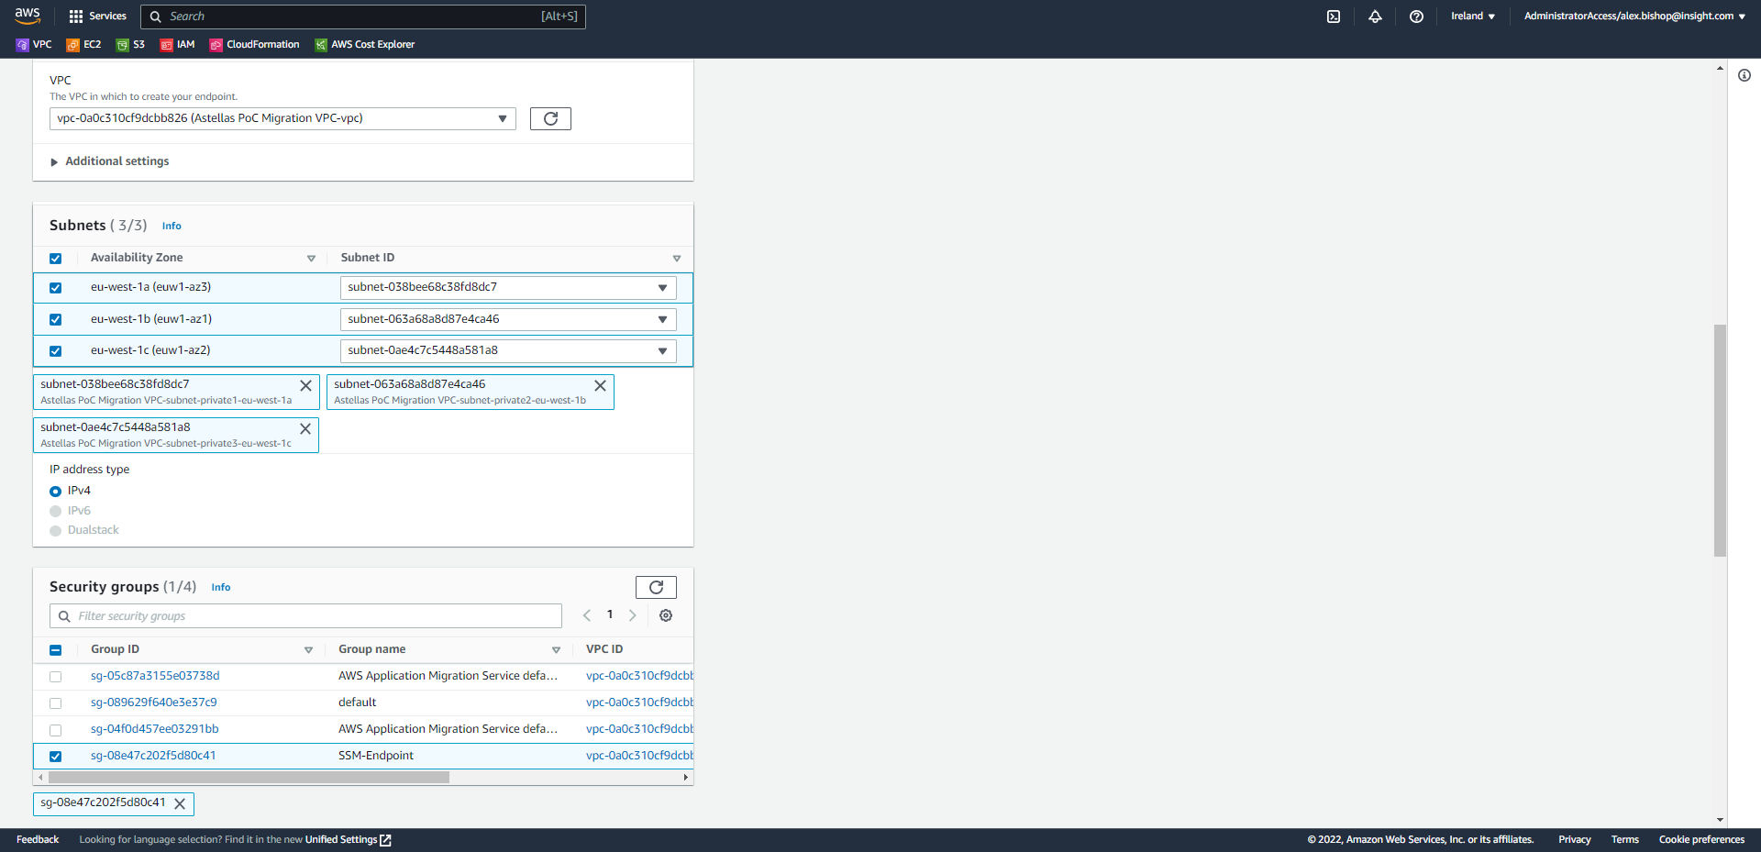

Finally, scroll to the bottom of the page and click Create endpoint.

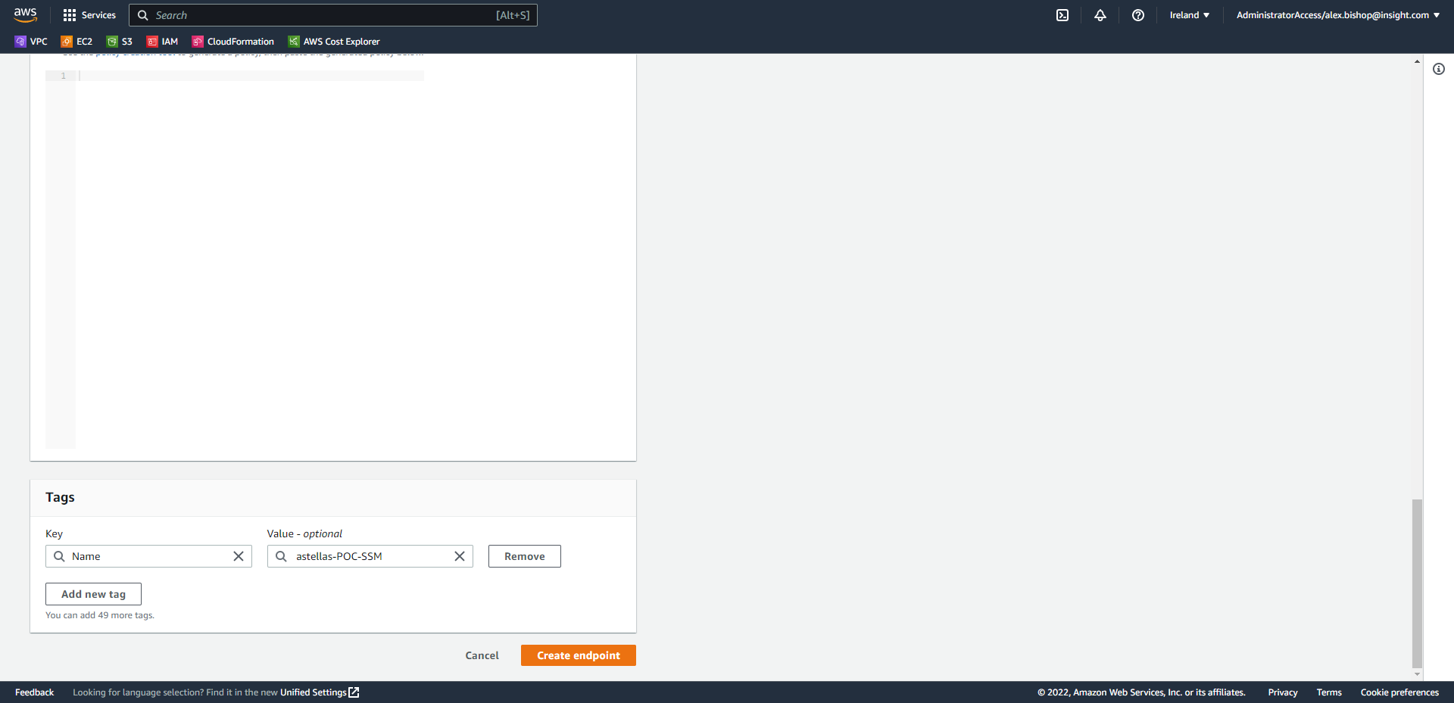

A second Interface endpoint must also be created for SSM messages.

Again, click “Create endpoint”.



This time, name the endpoint *“astellas-POC-SSM-Messages”,* filter the services to “ssm” and choose the *“com.amazonaws.eu-west-1.ssmmessages”* Interface.

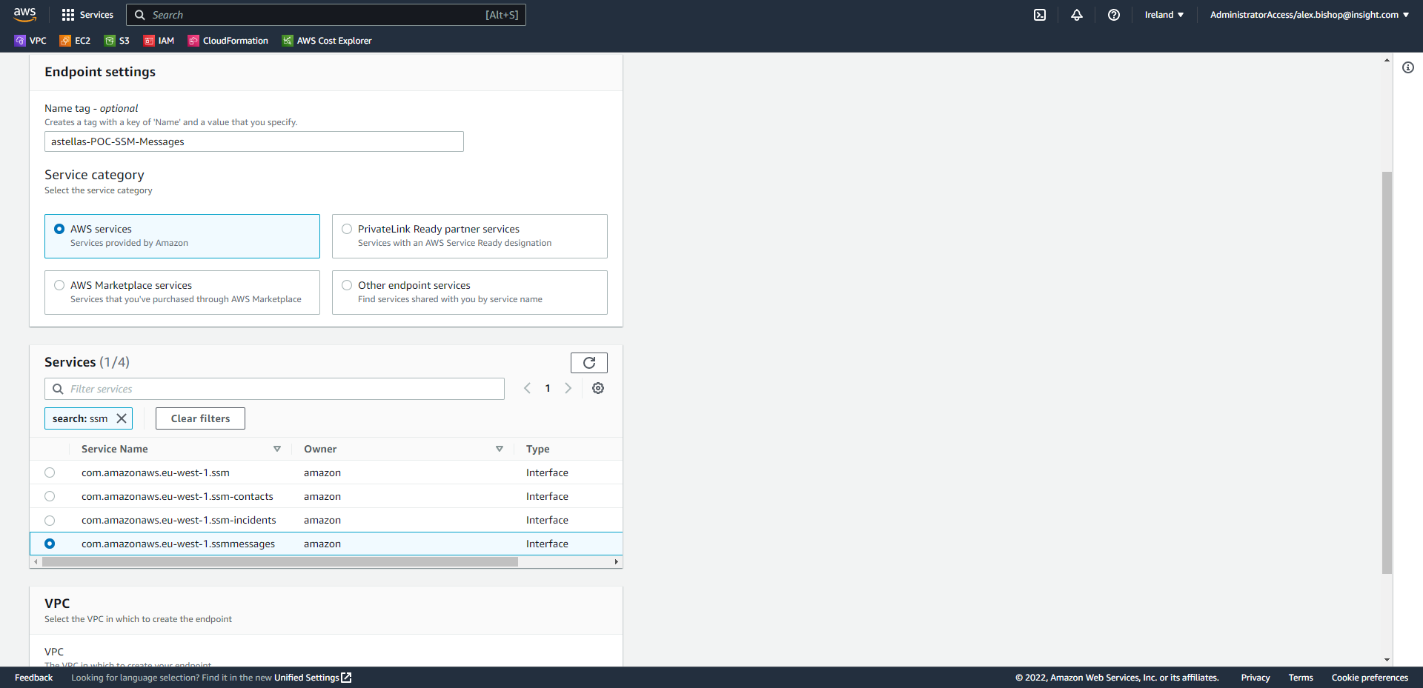

Again, select the same VPC and private subnet that hosts your server (this scenario selects all private subnets in the VPC). Choose the IPv4 IP address type and select the SSM-Endpoint Security Group.



Finally, scroll to the bottom of the page and click Create endpoint.



Your two VPC Interface Endpoints for SSM will appear as so:

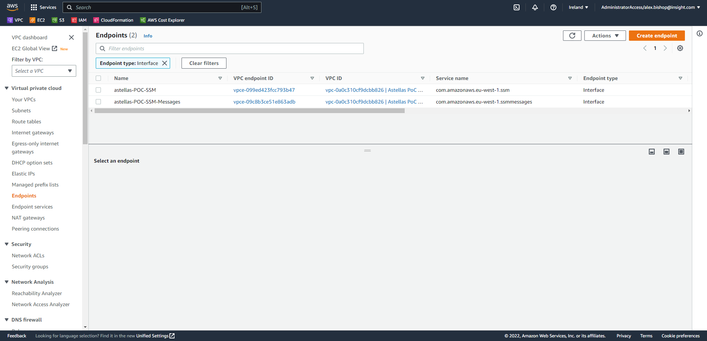

To continue the Systems Manager setup, open the AWS Systems Manager Console and click “Quick Setup” in the left-hand navigation menu at the top.

Click Create under “Host Management”

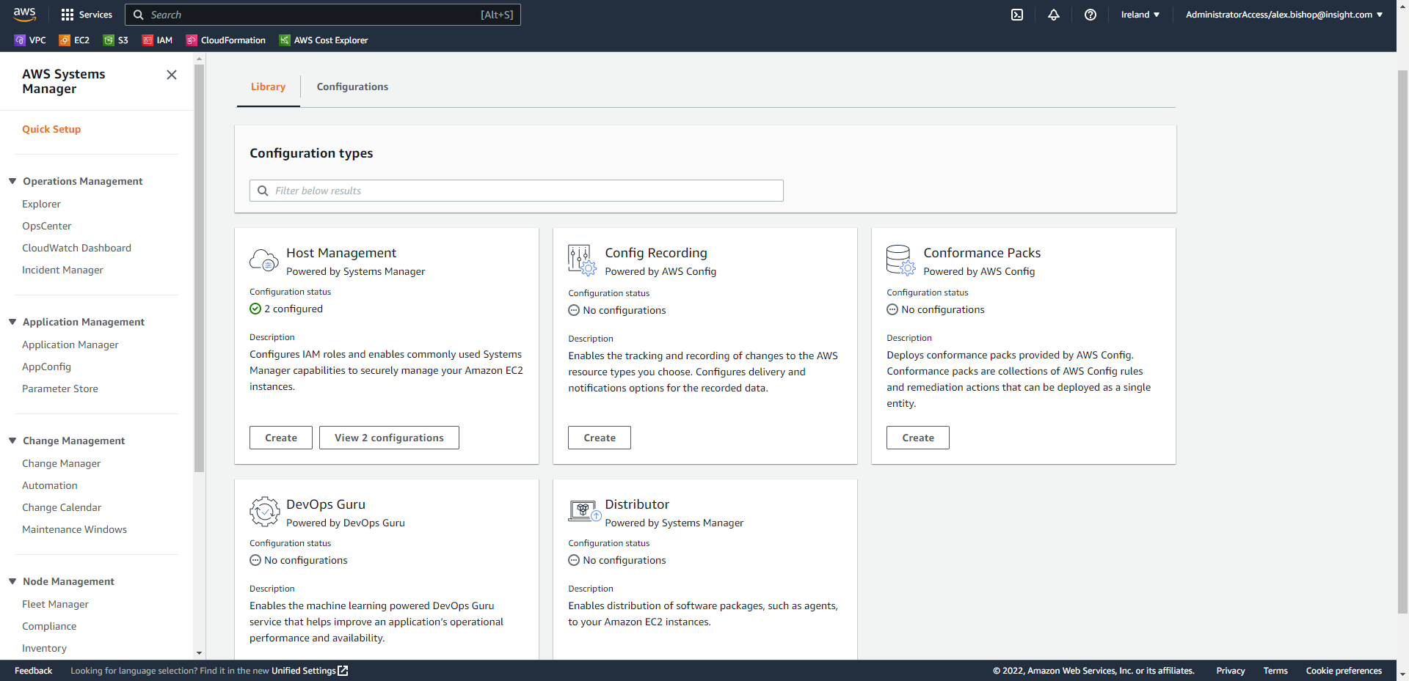

Ensure that all the Systems Manger preference check boxes are ticked and tick the “Install and configure the CloudWatch agent” check box under Amazon CloudWatch.

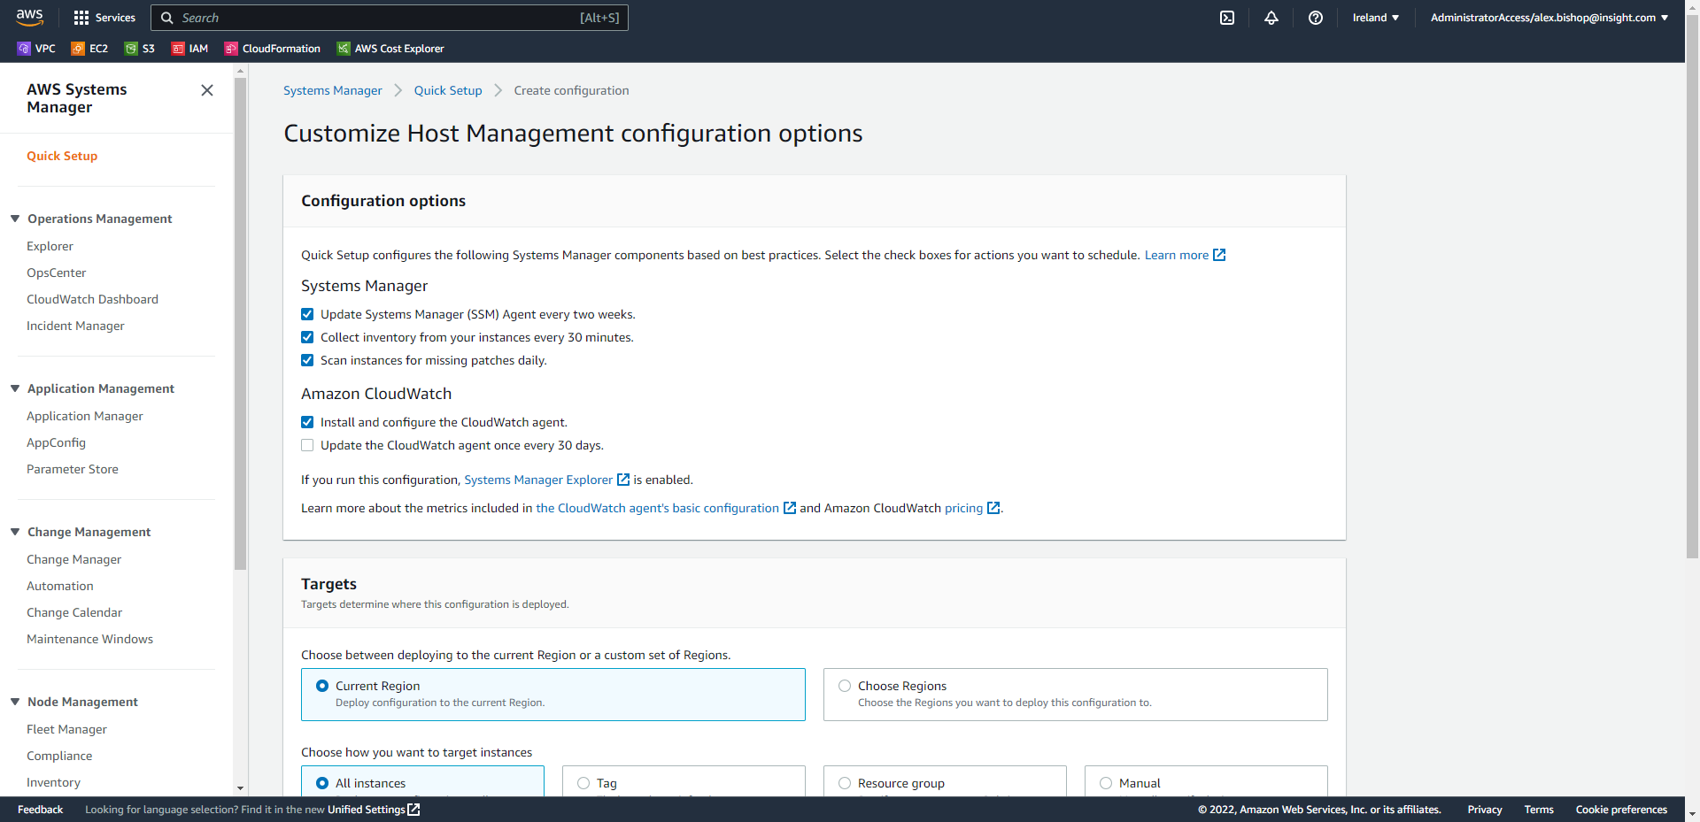

For “Targets” select “Tag” and Add *Key:* “ssm” and *Value:* “true” which is a tag used in our Launch Template.

Finally Click Create.

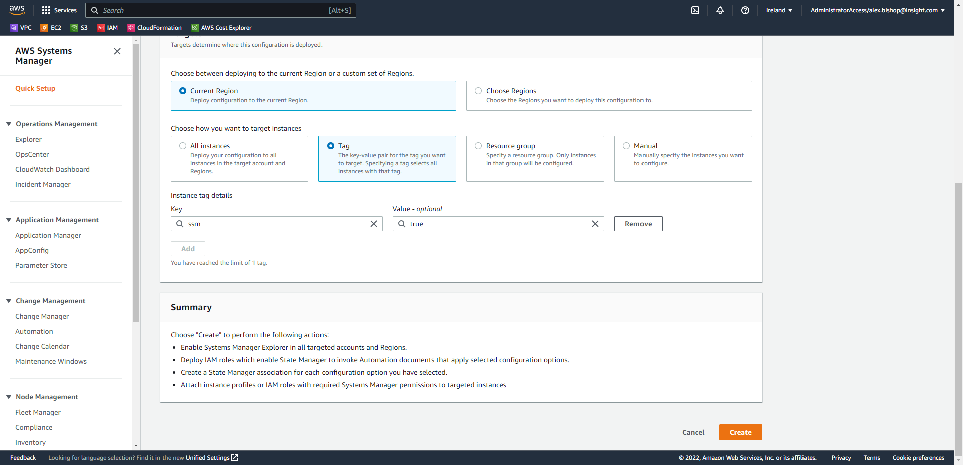

The Host Management screen will display the Configuration status of SSM for hosts. There should be 1 Success in your Configuration status. There is 2 Success 1 Failed in this screenshot as at this point two servers had been deployed with SSM in this test lab and one without in the eu-west-2 region.

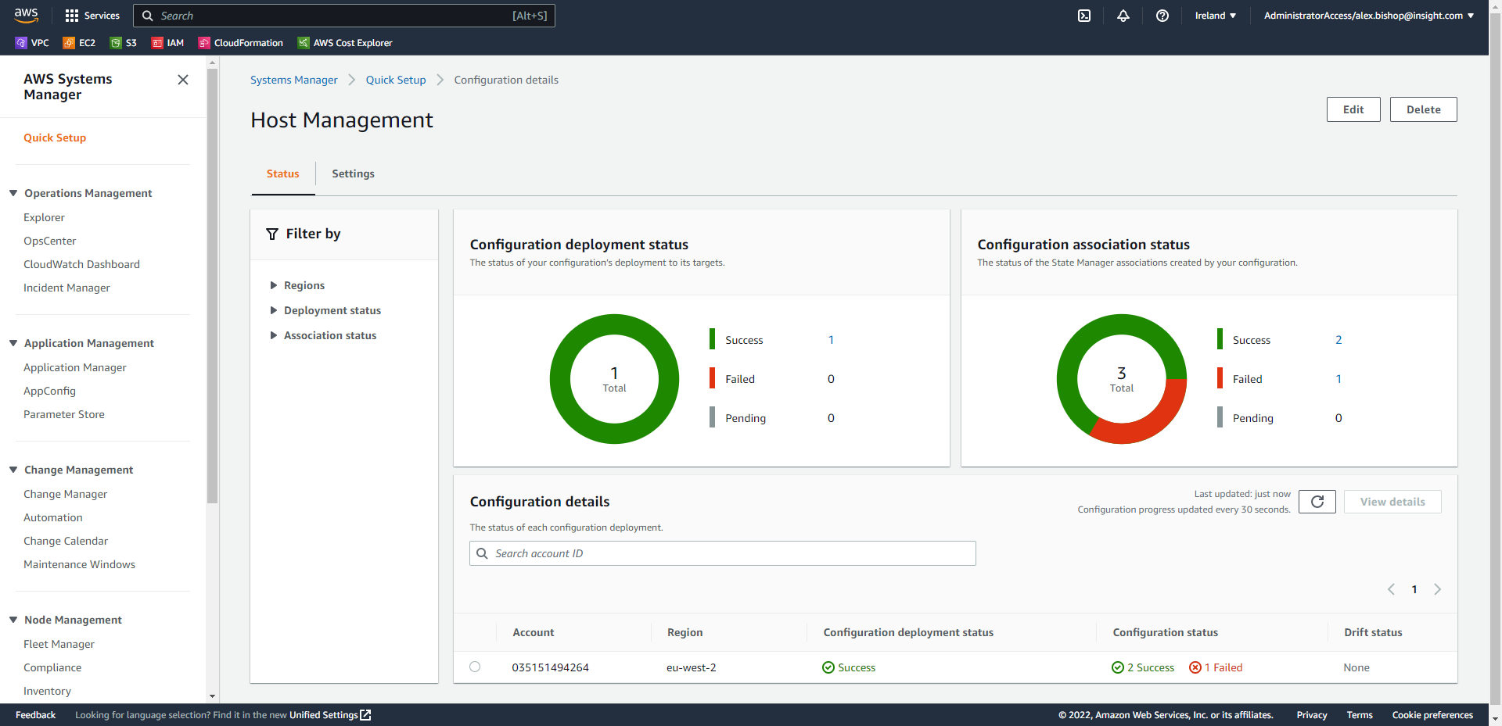

Back on the Migration dashboard for the server you will see the “Lifecycle” which will display that the migration is Ready for testing. Choose “Test and cutover > Launch test instances”.

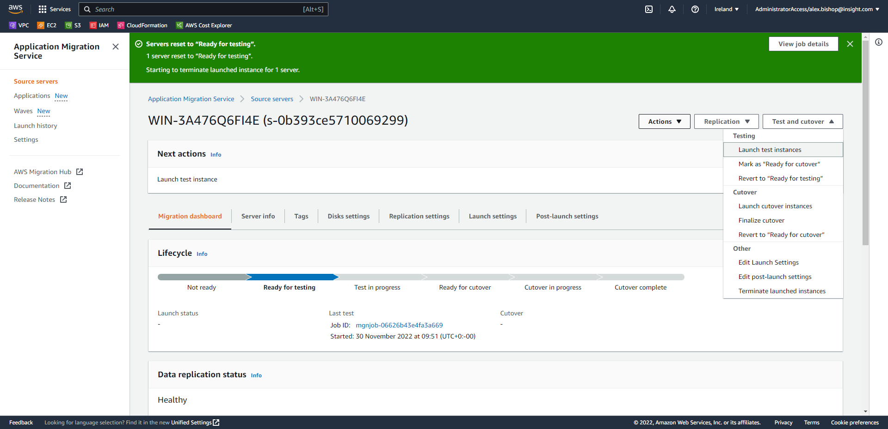

Select Launch.

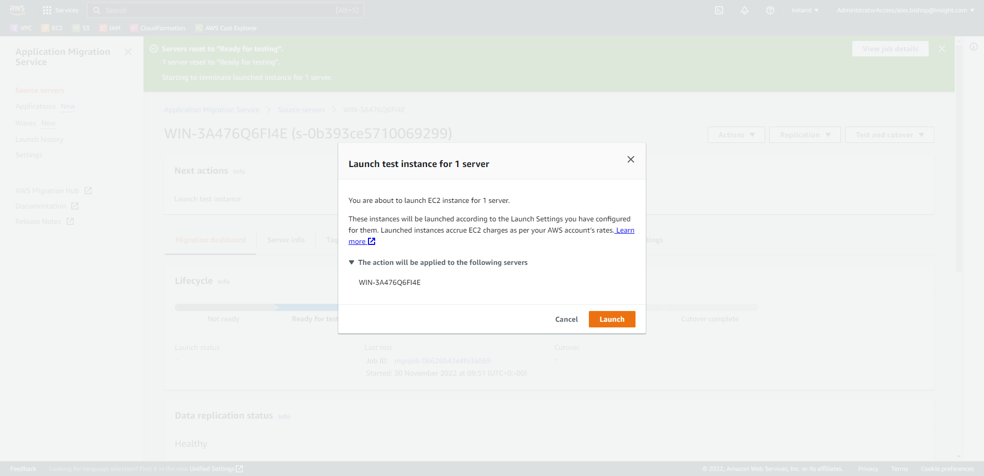

1. Testing the RDP Connection

Now that the source server is in the “Test in progress” phase, we will be performing a test of the RDP connection to connect to our instance.

View you EC2 instances to check the status of the instance launch (it may take 10 minutes or so to launch the instance). Once the instance is in a running state revisit the Systems Manager console and select Fleet Manager in the left-hand navigation menu.

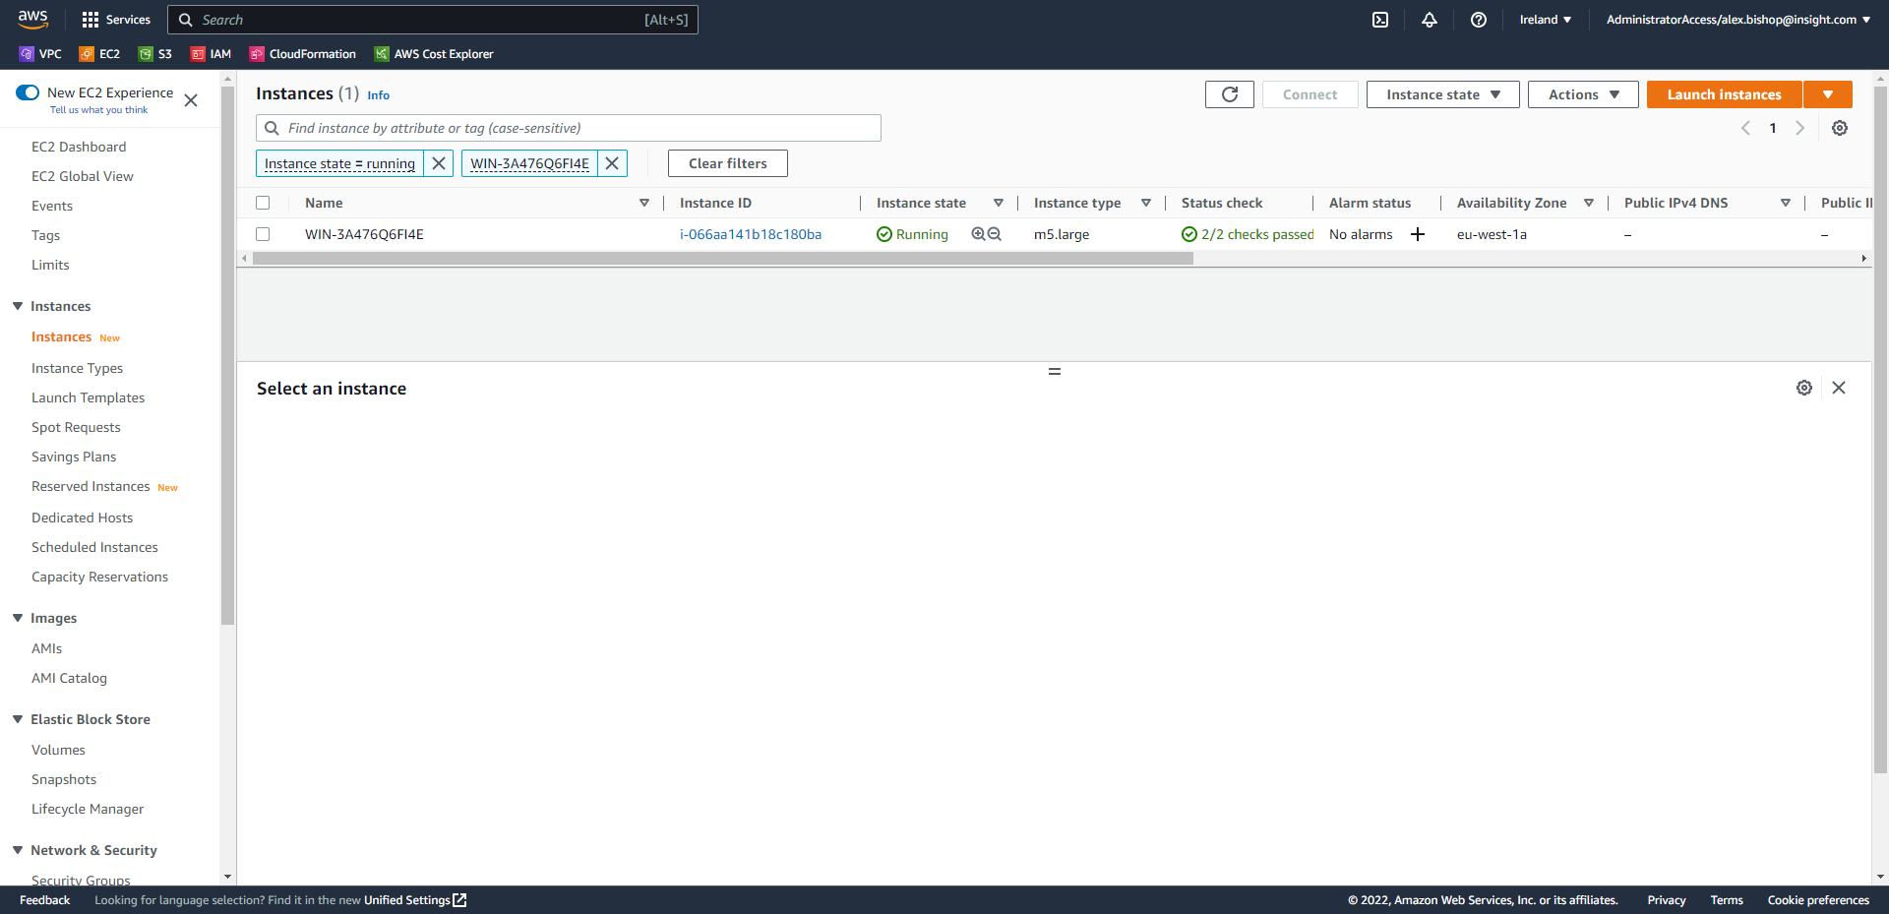

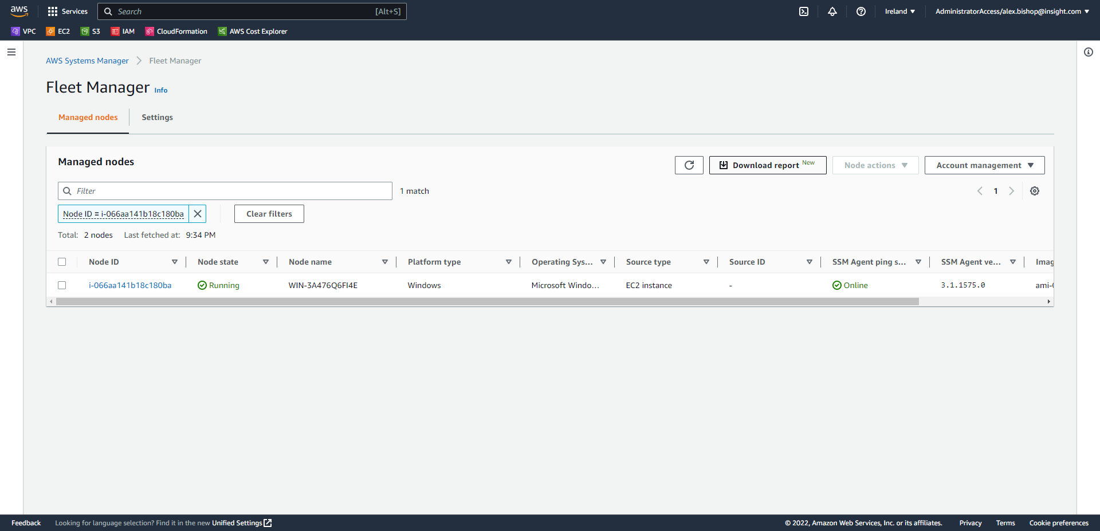

Select your instance (Node in Fleet Manager) and choose *“Node actions > Connect with Remote Desktop”*

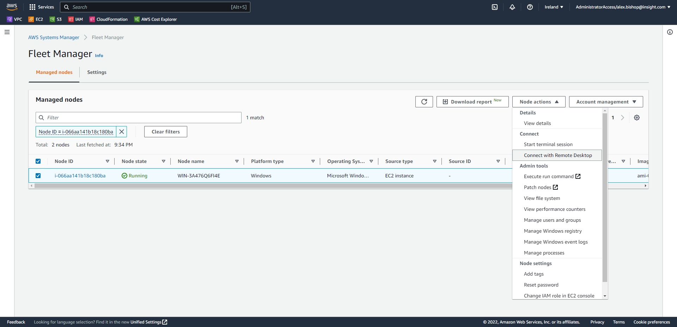

Enter the user credentials for the server (the same credentials you would use on premise) and click connect.

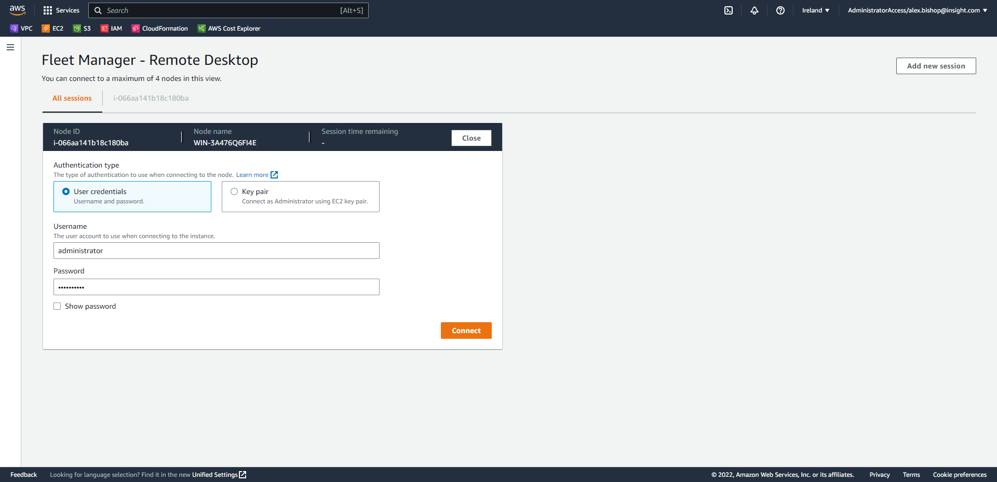

You will connect to the migrated EC2 instance of your server.

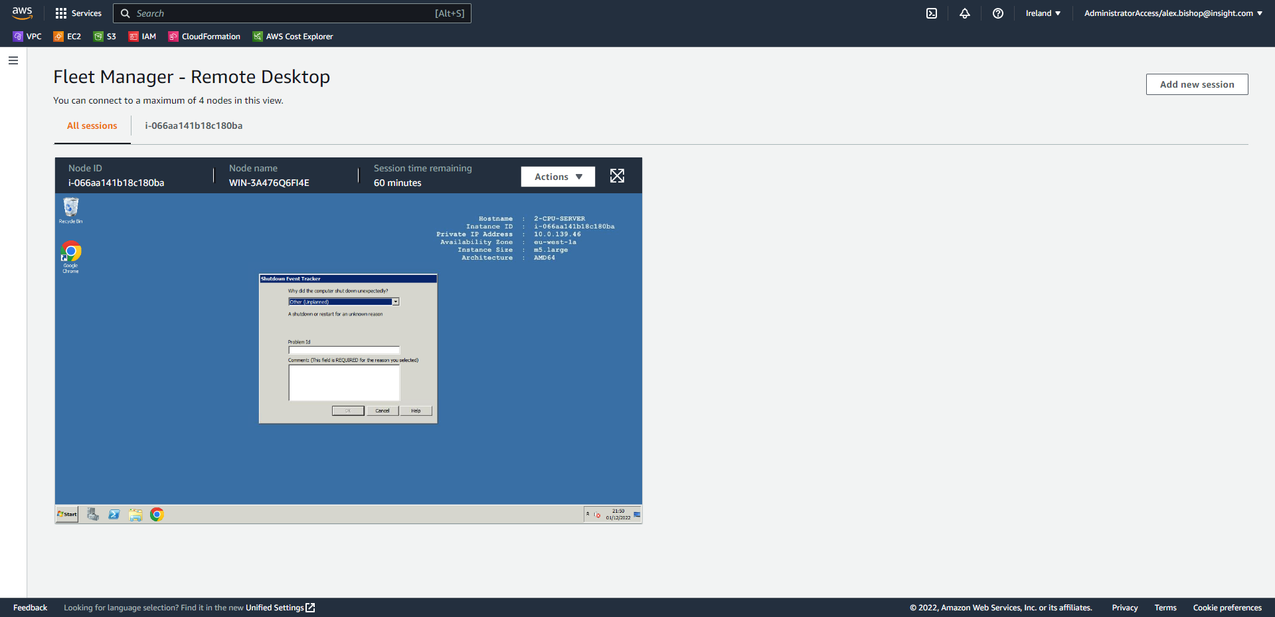

Once happy, click *“Actions > End session”* to end this session.

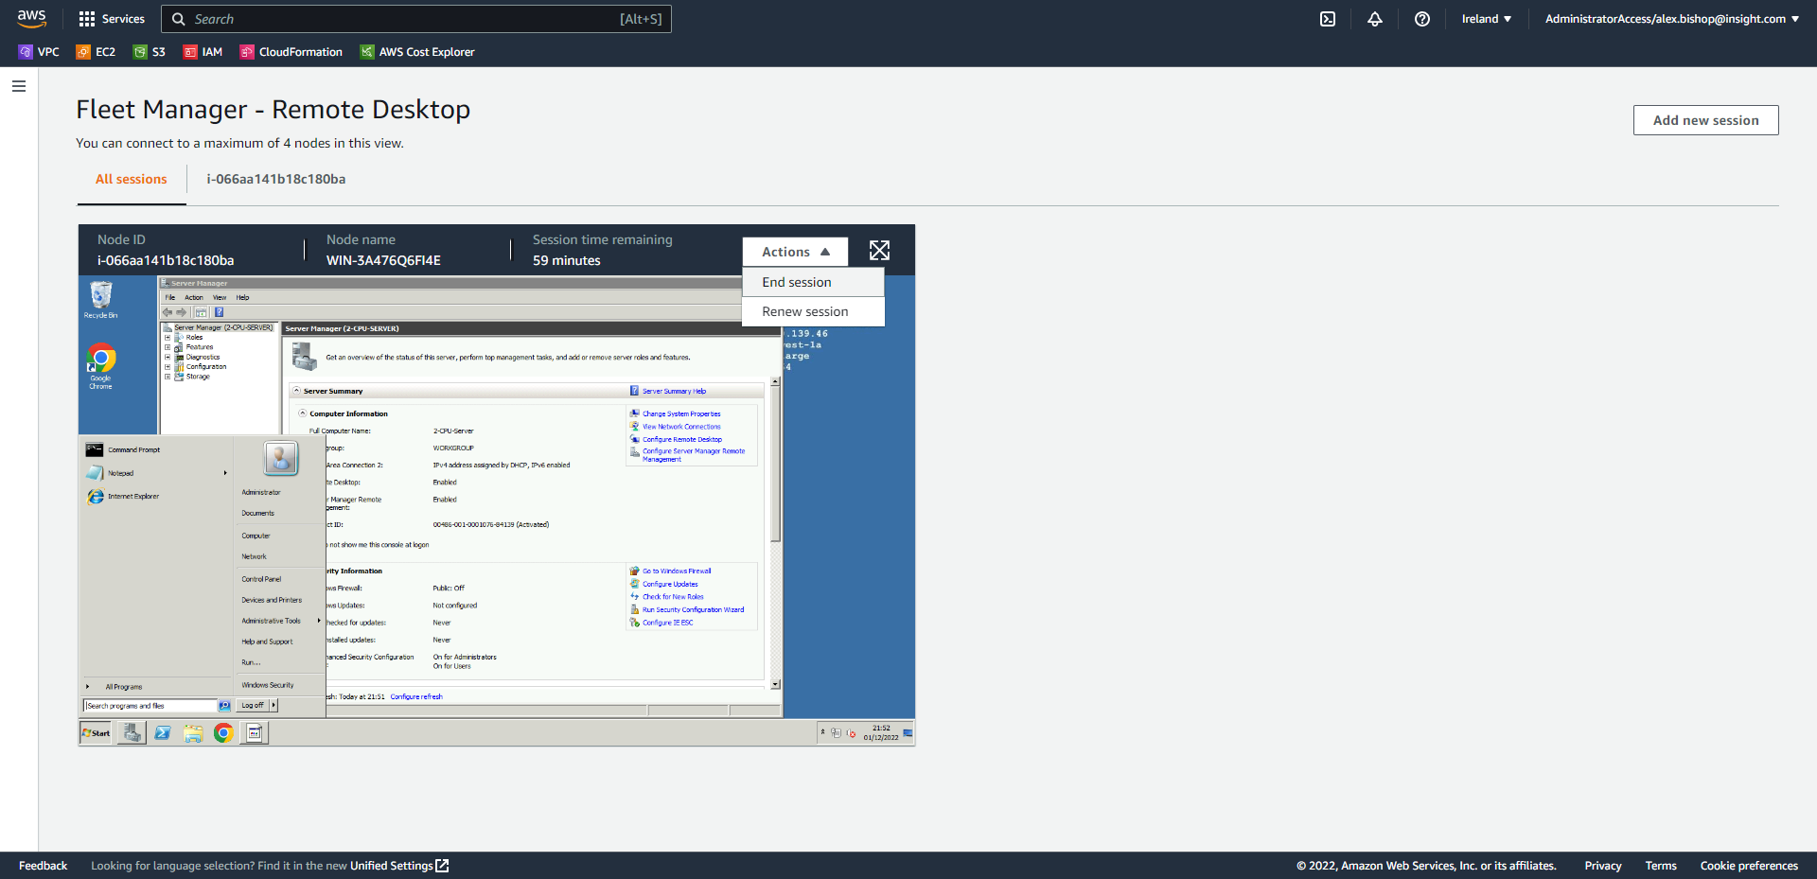

Click End session.

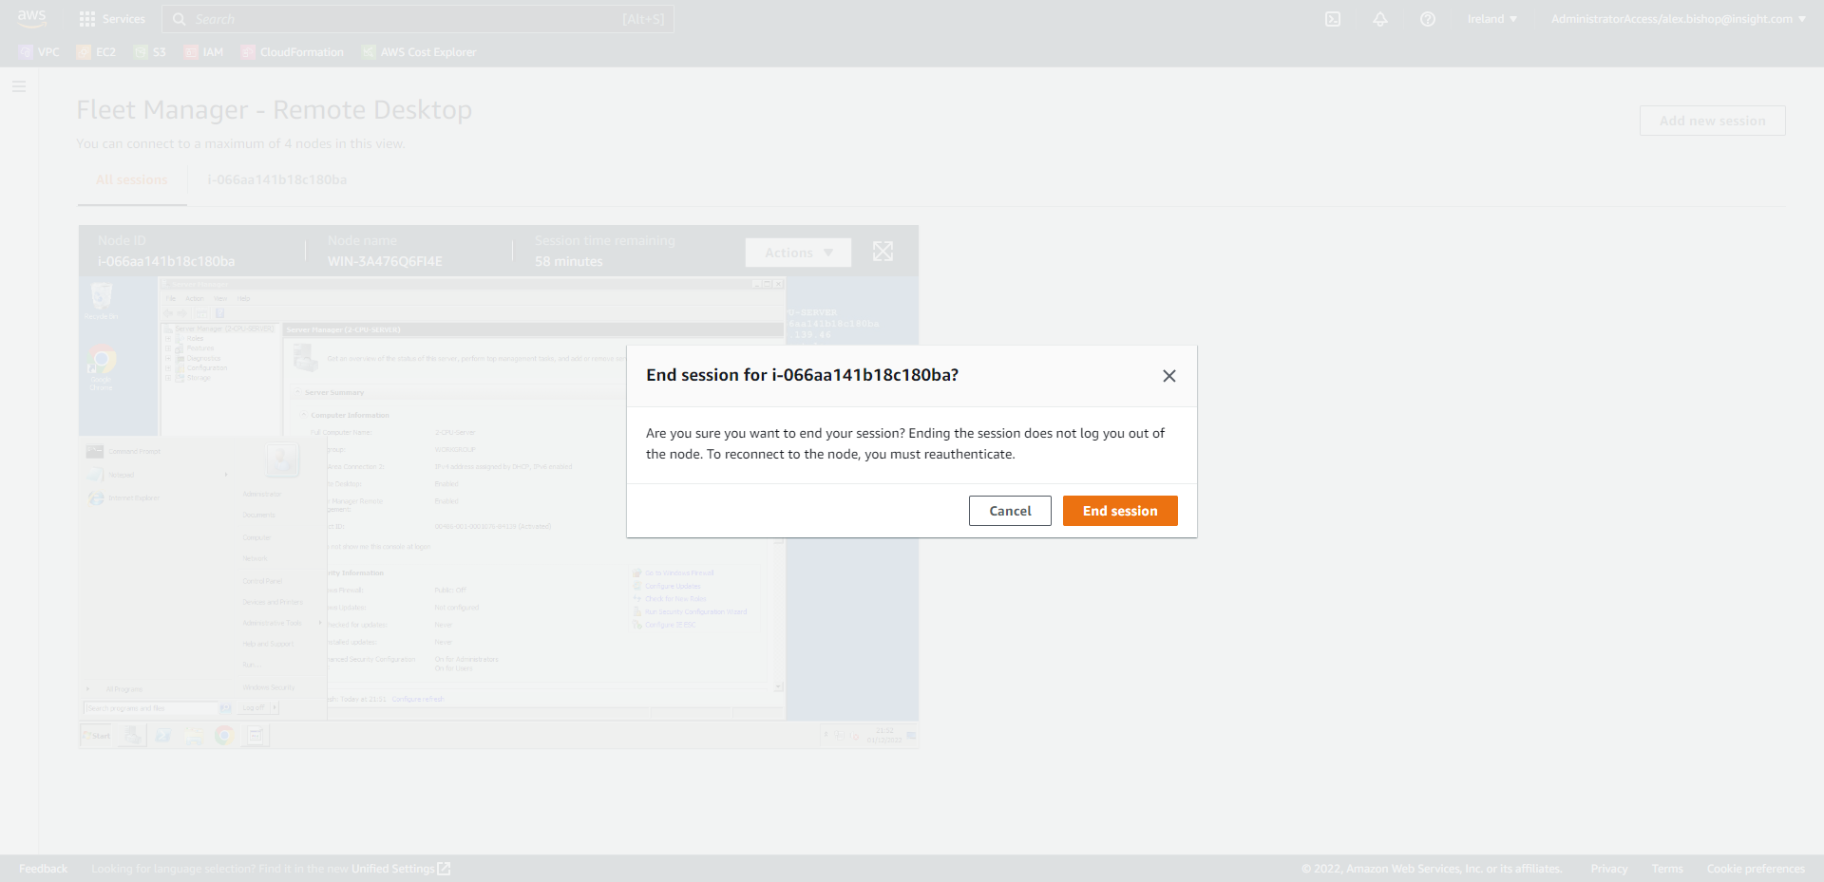

1. Complete the Cutover

To complete the cutover for your instance from the Source servers Migration dashboard, select *“Test and cutover > Mark as “Ready for cutover””* (the source server name has been changed to 2-CPU-Server for simplicity in this Lab).

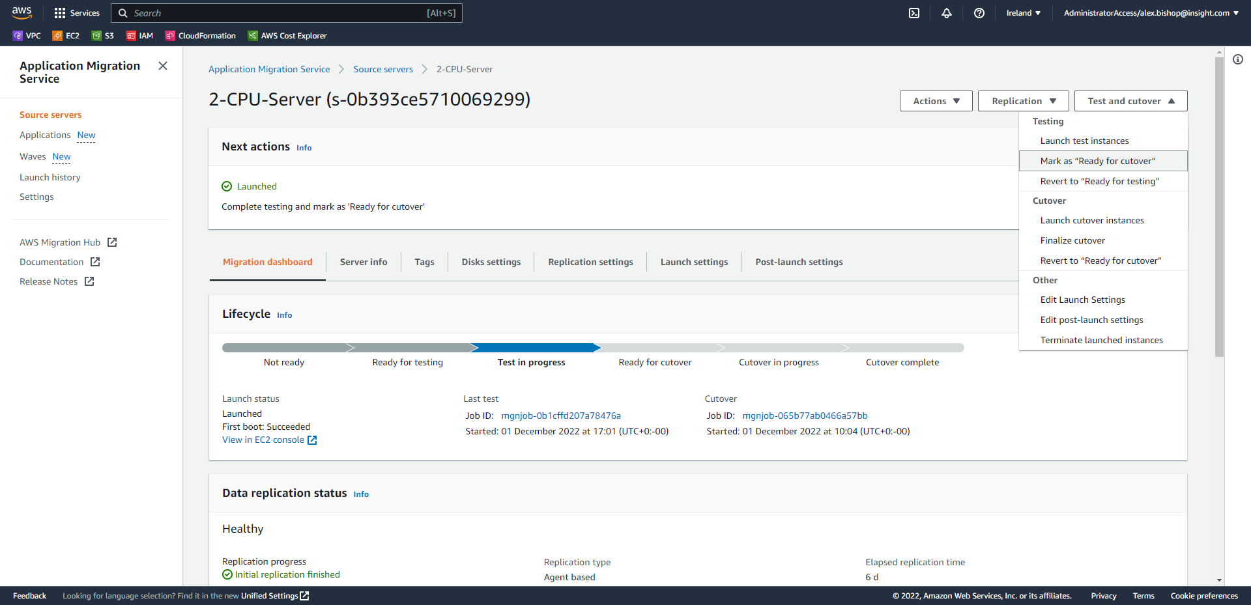

Select the checkbox to terminate the launched instances and click Continue.

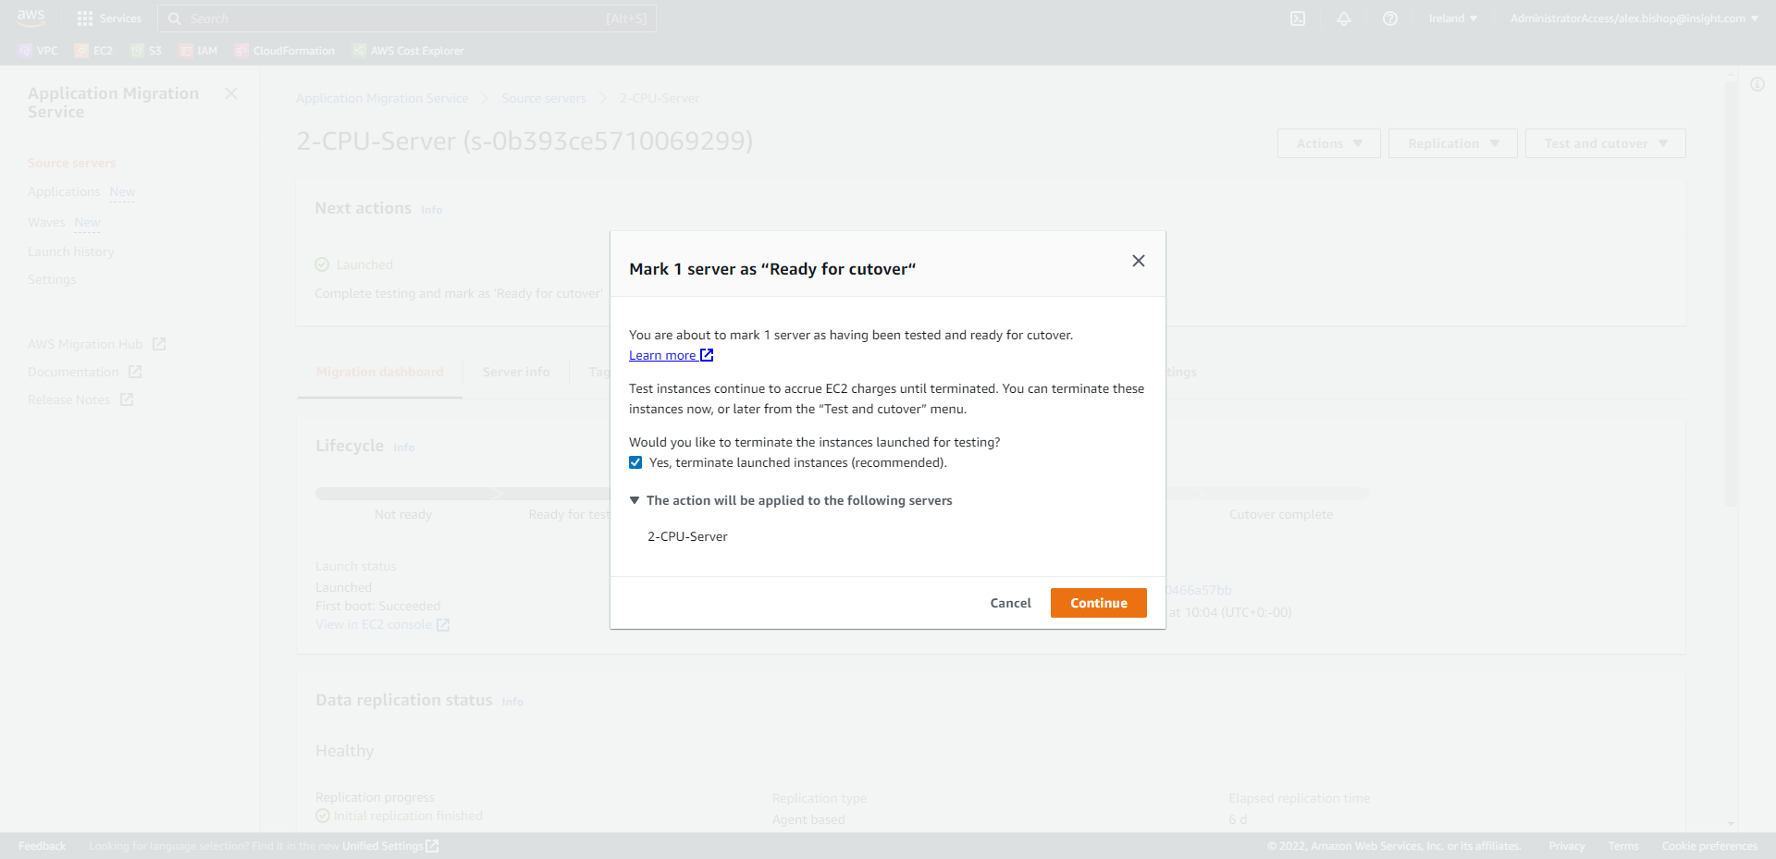

Once in the “Ready for cutover” state proceed to cutover the instance and select *“Test and cutover > Launch cutover instances”*

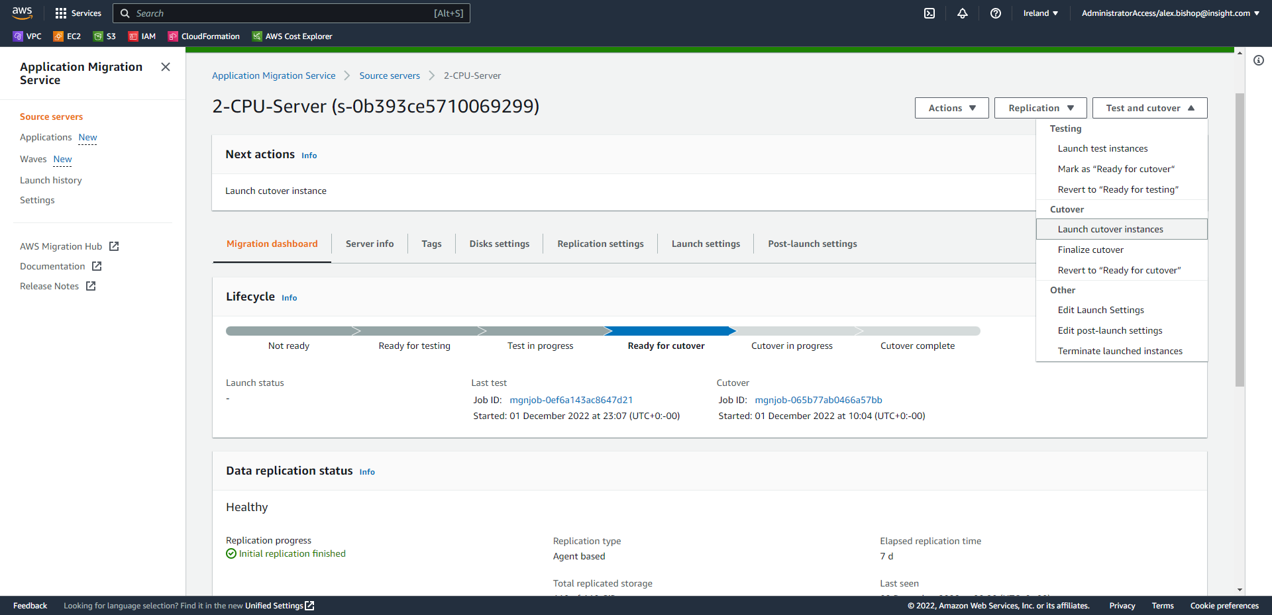

Click Launch.

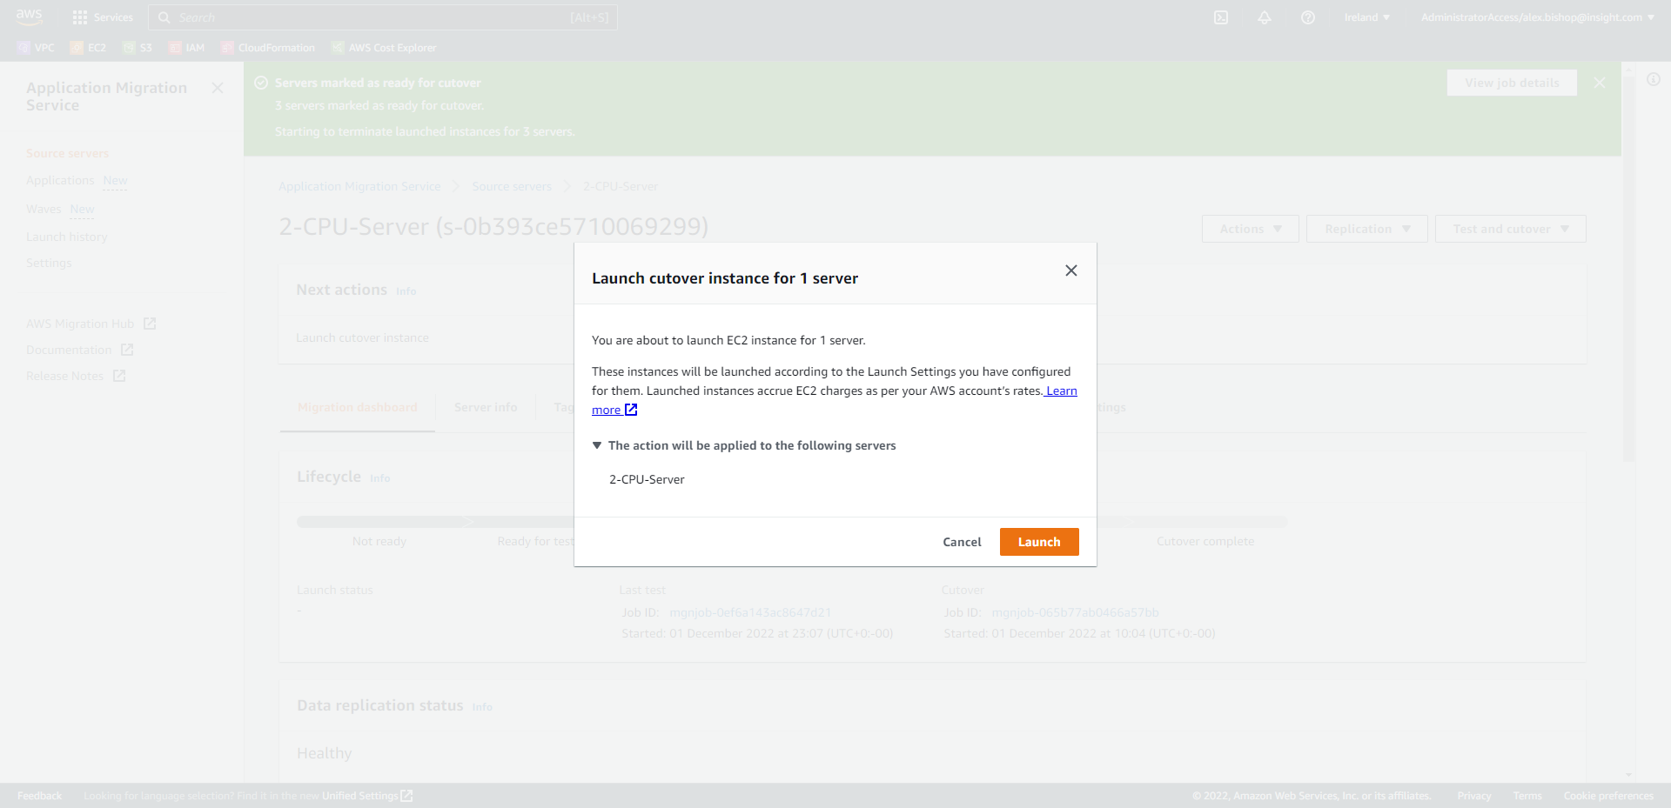

The cutover will now be in progress. It will take around 15 minutes to complete the job.

The final step in the Migration Lifecycle is to Finalize the cutover. Select *“Test and cutover > Finalize cutover”*

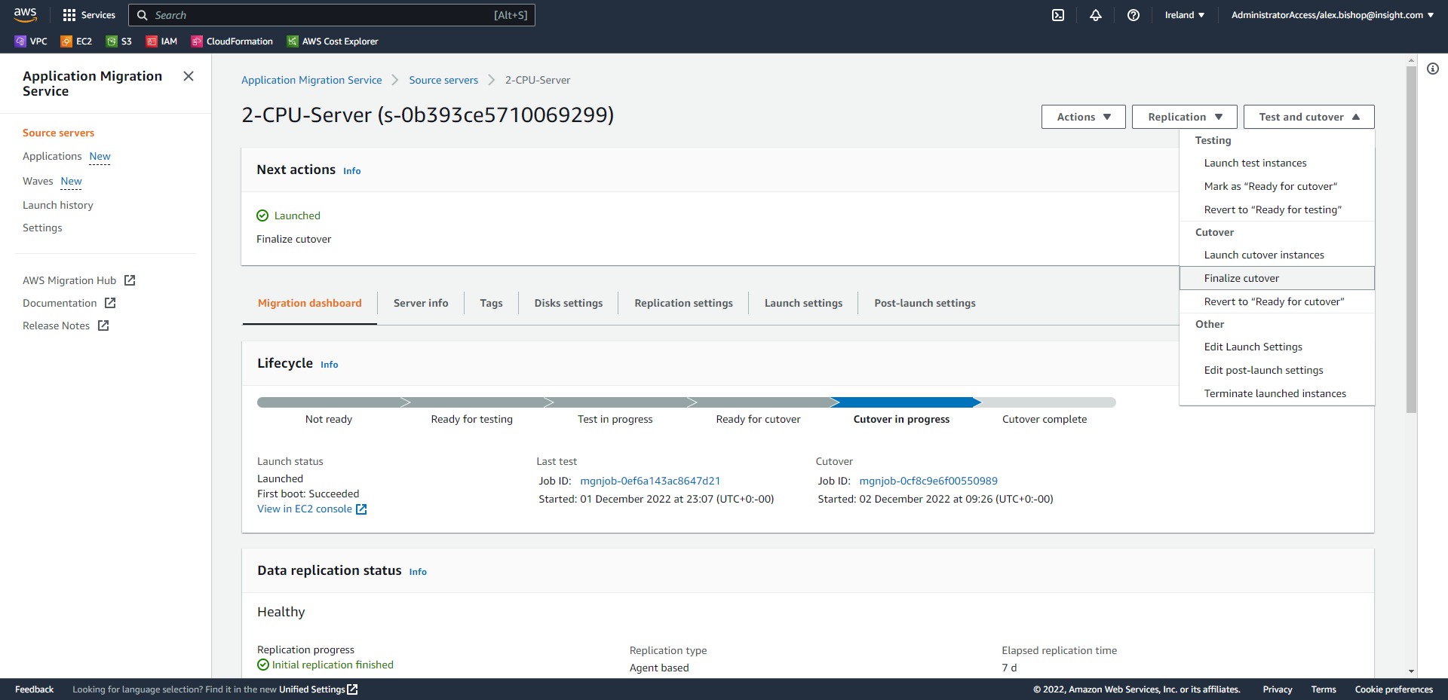

Click Finalize.

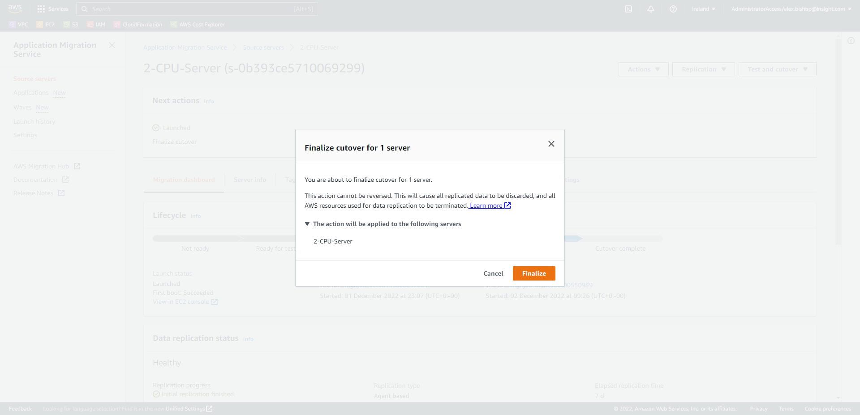

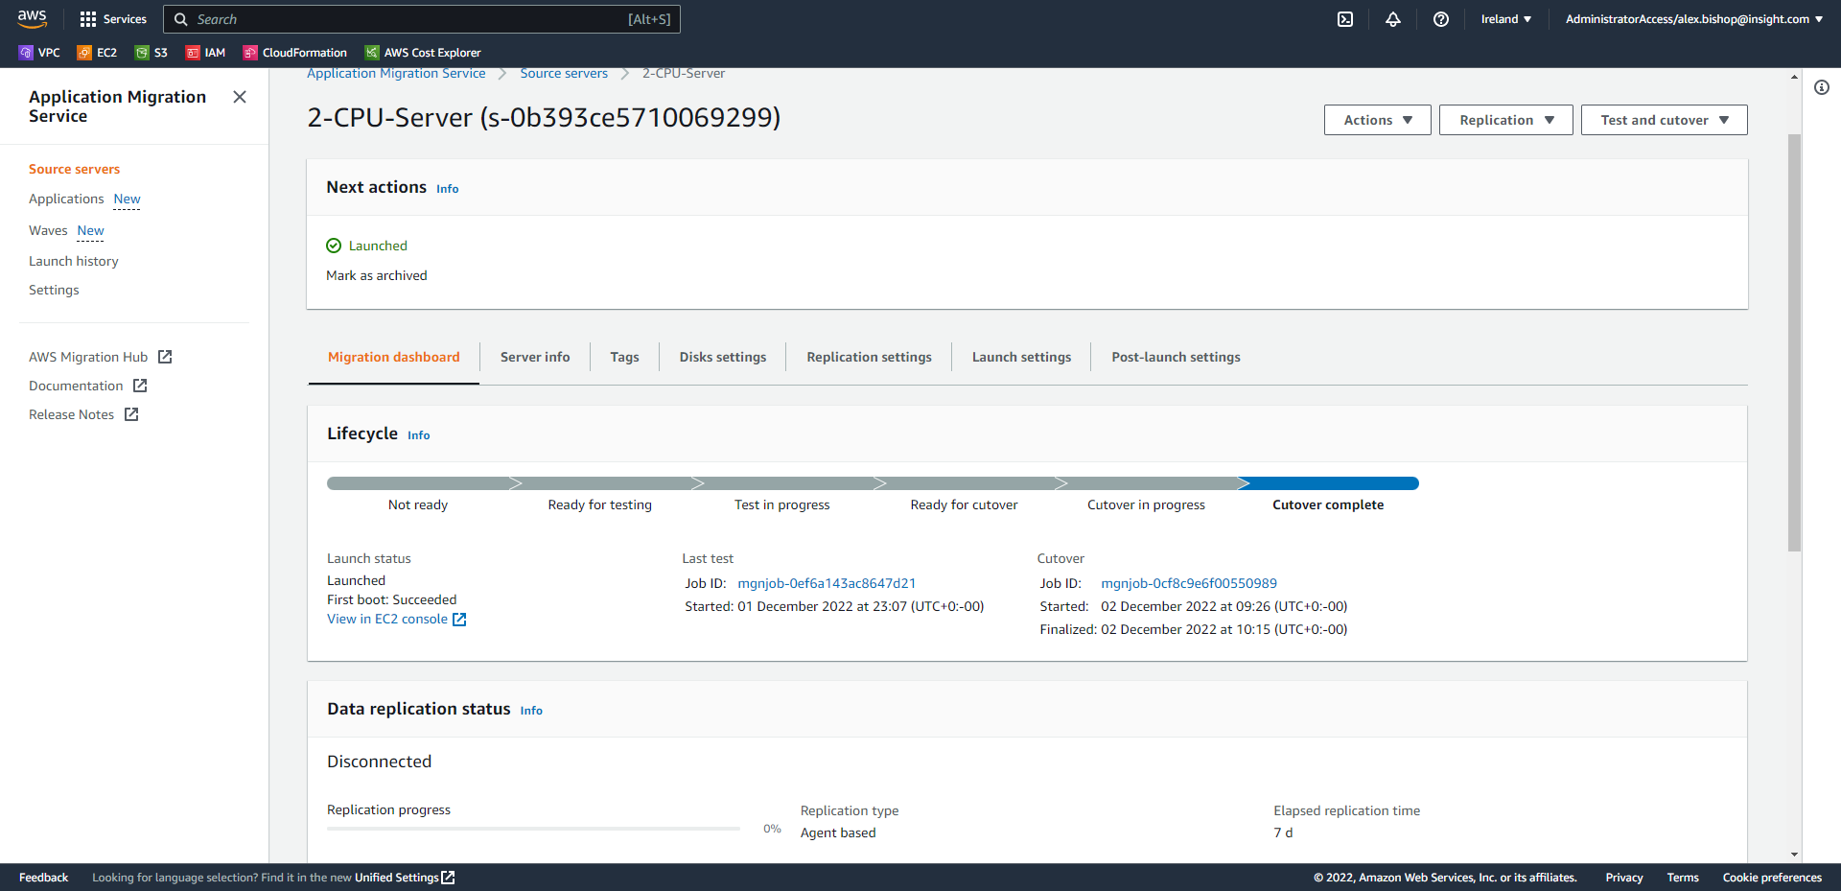

Repeat these steps for all three servers and you will have three managed nodes in Systems Manager Fleet Manager which you can establish an RDP connection to from within private subnets.

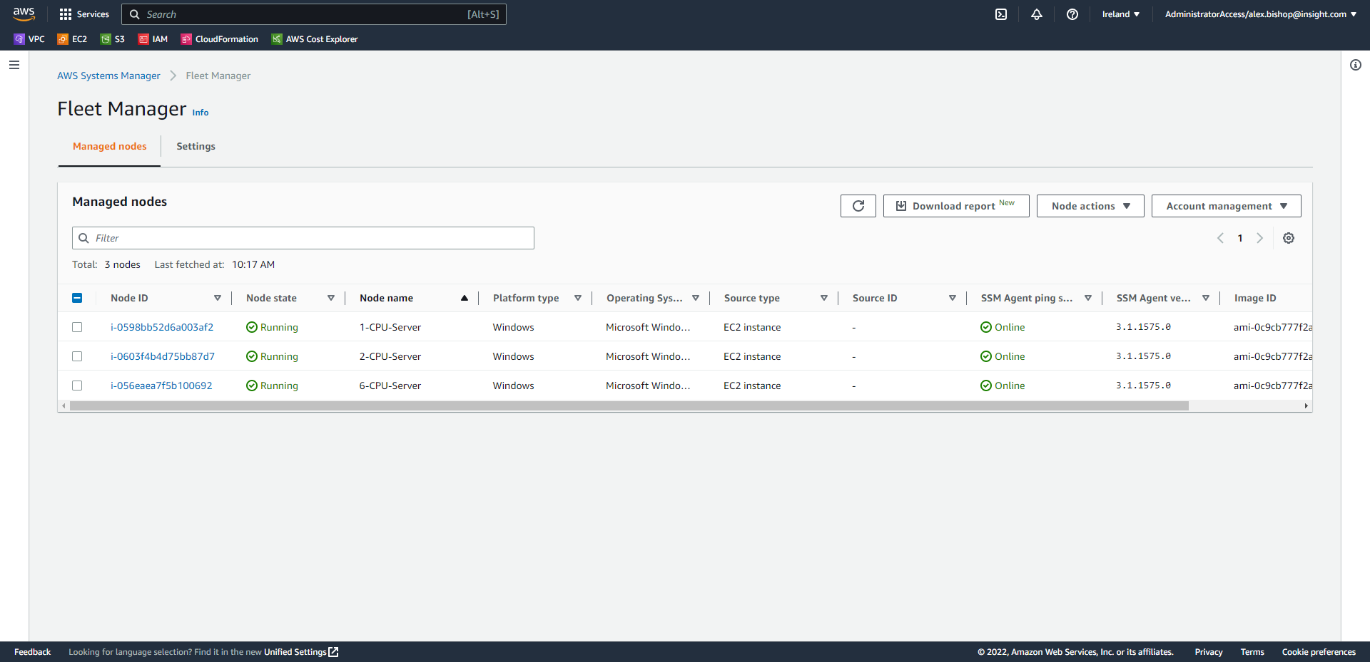

Note: In this lab environment we have migrated from a 6vCPU vSphere server with 12GB RAM rather than the 12CPU, 8 RAM spec due to a limitation with our vSphere environment. However, the process is entirely the same regardless of CPU and memory.

1. Upgrading to Windows Server 2022 (Systems Manager Automation)

*If no operating system upgrade is required skip to Appendix F.*

Since there is no option in the Application Migration Service to upgrade the OS version, a new EC2 instance must built using the Systems Manager Automation document: “*AWSEC2-CloneInstanceAndUpgradeWindows”.*

Please find all the prerequisites for the Windows Server automated upgrade here: [*https://docs.aws.amazon.com/AWSEC2/latest/WindowsGuide/automated-upgrades.html*](https://docs.aws.amazon.com/AWSEC2/latest/WindowsGuide/automated-upgrades.html)

Key prerequisites: perform on an EC2 instance with an unencrypted EBS root volume, minimum 20GB free disk space on boot disk and a valid Windows license.

***In this example a Windows Server 2012 R2 EC2 instance his being used to demonstrate the upgrade as our lab virtual machines do not have valid Windows licenses.***

Navigate to the Systems Manager console and click Automation from the navigation menu.

Select Execute automation on the right-hand side.

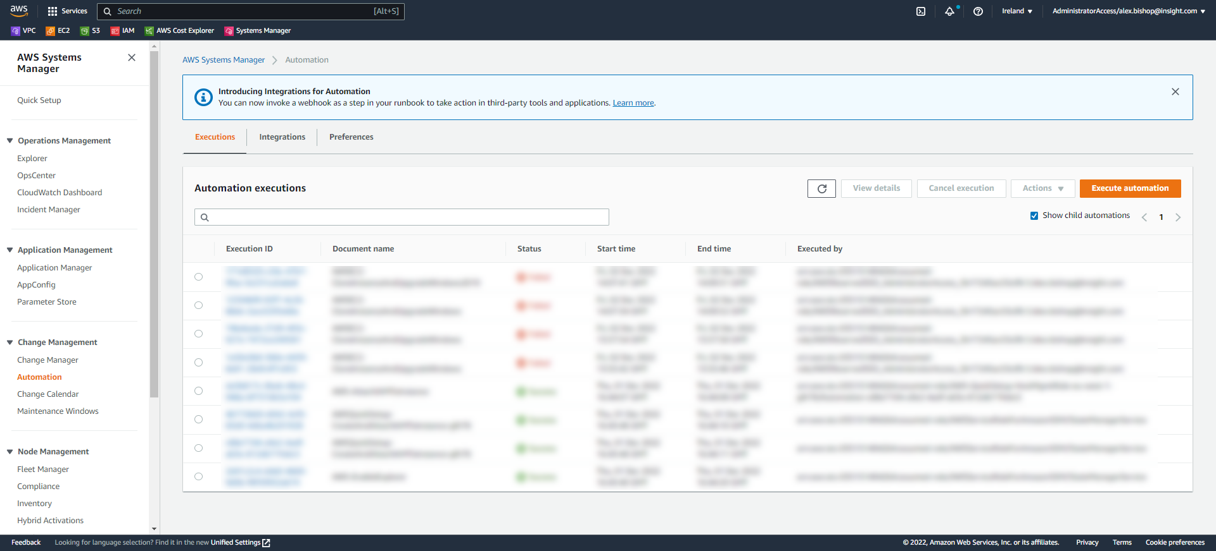

Enter “*AWSEC2-CloneInstanceAndUpgradeWindows”* into the Automation document search bar and select the automation document.

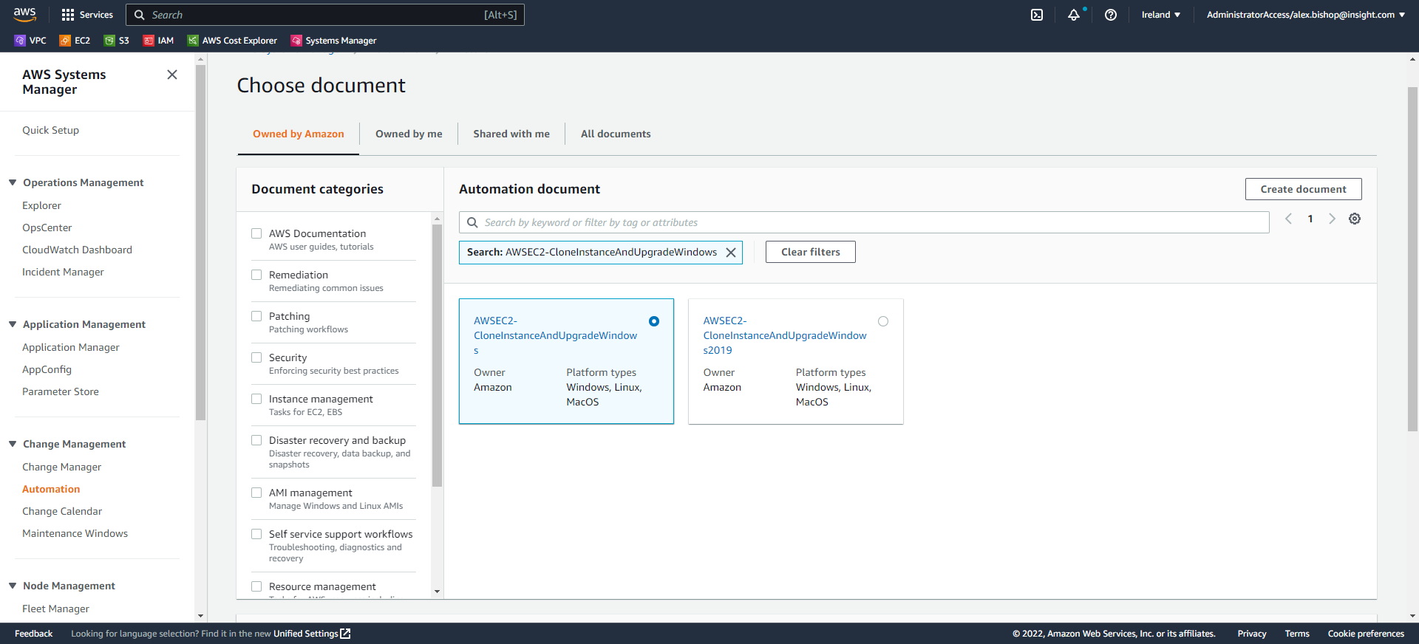

Scroll down and click Next.

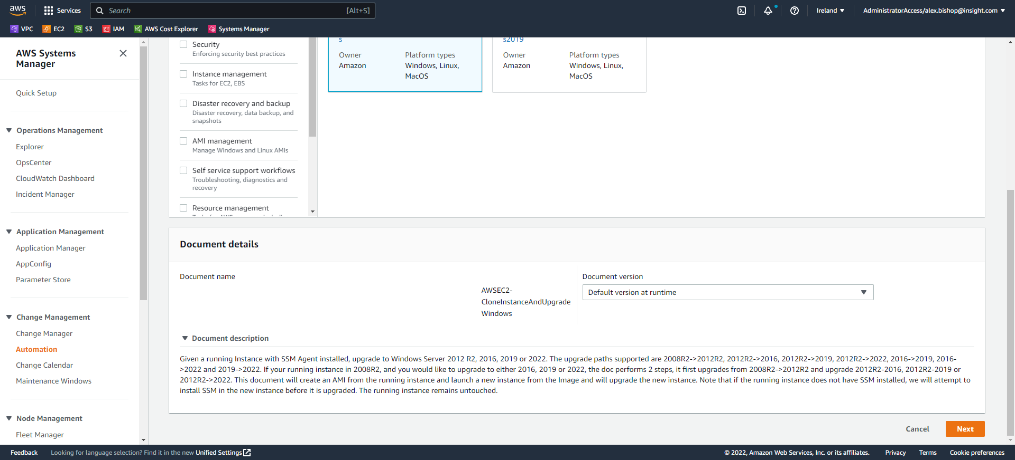

On the *Execute automation document* page use the following parameters:

* Select “*Simple execution”*
* Select the EC2 instance you wish to upgrade.
* IamInstanceProfile: “SSM_EC2Role” (created earlier)
* TargetWindowVersion: “2022” (for Windows Server 2022 OS)
* SubnetId: (navigate to the EC2 console and select your instance to find the Subnet ID and copy and paste)

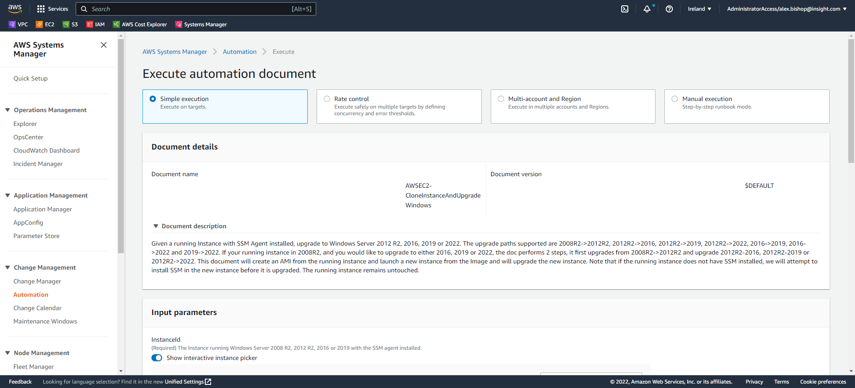

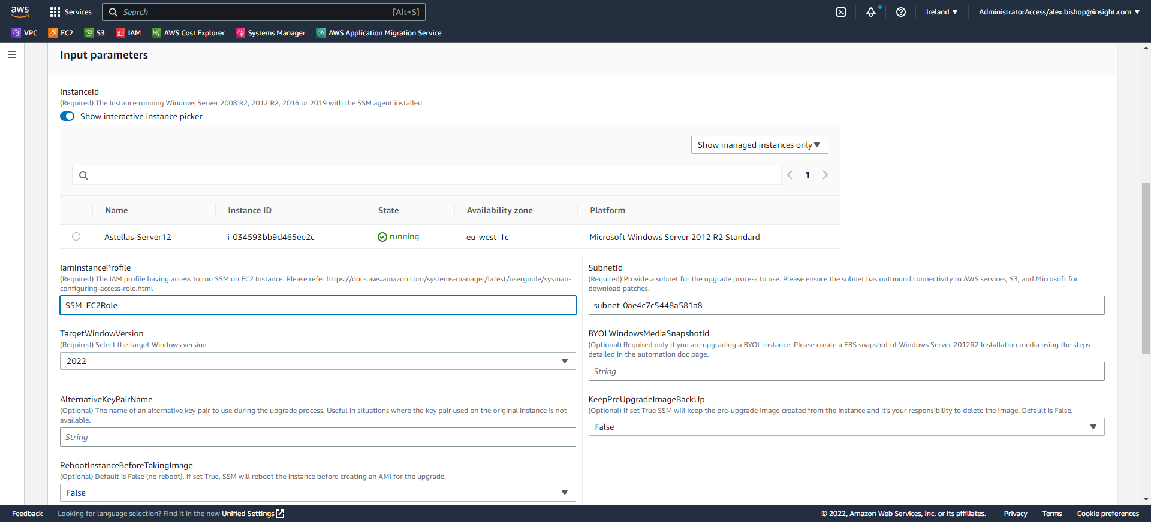

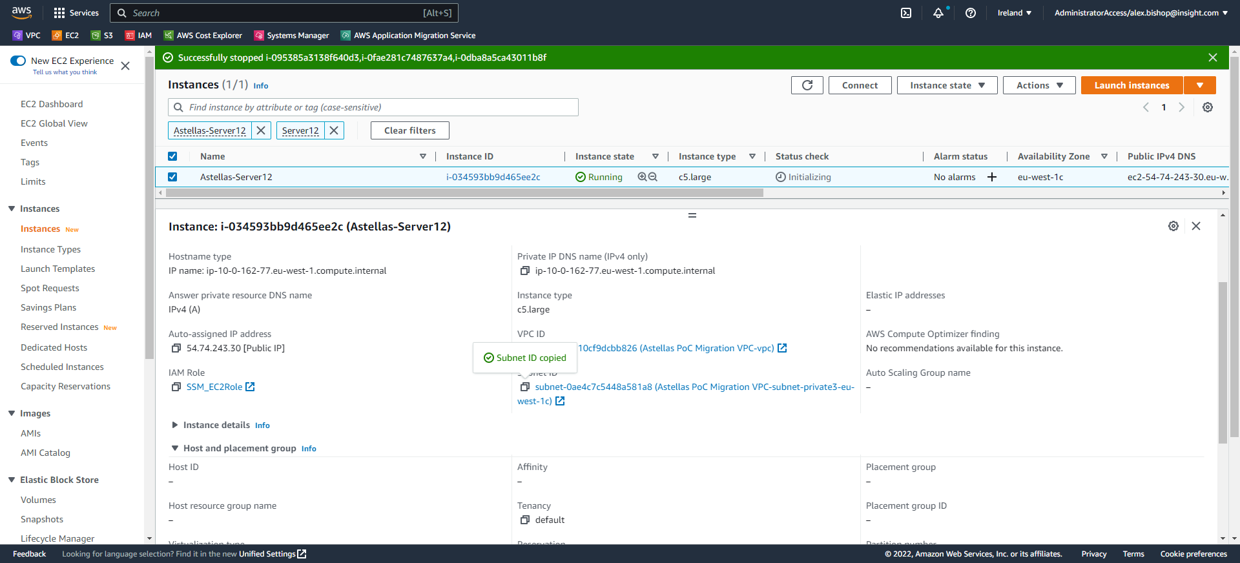

Finally, scroll to the bottom of the page and select Execute.

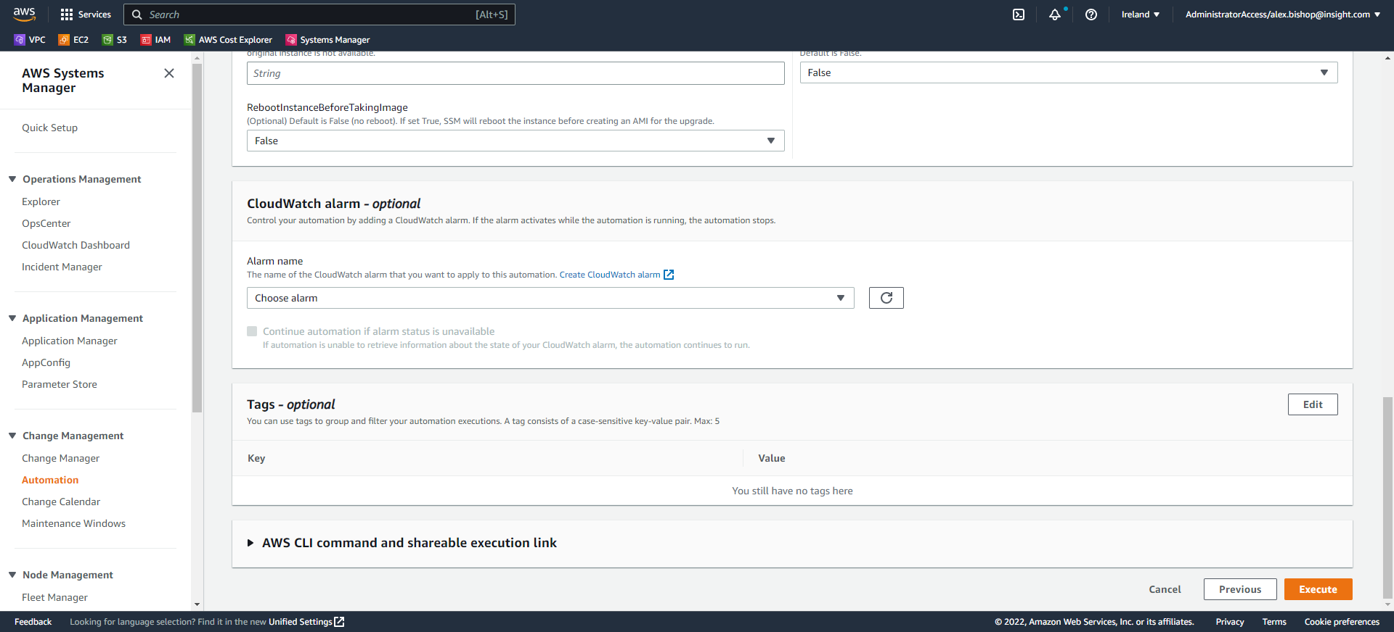

You can view the Execution status and monitor the Executed steps until the automated upgrade is complete (this may take two or so hours).

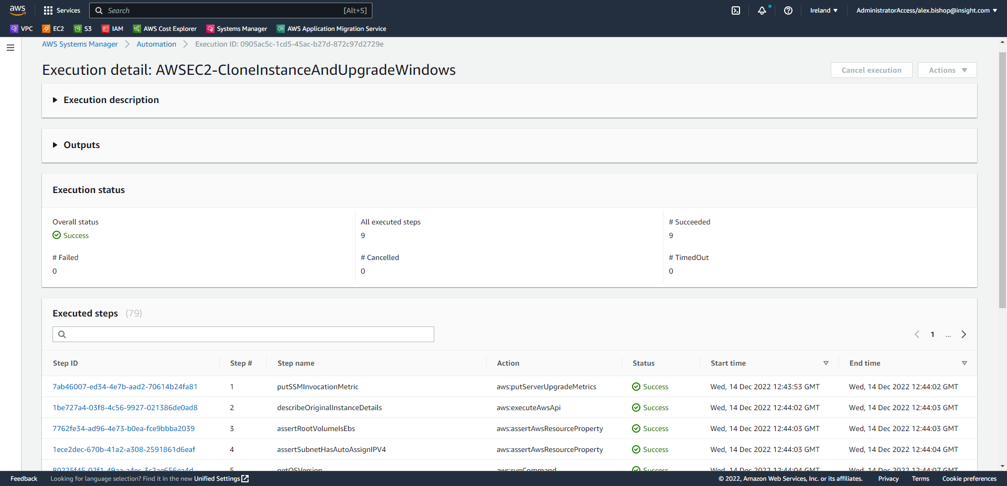

Once the Overall status is states “Success”, open the EC2 console and select AMIs from the navigation menu (it is not necessary for the automation to run all of the steps, these are conditional based on the behaviour of the automation and the instance).

Select your new AMI created from the automation upgrade document (filter by date to make finding the AMI easier).

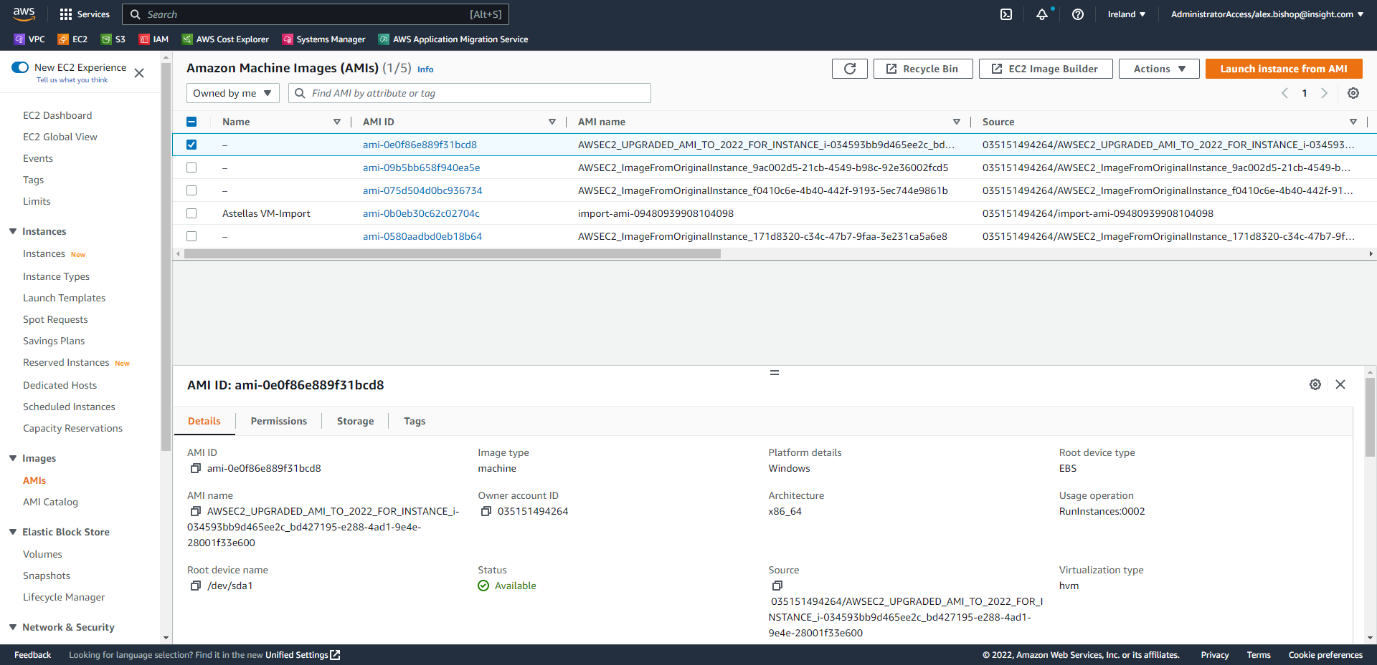

Once the AMI is selected click “Launch instance from AMI”.

In the settings to launch the instance use the following settings:

* Tags: *Key: “ssm” Value: “true”*
* The upgraded AMI will be automatically selected
* Select the Instance Type as the automation document will not automatically select the instance type for you.
* Private Subnet
* SSM-Endpoint Security Group
* SSM_EC2Role IAM instance profile

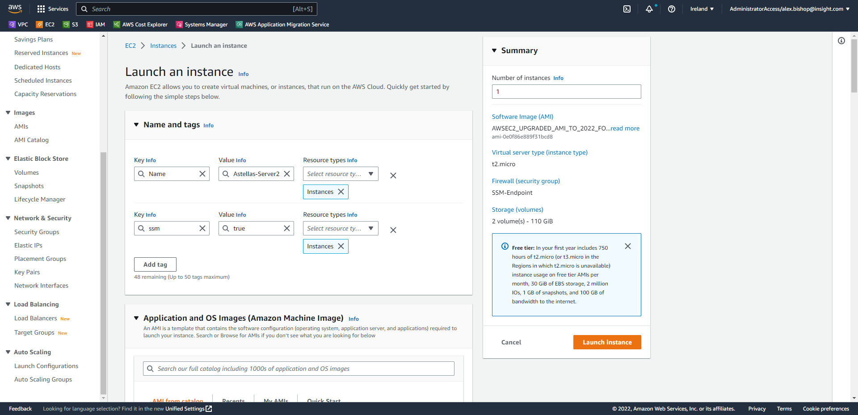

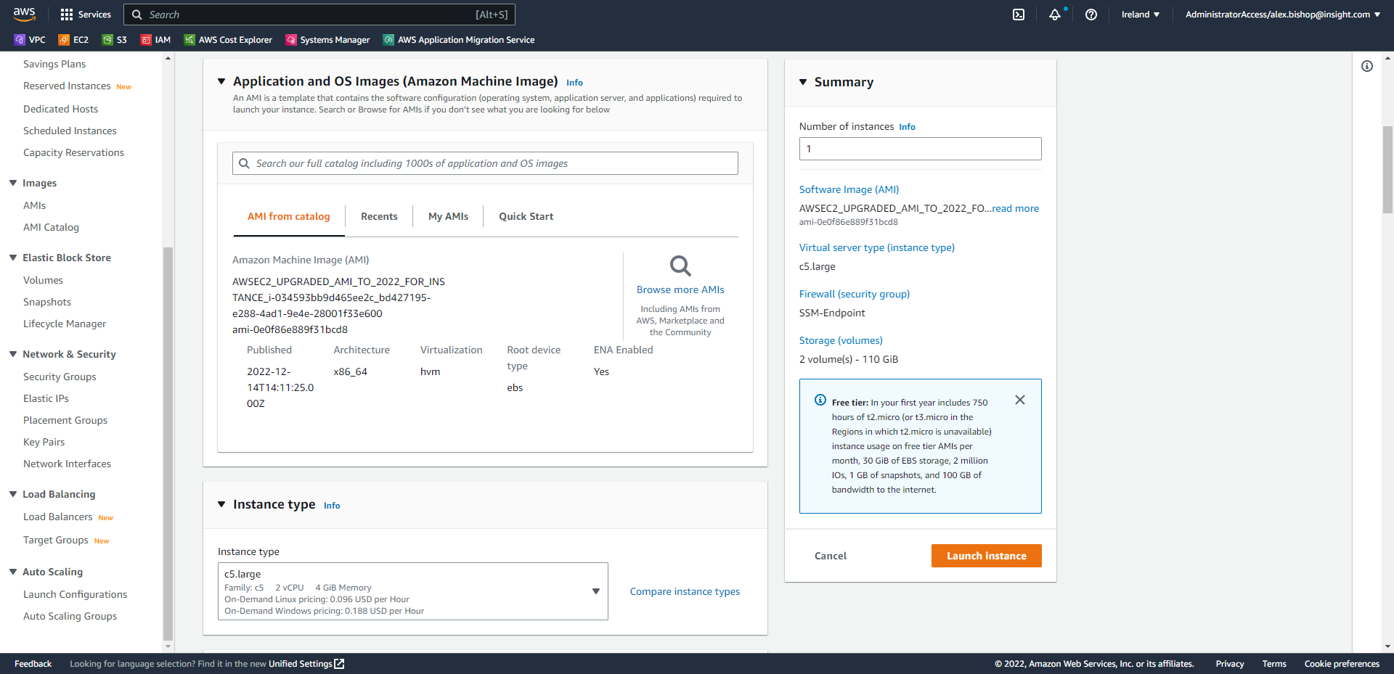

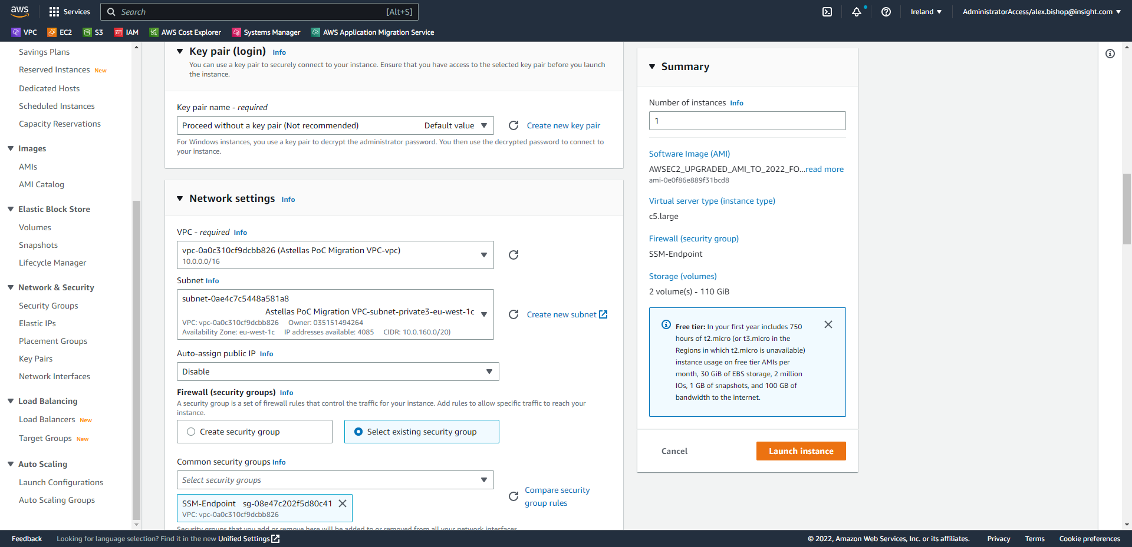

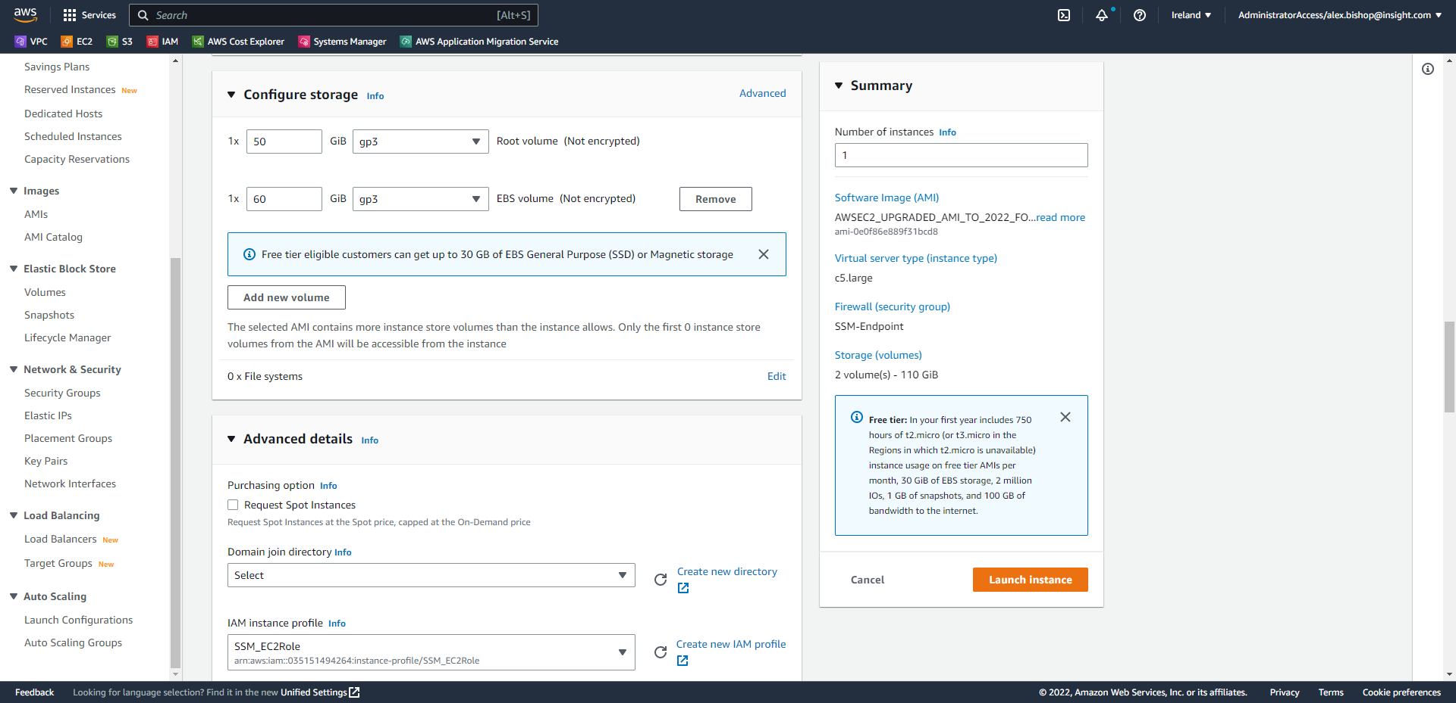Finally, click Launch instance.

Once the instance has launched, open Fleet Manager from the Systems Manager console.

Select your new instance and click *“Node actions > Connect with Remote Desktop”*.

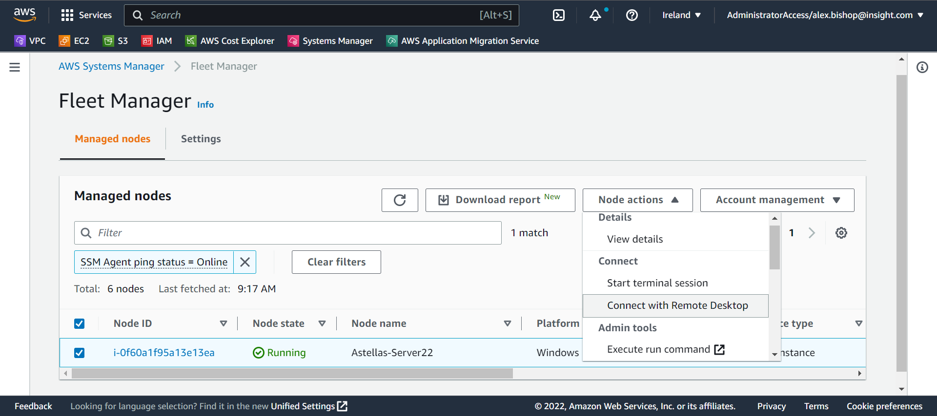

Enter your usual credentials for the server and choose to Connect.

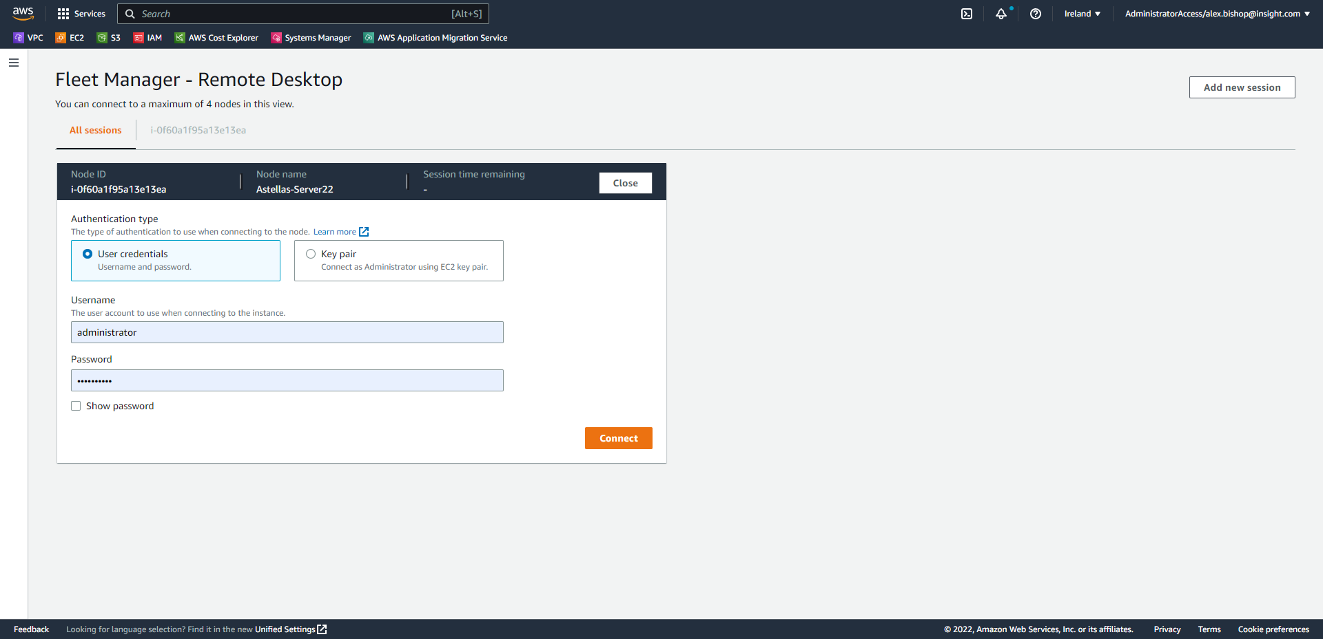

You will now be connected to the upgraded EC2 instance (Windows Server 2022)

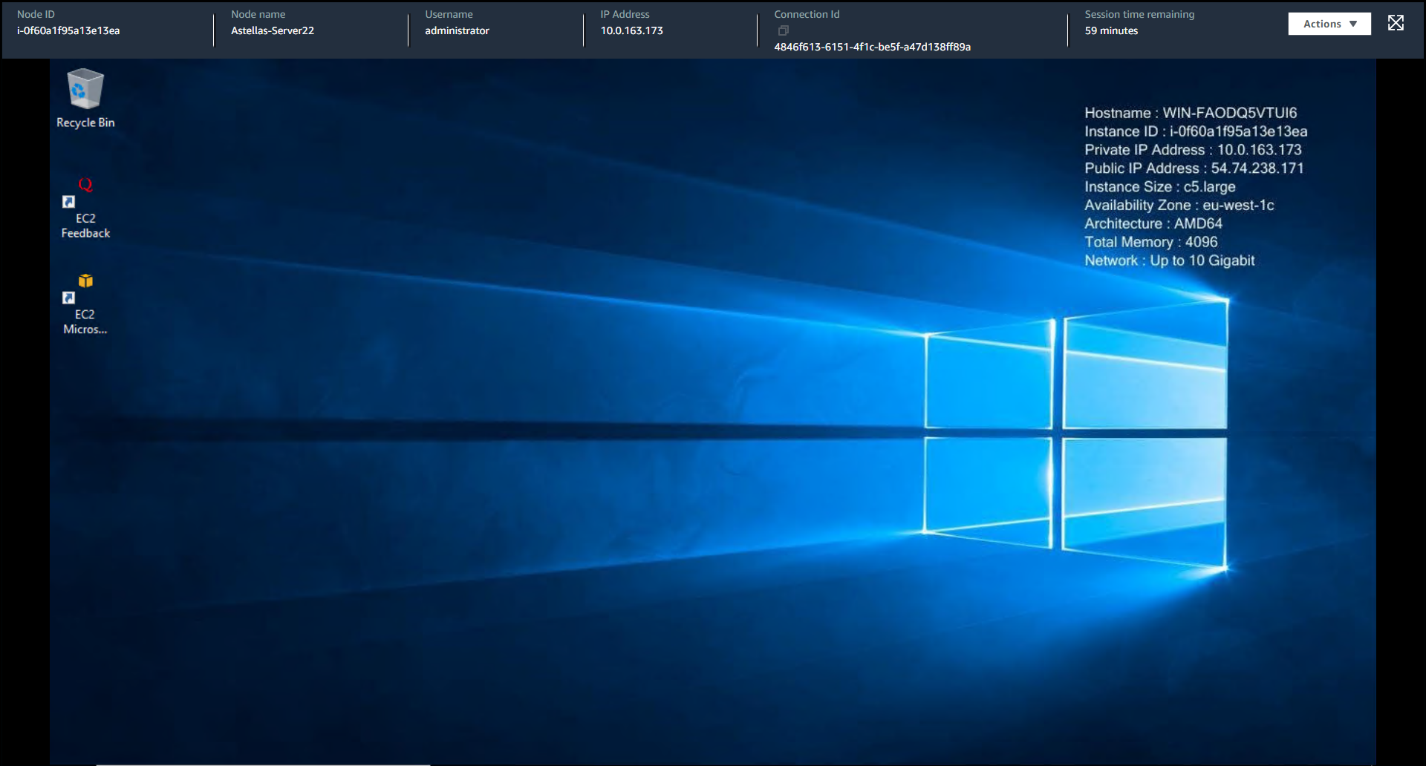

1. Install AWS EMP Compatibility Package Builder (EUPMPPPLAP050 Migration Path)

To migrate EUPMPPPLAP50 to AWS and maintain the legacy application, the EMP Compatibility Package must be installed onto EUPMPPPLAP050 as per the following link: <https://docs.aws.amazon.com/emp/latest/userguide/emp-install-compatibility-package-builder.html>.

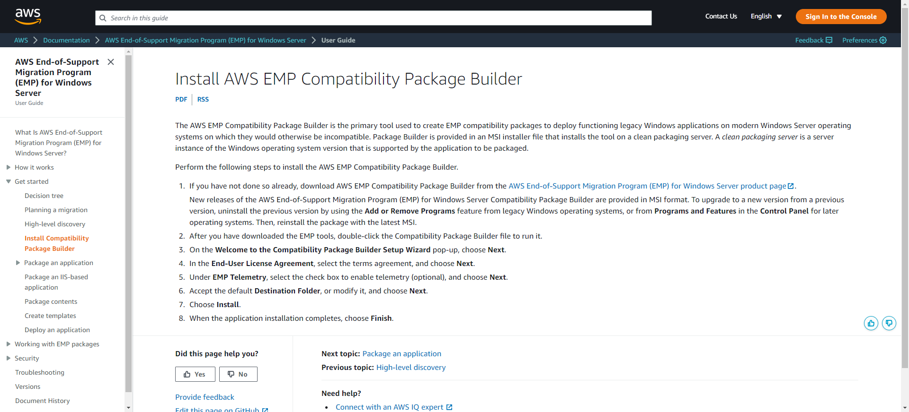

Open the link and follow the instructions to open the “[AWS End-of-Support Migration Program (EMP) for Windows Server product page](http://aws.amazon.com/emp-windows-server)” which can also be found here: <https://aws.amazon.com/emp-windows-server/>

Select “Download EMP Tooling”.

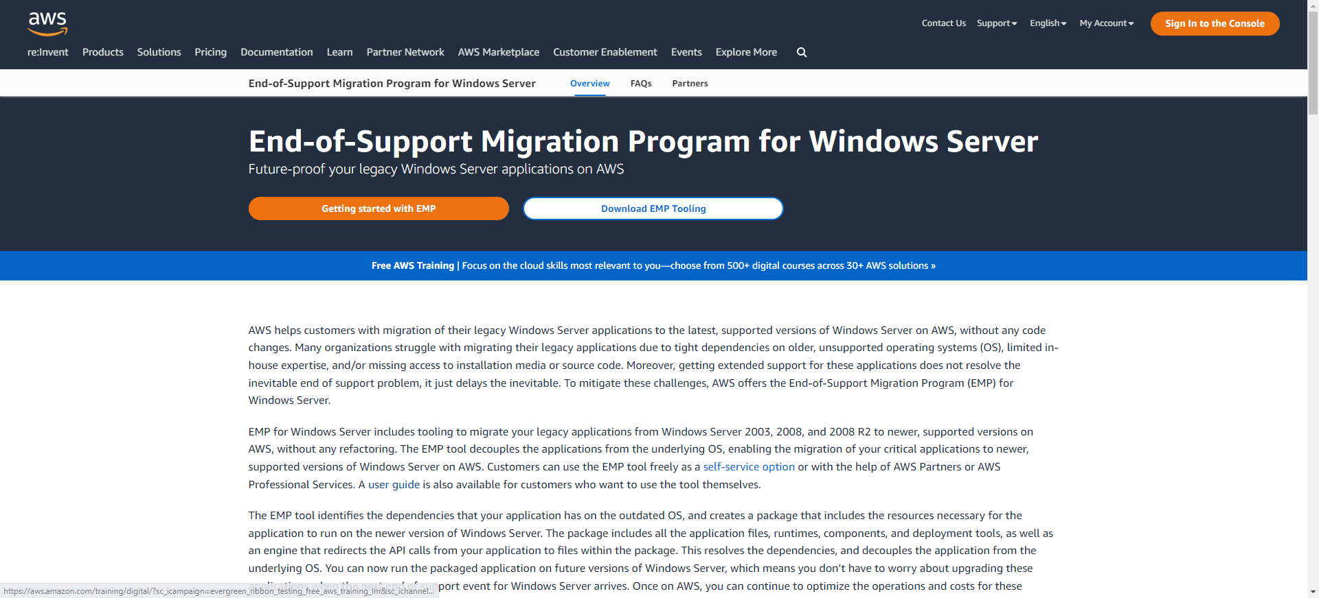

Enter the required details and click Submit.

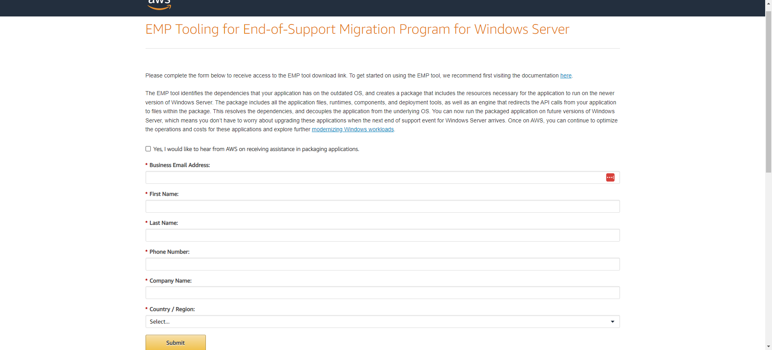

Open the first link to download the EMP tool.

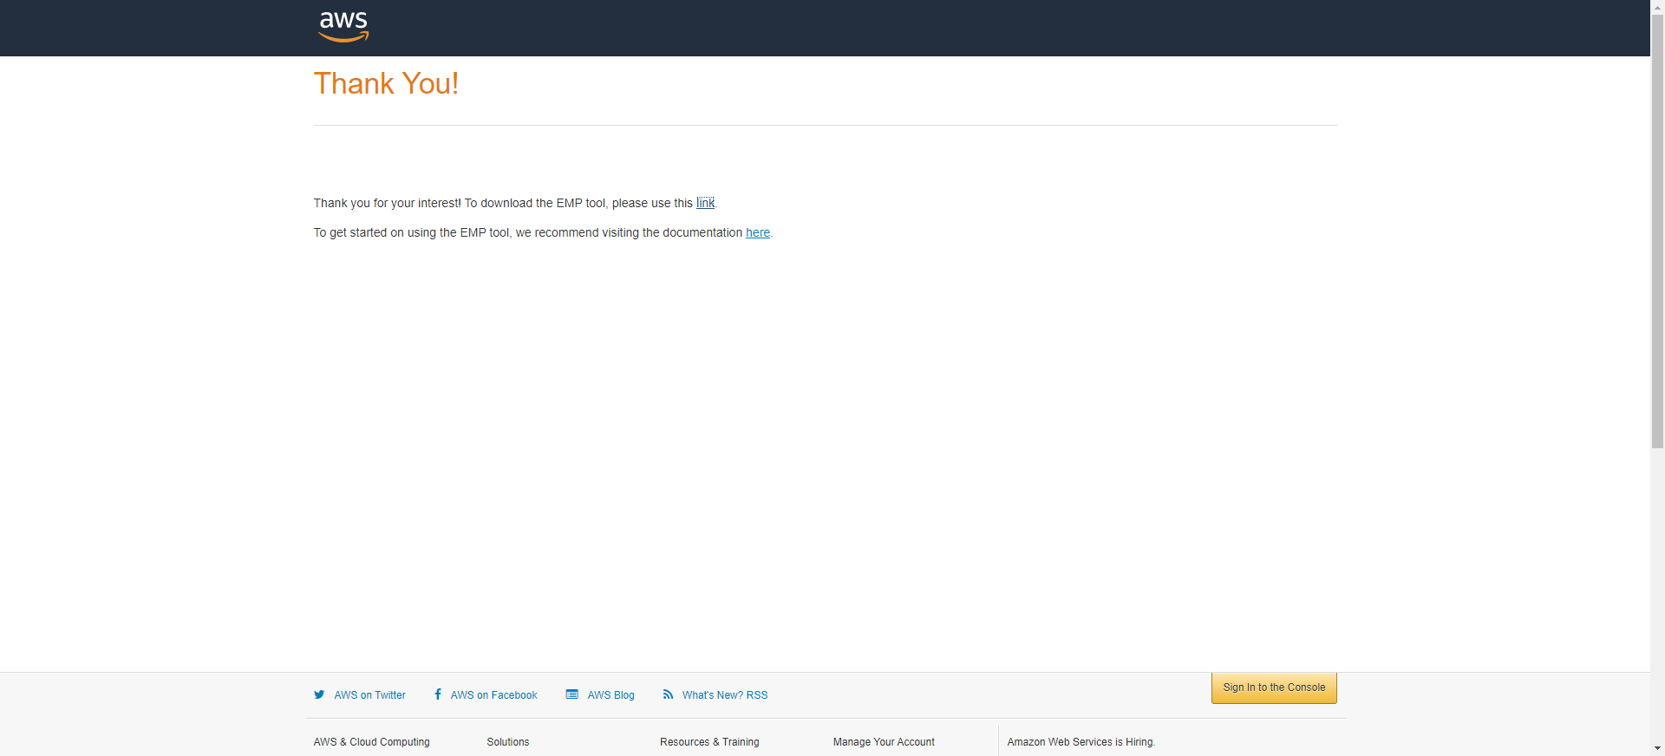

Double-click the installation file to run it.

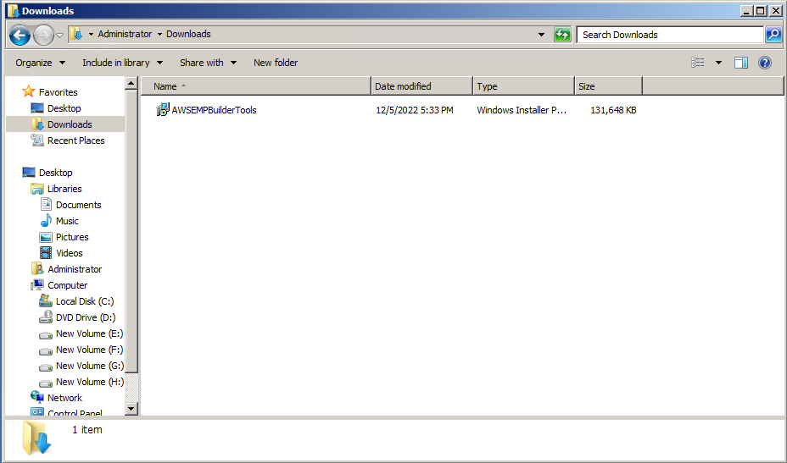

Click Run.

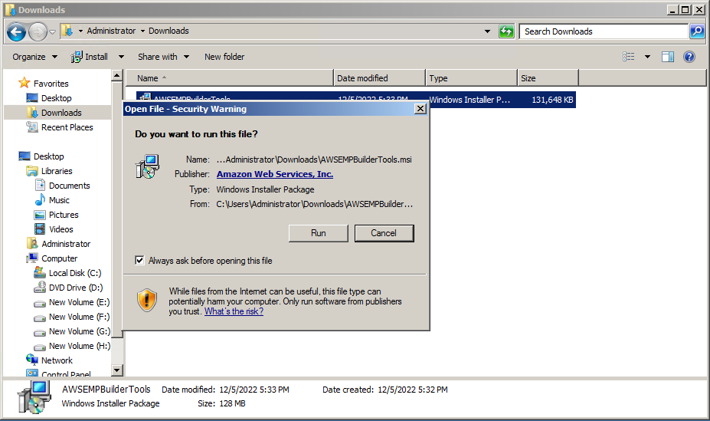

Click Next.

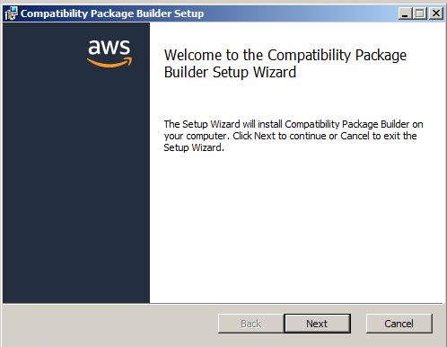

Accept the license agreement and click Next.

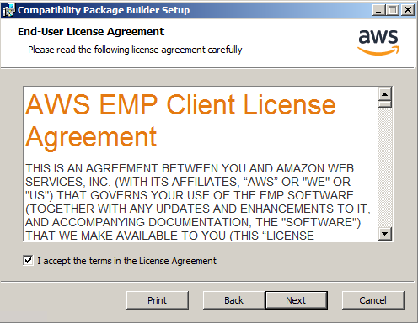

Under EMP Telemetry, select the check box to enable telemetry (optional), and choose Next.

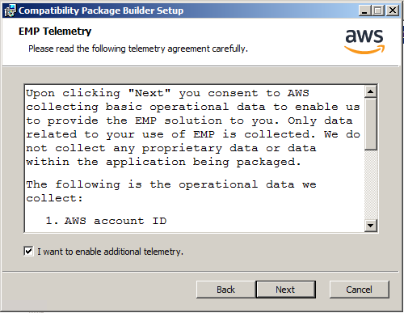

Accept the default Destination Folder, or modify it, and choose Next.

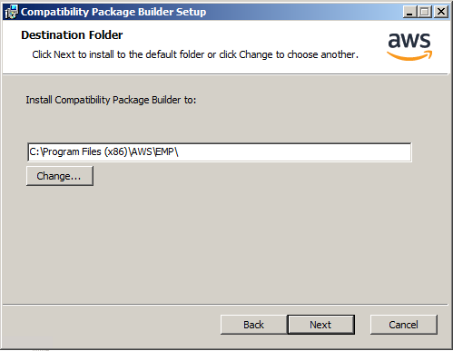

Choose Install.

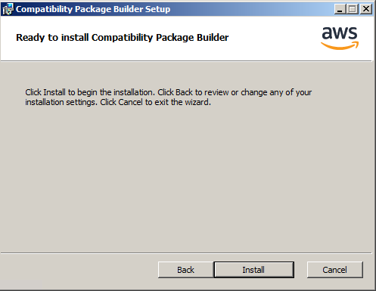

When the application installation completes, choose Finish.

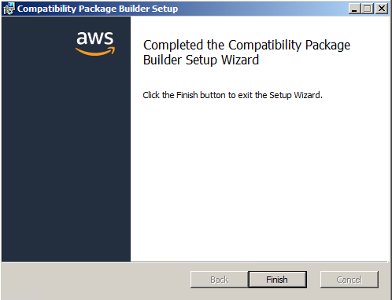

1. Package the Application (EUPMPPPLAP050 Migration Path)

AWS recommend that an Application Discovery activity/checklist be performed on the identified package following a process defined in the following link <https://docs.aws.amazon.com/emp/latest/userguide/emp-high-level-discovery.html>

Launch the Legacy Application

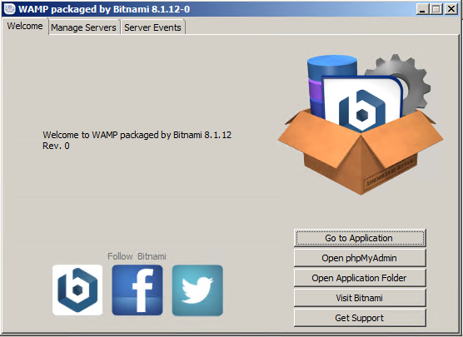

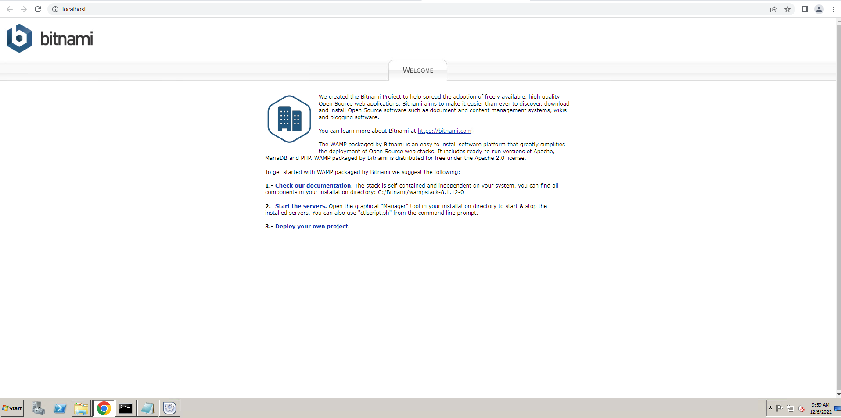

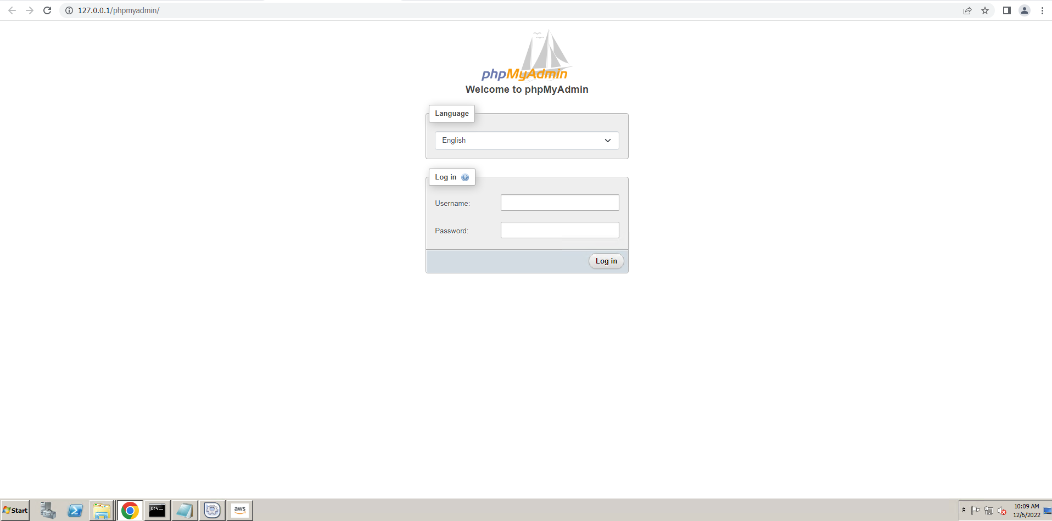

Launch the EMP GPR Service *Start->Programs->Amazon Web Services->Guided Reverse Packager*

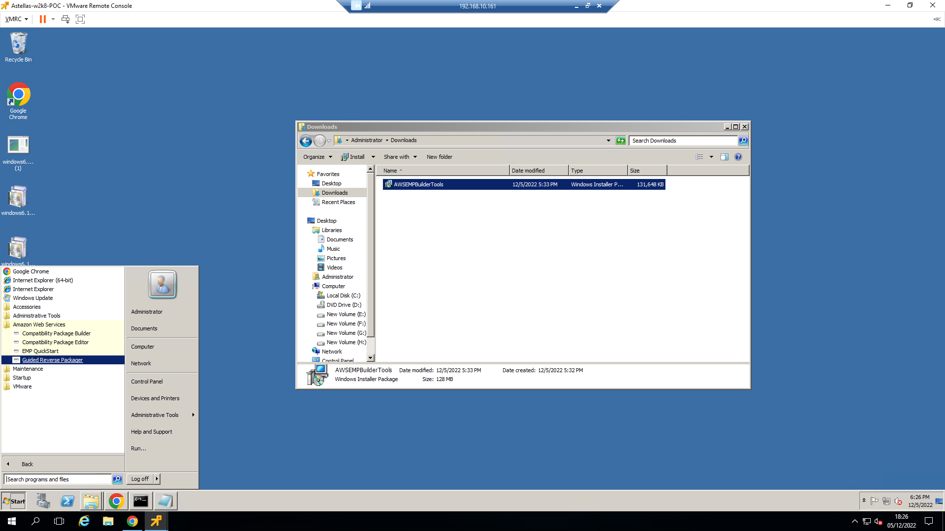

Click “Select Folder” and browse to the Application Folder.

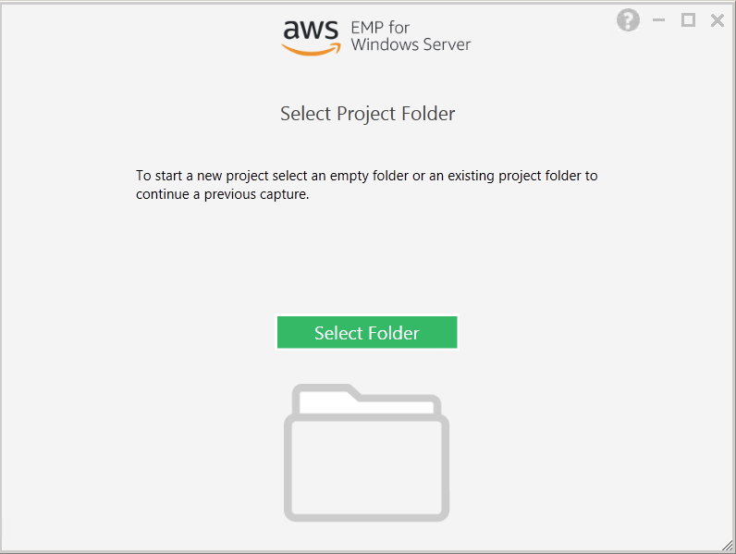

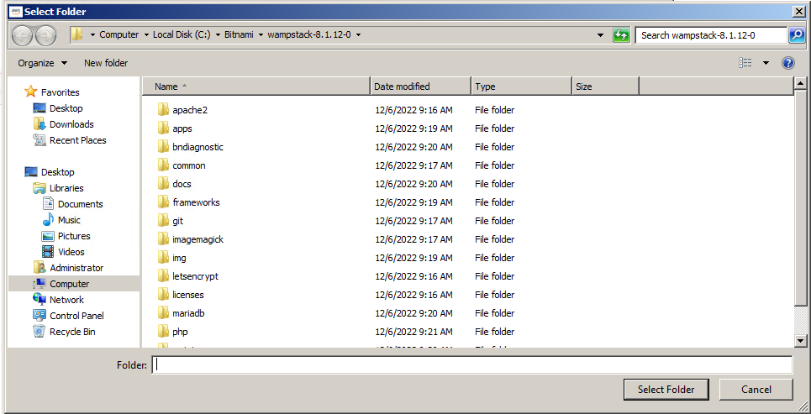

Select Runtime Analysis Start.

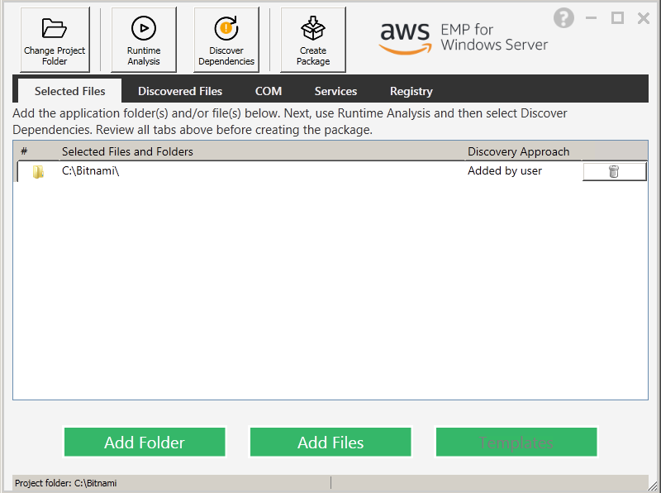

Run the Services within the Legacy Application to capture typical workflow processes etc. This scenario includes Starts, Stops and Resets of an Apache Web Server and a MariaDB Database.

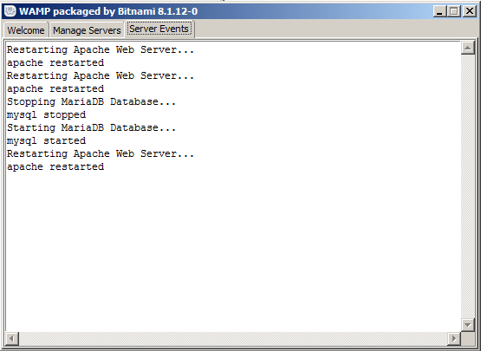

Stop running the typical workflows within the Application after a period and choose to Stop the Runtime Analysis in the EMP for Windows Server application.

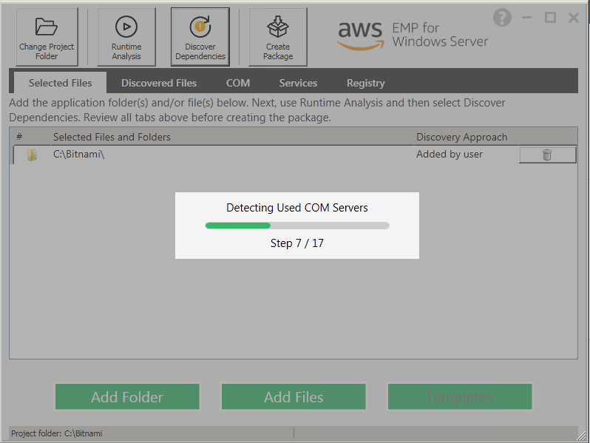

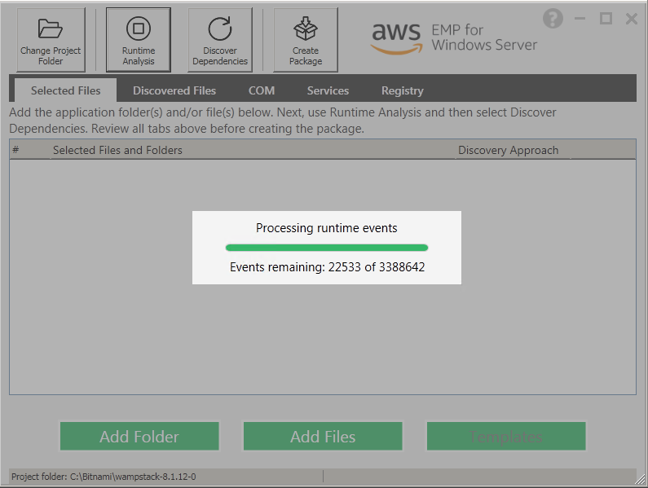

Select “Discover Dependencies”. Then, click “Package App”.

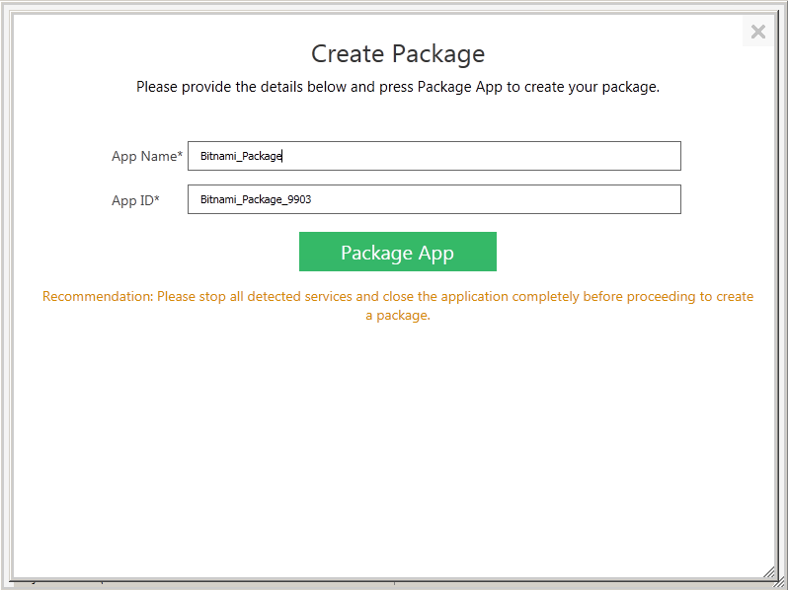

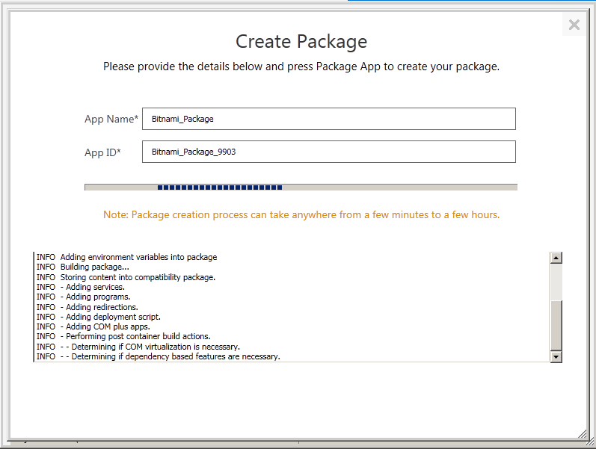

Once complete click Open Package.

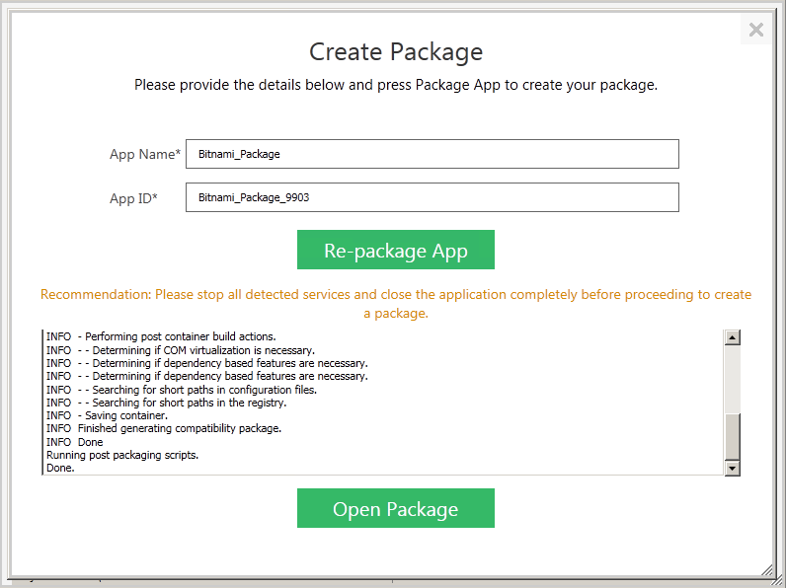

The output of the GRP tool will be to produce a Legacy Application Package with all Files, Folders and Services placed into the Application Folder.

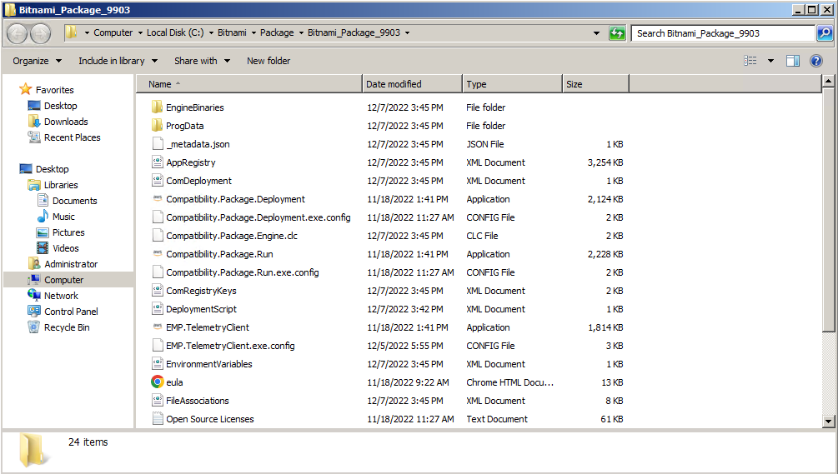

1. Copy the Packaged Application to Amazon S3

To access the packaged application from the EC2 instance we will copy the files and application data to a Bucket in Amazon S3 then copy it. For this to work the role on the server will need to be adjusted to access the bucket.

Firstly, the SSM_EC2 role created earlier will need to be edited to include access for S3 and, to deploy the AWS EPM Deployment tool another policy to Execute API’s.

Navigate to the Identity and Access Management (IAM) console and select Roles in the left-hand navigation menu. Use the search bar to browse to the SSM_EC2Role by entering “ssm” into the search bar.

Click to open the role and edit its settings.

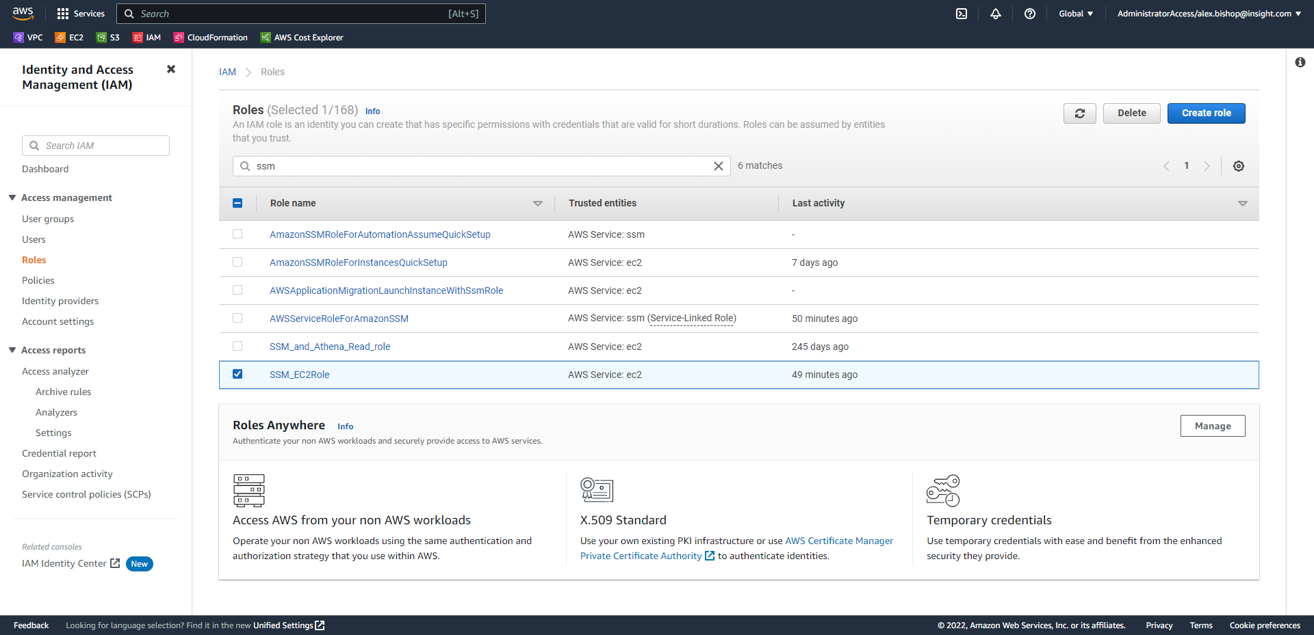

Select “Add permissions > Attach policies”

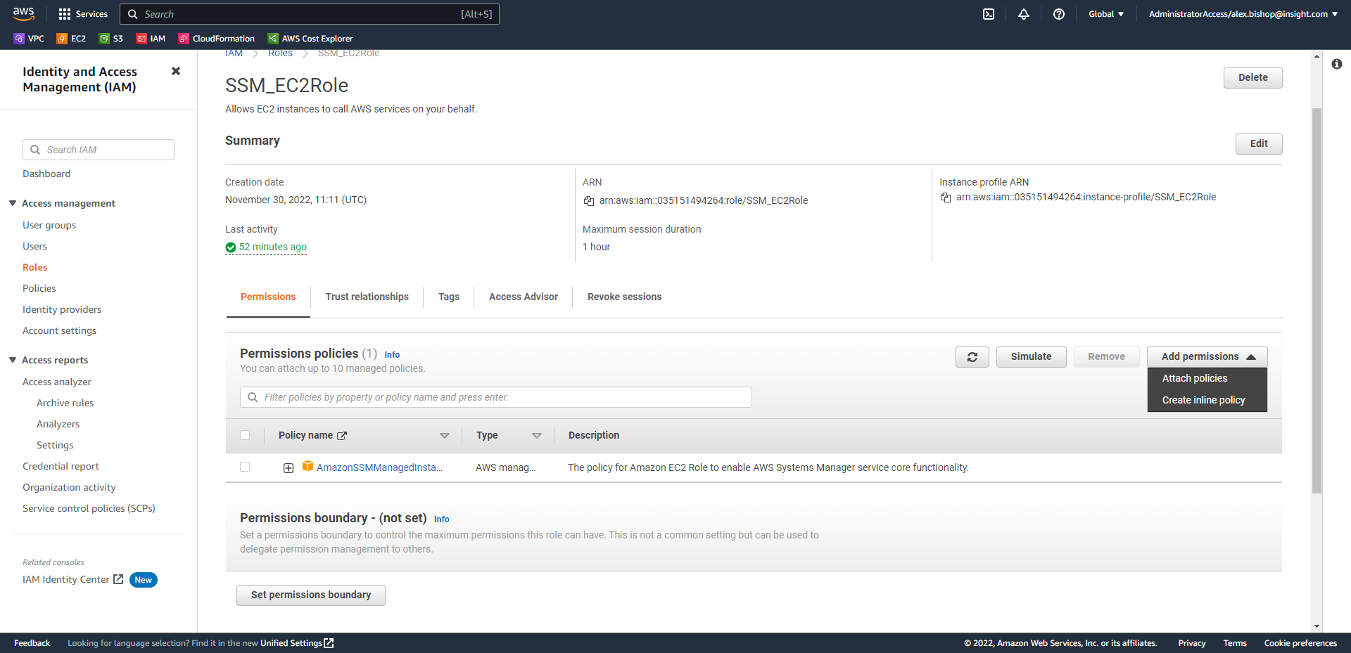

Filter the policies to S3 and select “AmazonS3FullAccess” and click Attach policies.

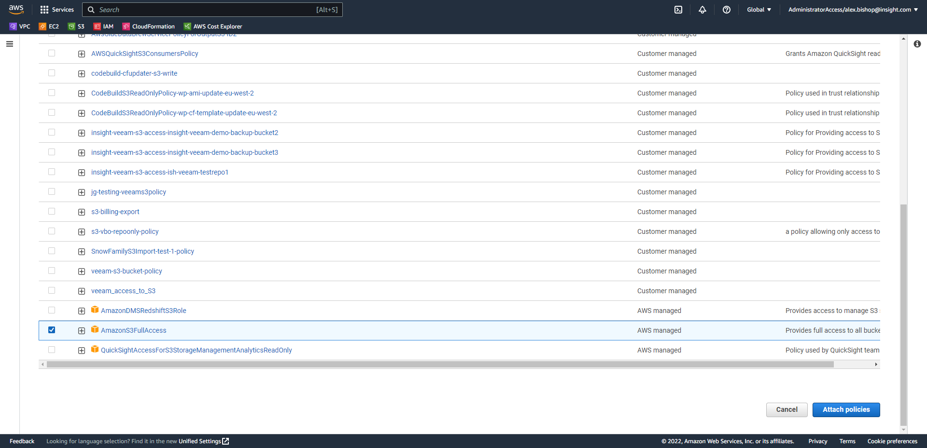

This time from the Permissions page of the SSM_EC2Role select “Add permissions > Create inline policy”

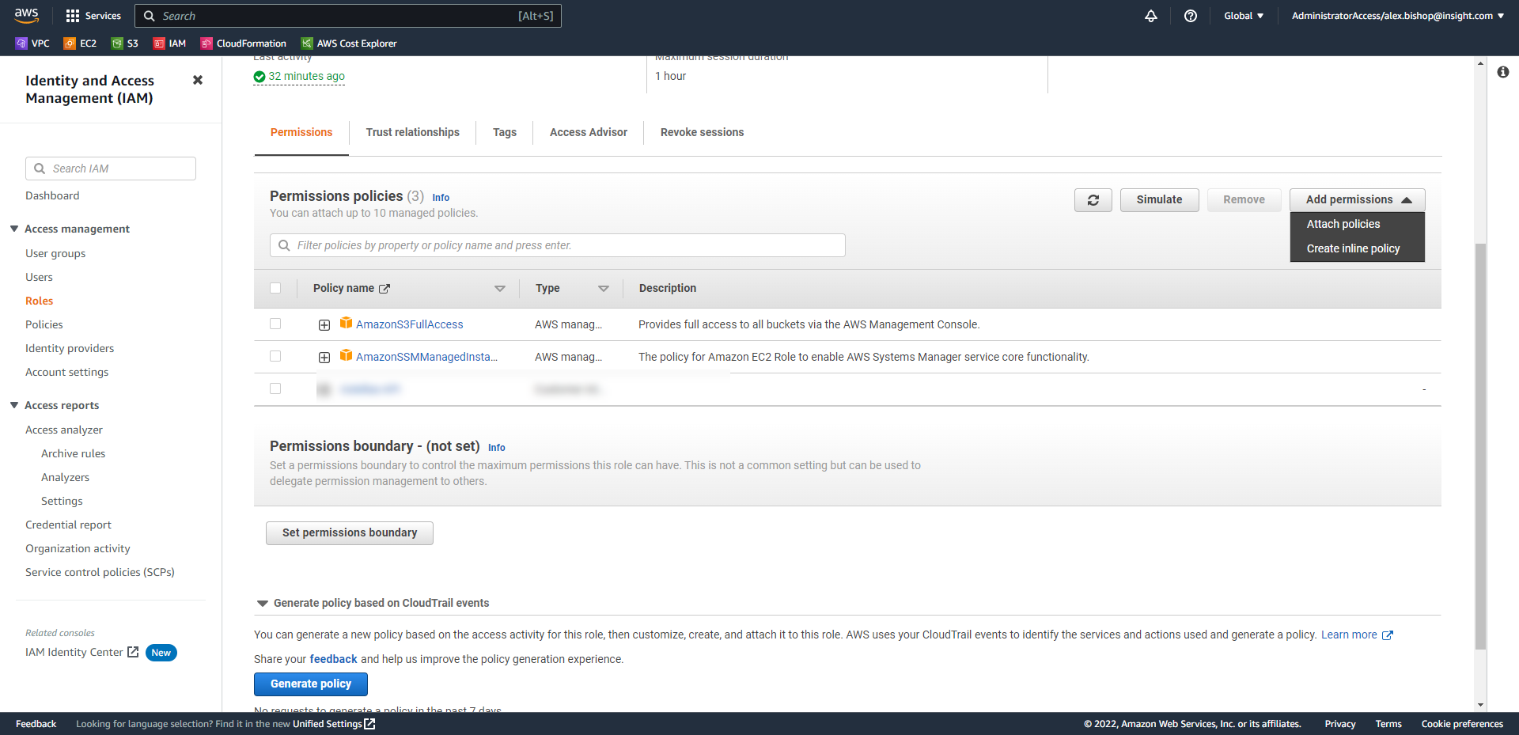

Select the tab for JSON and enter the following:

*{*

*"Version": "2012-10-17",*

*"Statement": [*

*{*

*"Effect": "Allow",*

*"Action": "execute-api:Invoke",*

*"Resource": "*"*

*}*

*]*

*}*

Click Review policy, name the policy, and click Create policy.

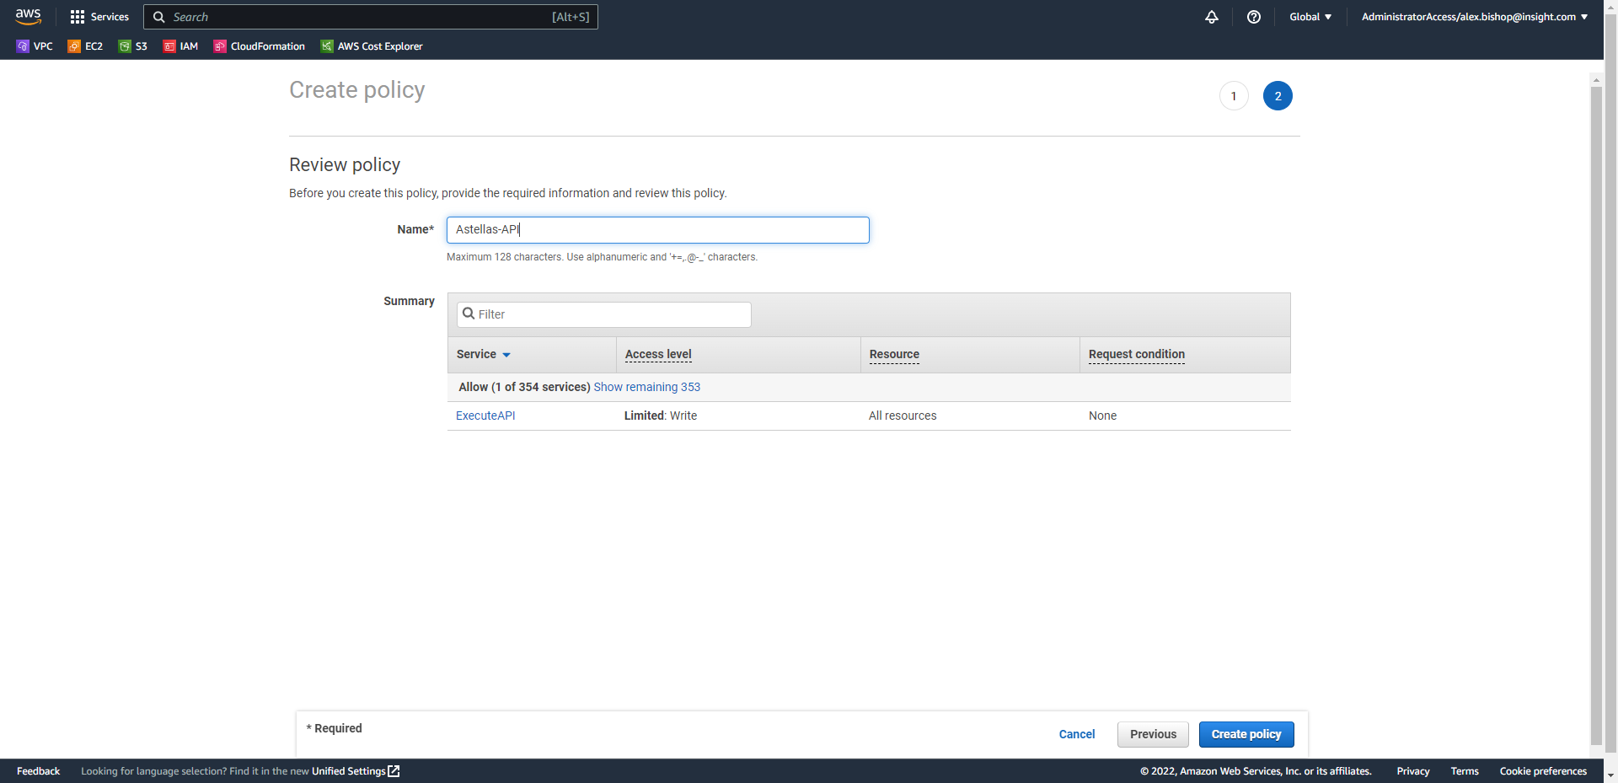

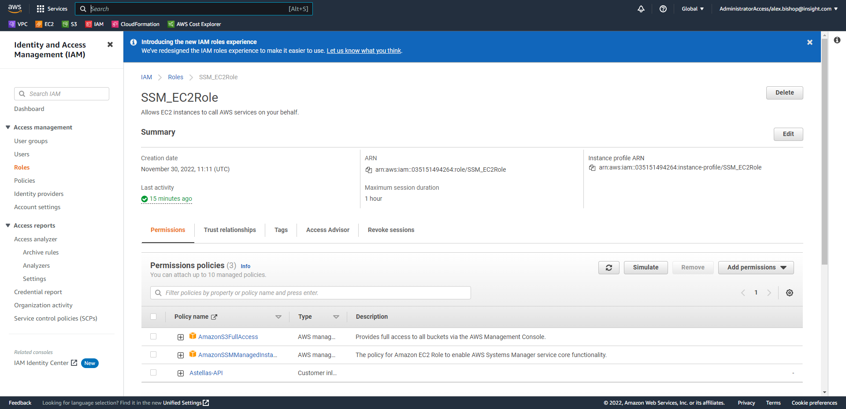

These additional policies will automatically update to the EC2 instances as they have the role already attached.

Now, open the Amazon S3 Console, select Buckets from the left-hand navigation menu and click Create bucket.

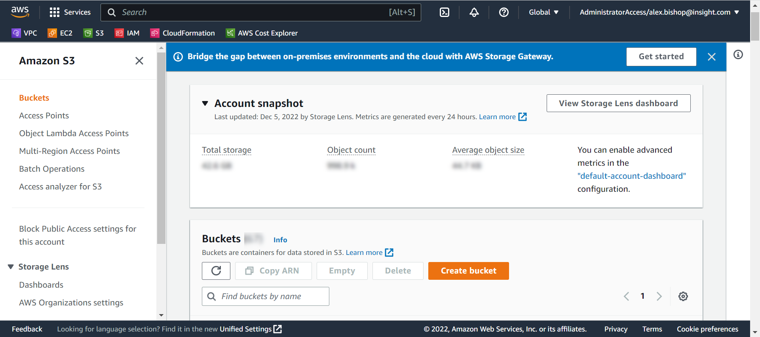

Name the S3 bucket as appropriate (S3 bucket names are globally unique) and choose a region.

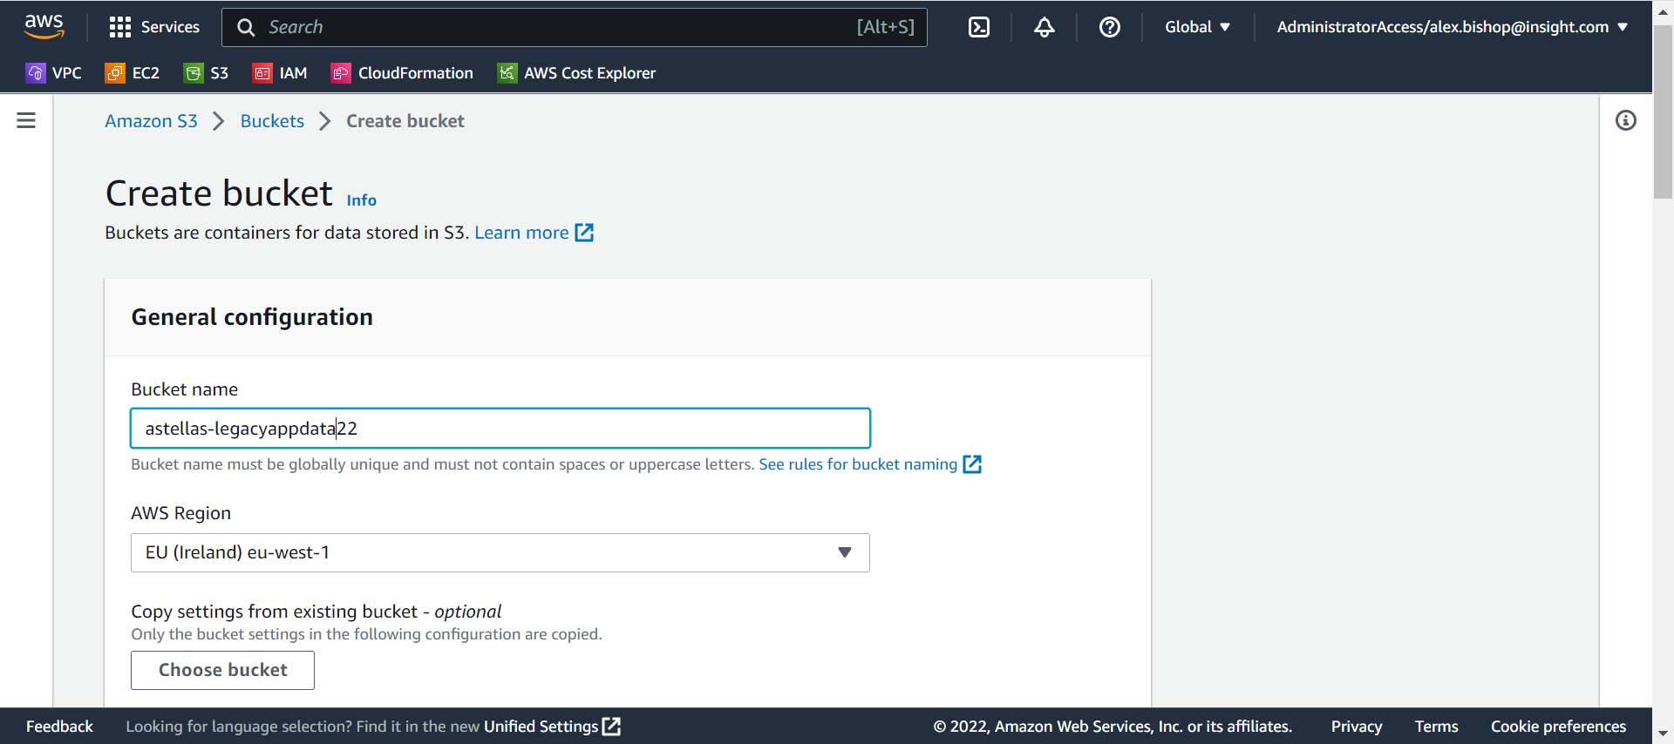

Scroll down to the bottom of the page and click Create bucket.

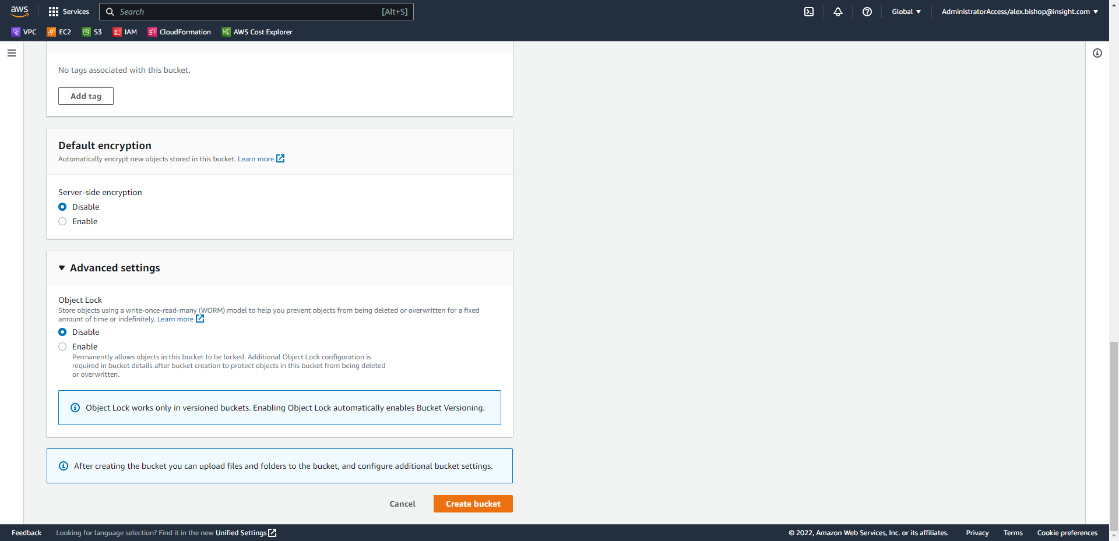

Open the newly created S3 Bucket and click Upload.

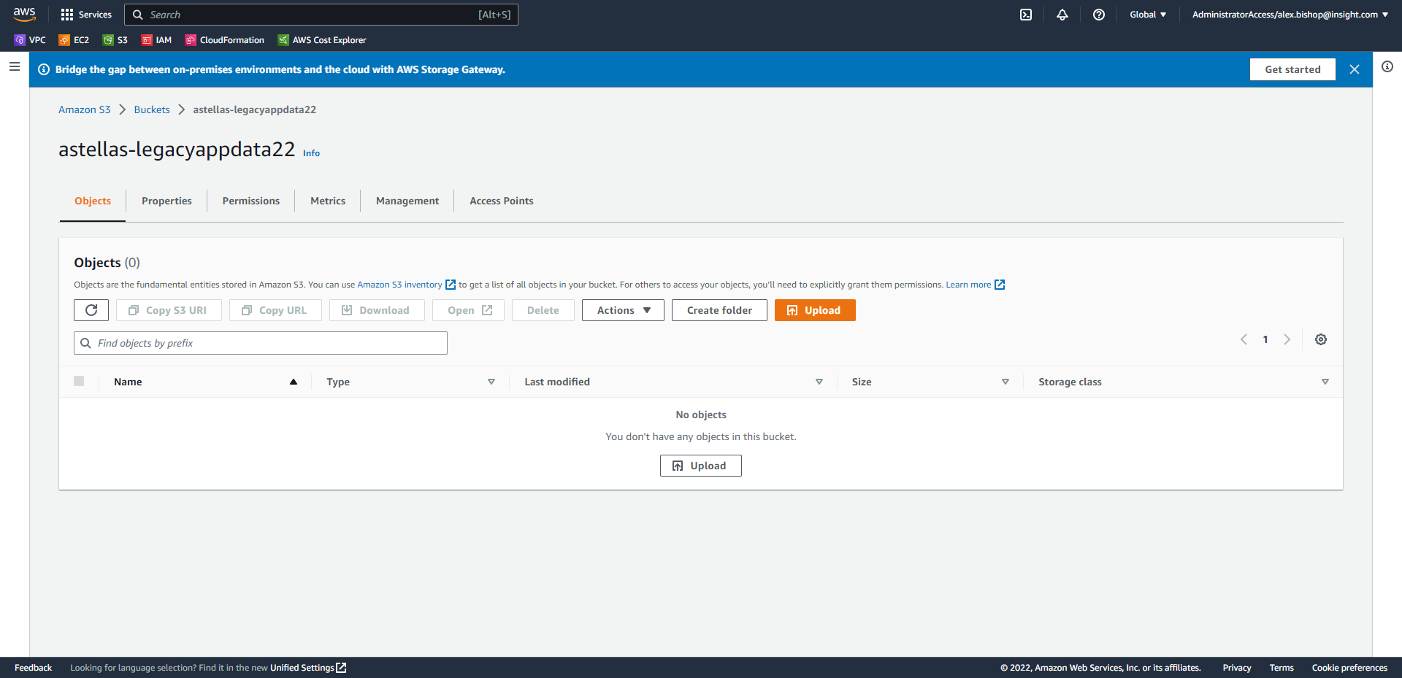

Click Add folder, browse to the packaged application and click Upload.

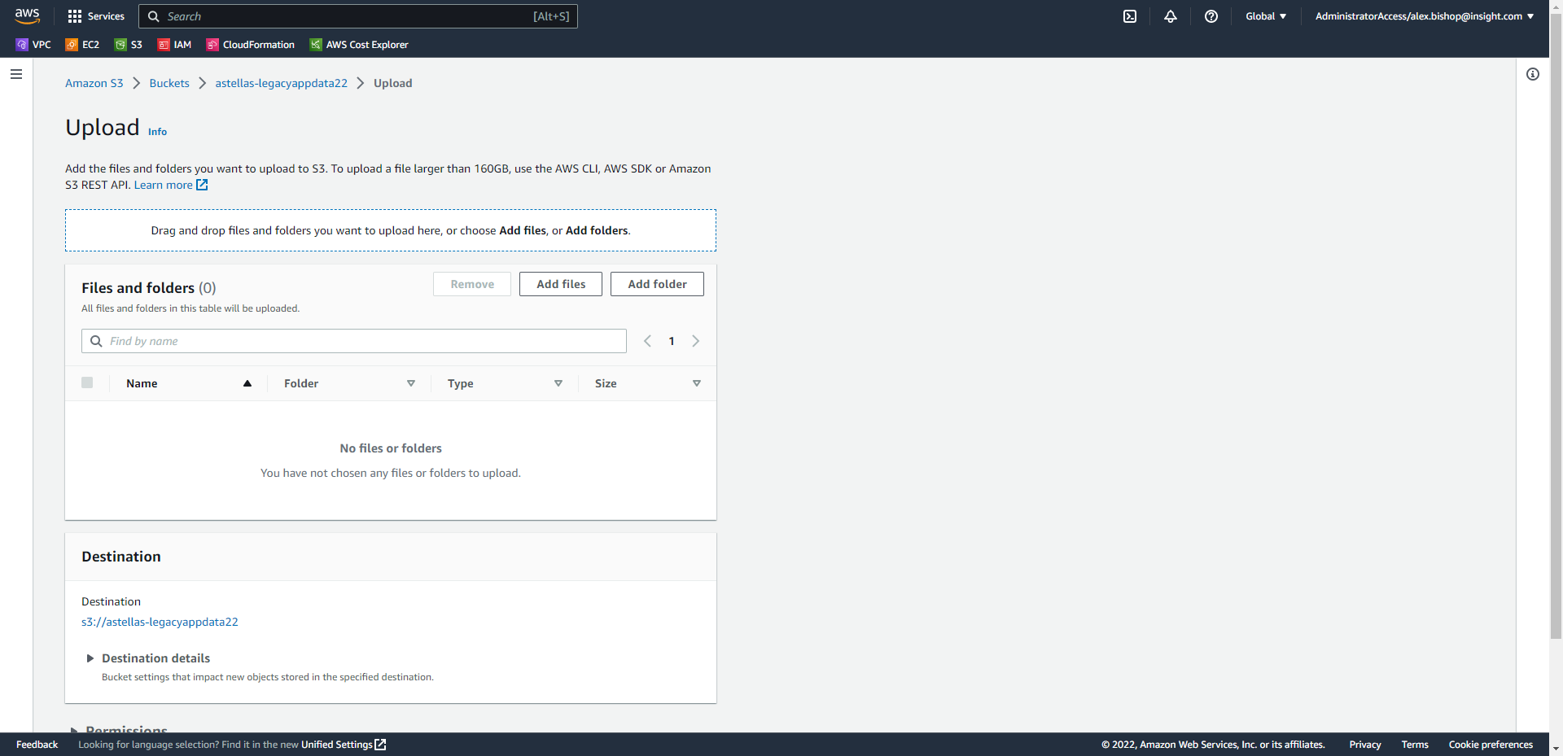

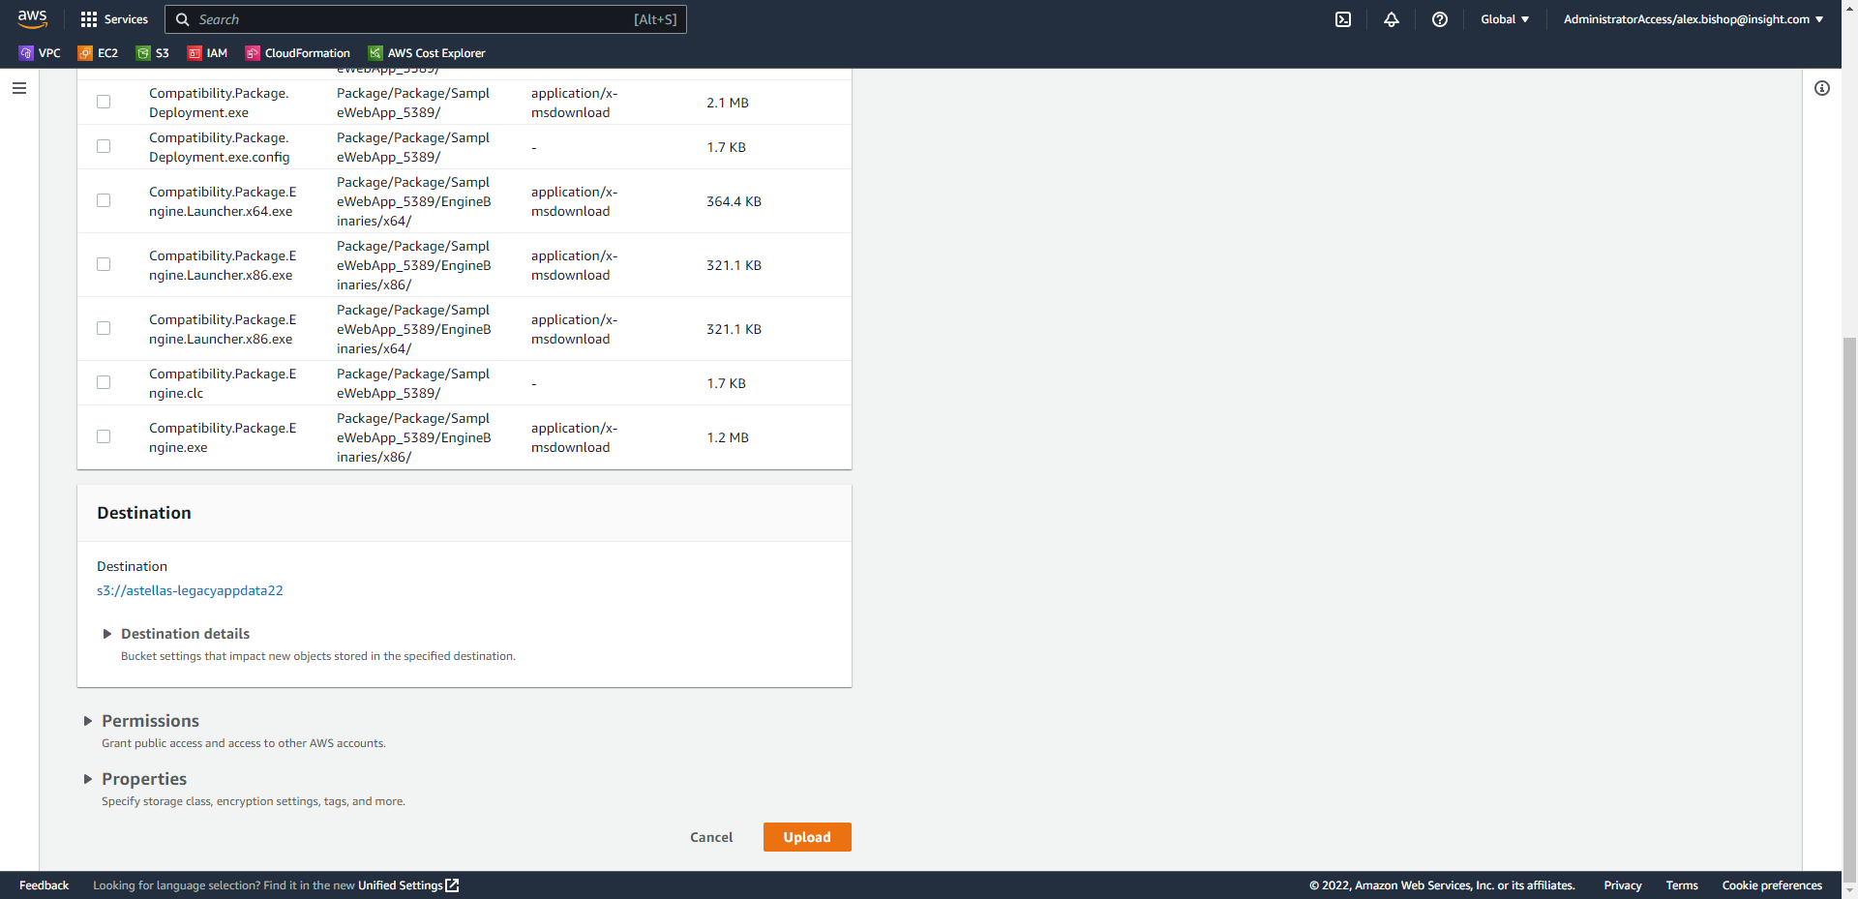

1. Create a Gateway Endpoint

A Gateway Endpoint must be created to access an object or files in an S3 bucket from an EC2 instance in a private subnet.

To create a gateway endpoint, open the VPC console and in the left-hand navigation menu select Endpoints.

Choose Create endpoint.

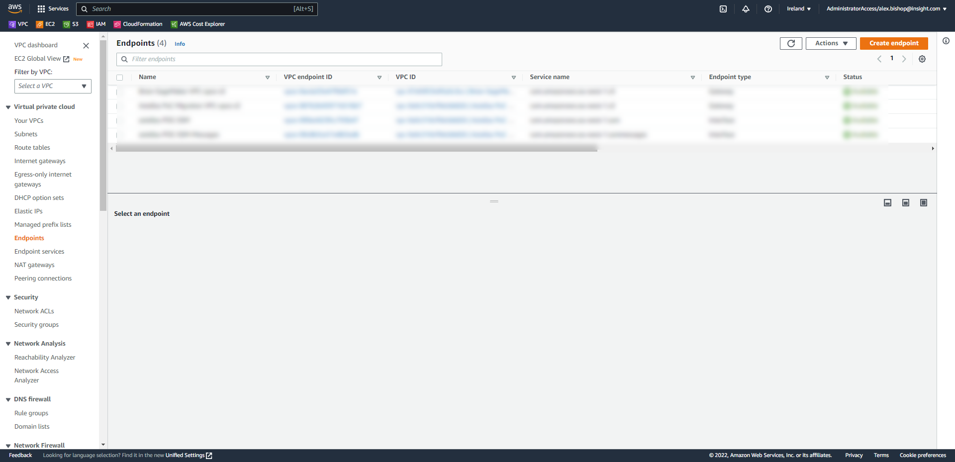

Name the endpoint as appropriate and select AWS services under the Service category section.

Filter the services to “S3” and select “com.amazon.eu-west-1.s3” (Type: Gateway).

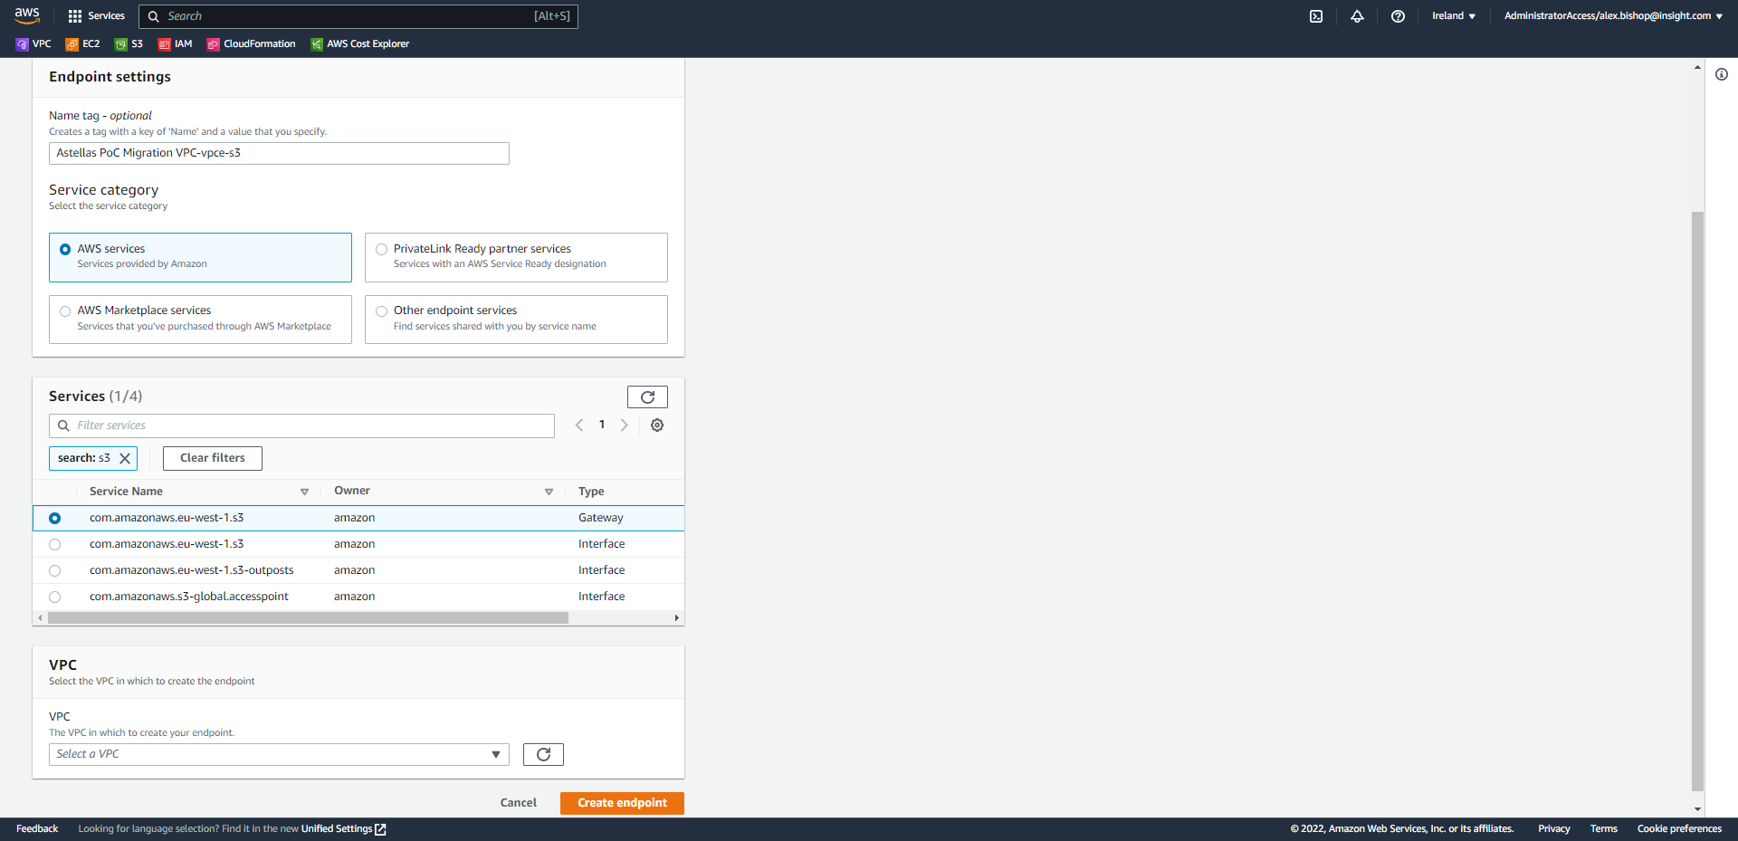

Choose the same VPC that you have deployed your EC2 instances to and for the Route tables, specify the route table(s) which to create routes to the service. Route tables control the routing of traffic between your VPC and the other service. At least on of these should be the route table associated with the Subnet you servers reside.

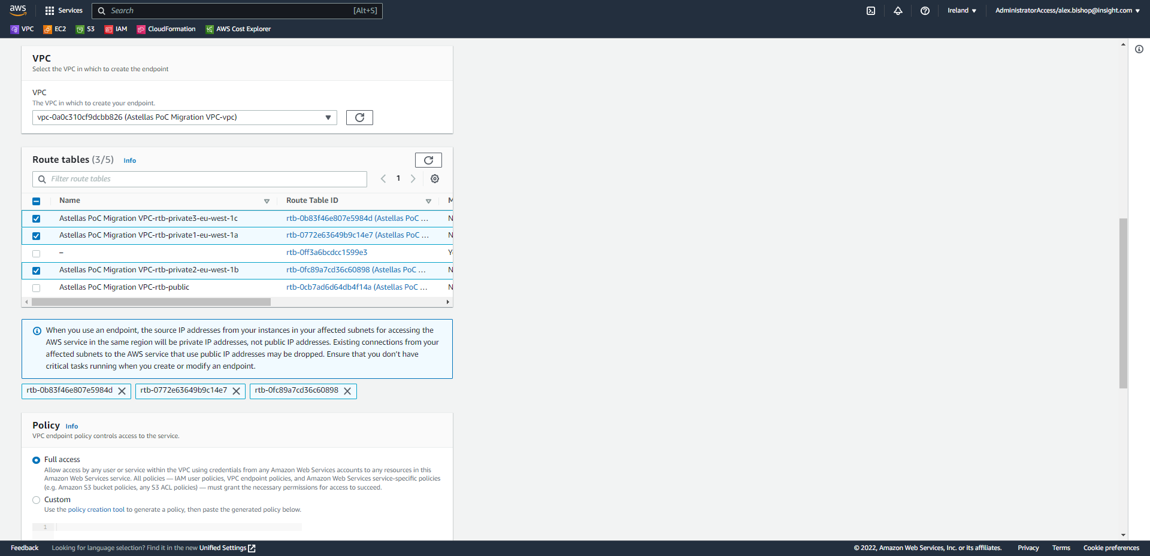

Scroll to the bottom of the page and click Create endpoint.

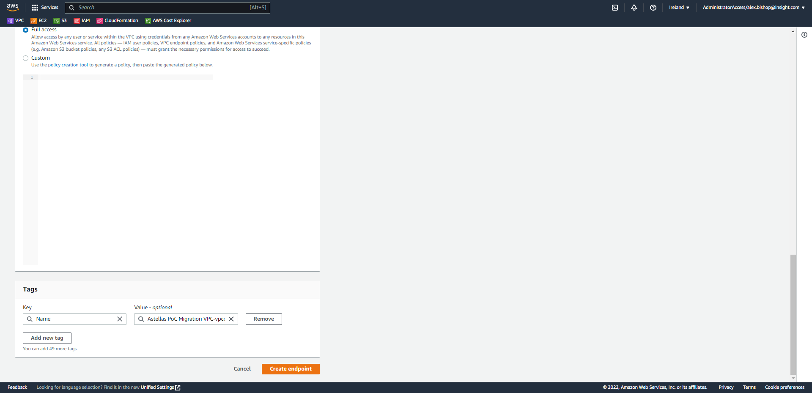

1. Create a NAT gateway

A NAT gateway is a requirement to access the S3 bucket over the public endpoint and retrieve the packaged application.

Open the VPC console and select Nat gateway from the navigation menu.

Click Create NAT gateway.

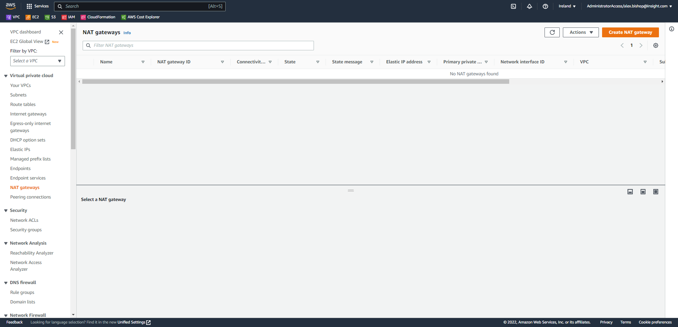

Name the NAT gateway as appropriate and select the subnet to associate it to (must be a public subnet in the same VPC as the EC2 instances). Also, choose the public connectivity type and select Allocate Elastic IP to assign an IP address to the NAT gateway.

Finally, click Create NAT gateway.

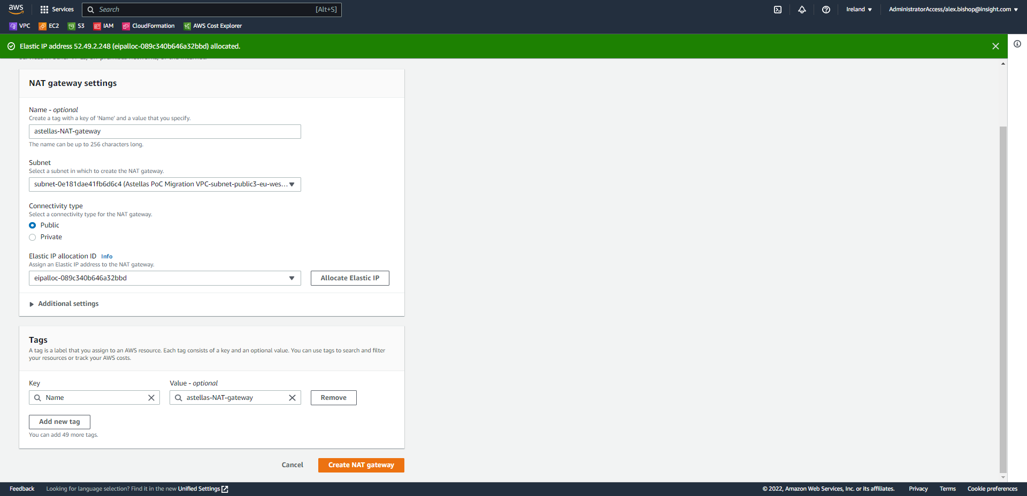

The route tables of the private subnet must have a custom route to point internet traffic to the NAT gateway.

Open the VPC console and select Route tables from the menu. Click on the Route table associated with the private subnet associated with your EC2 instances and select the tab for Route table.

Click Edit routes.

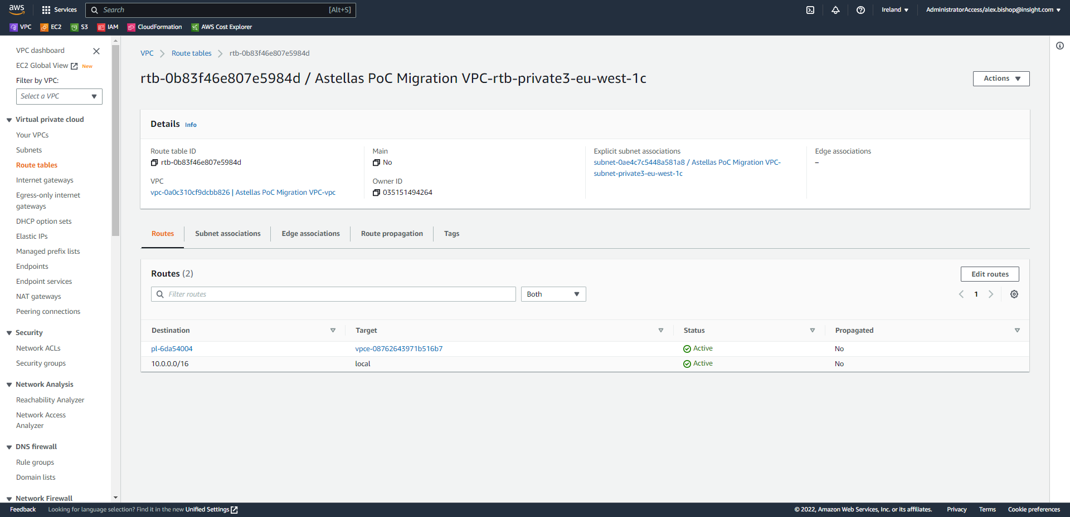

Click Add route.

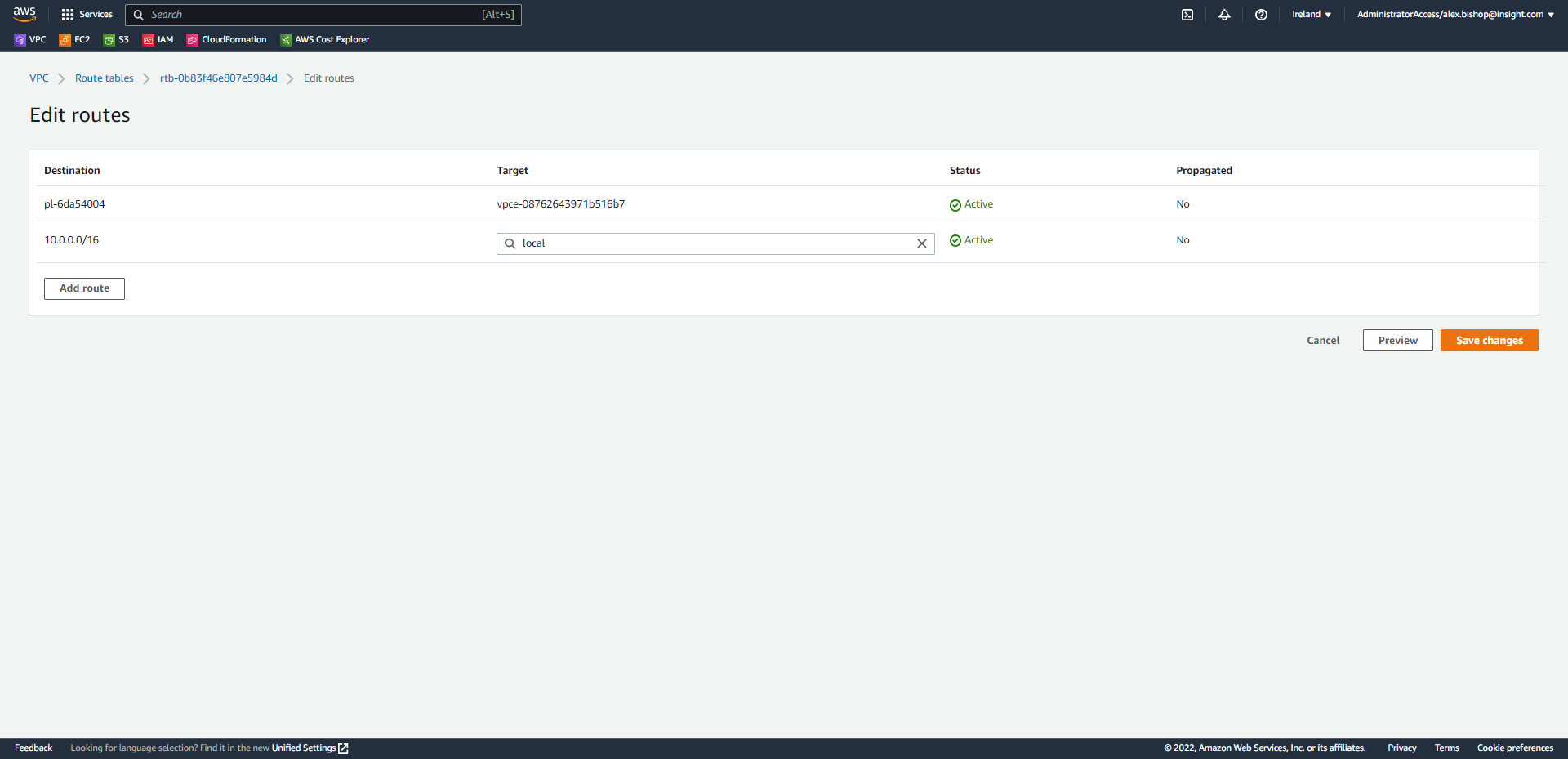

Destination: 0.0.0.0/0

Target: select the NAT Gateway

And save changes.

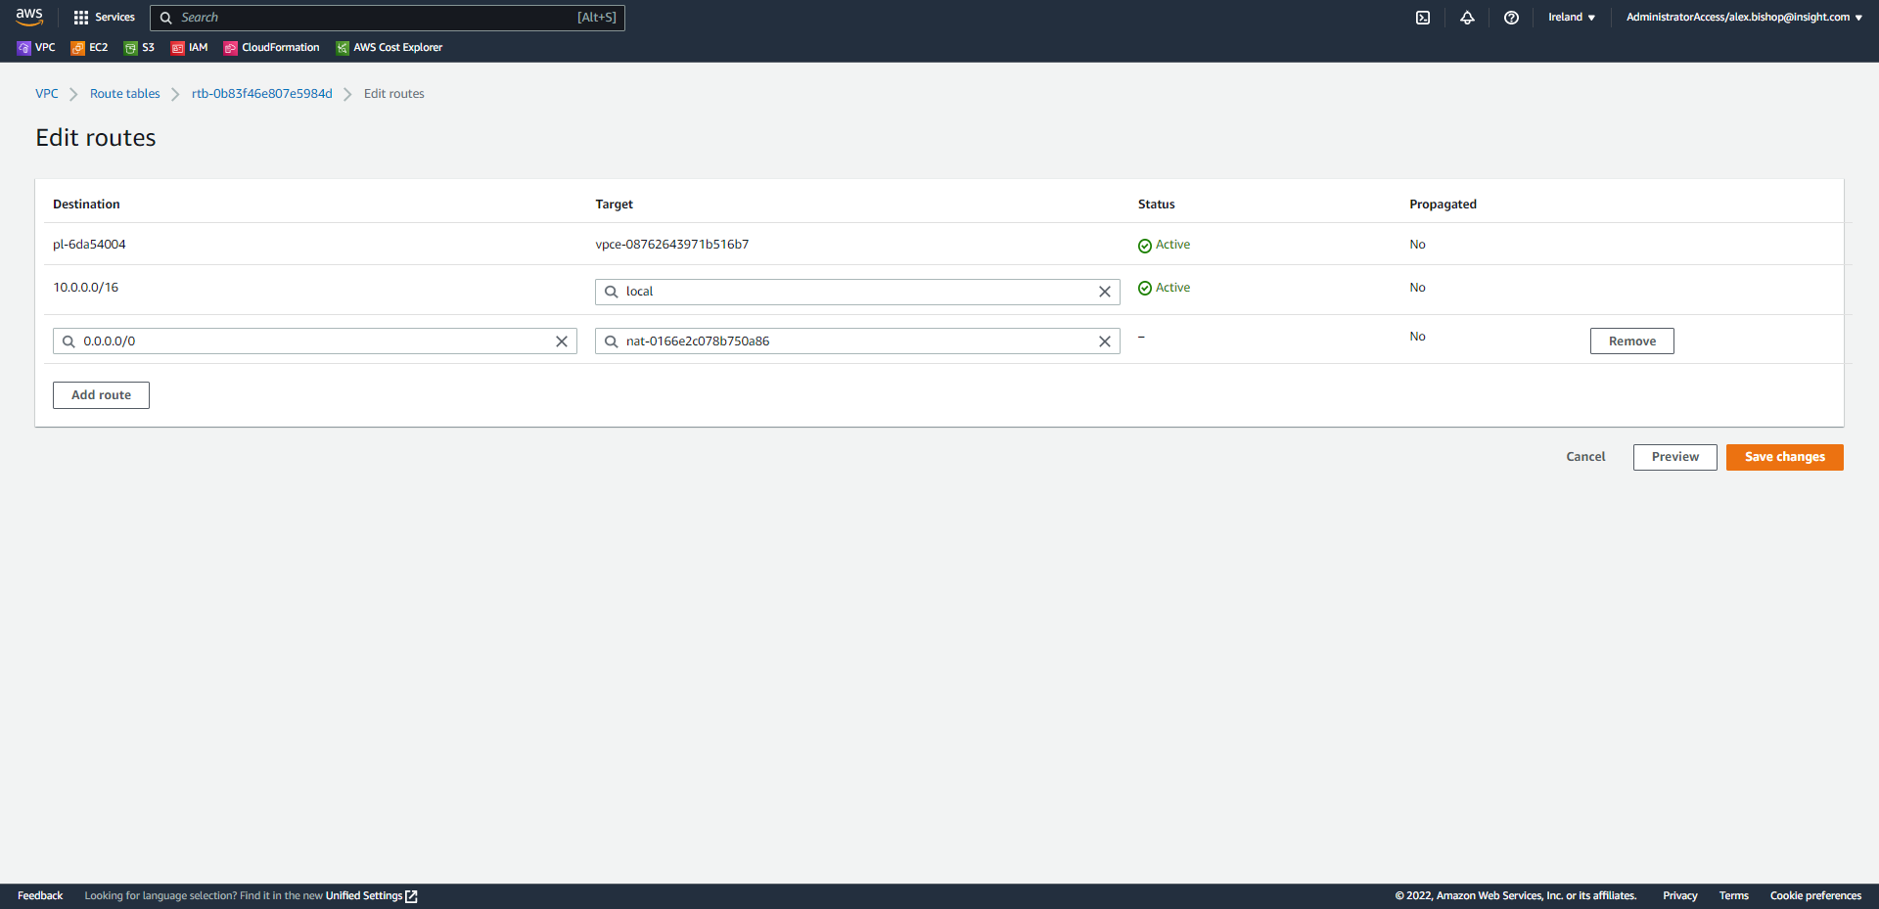

1. Create an Internet gateway

An Internet gateway is also required to allow your NAT gateway access to the internet via the VPC.

Open the VPC console and select Internet gateways from the navigation menu.

Click Create internet gateway.

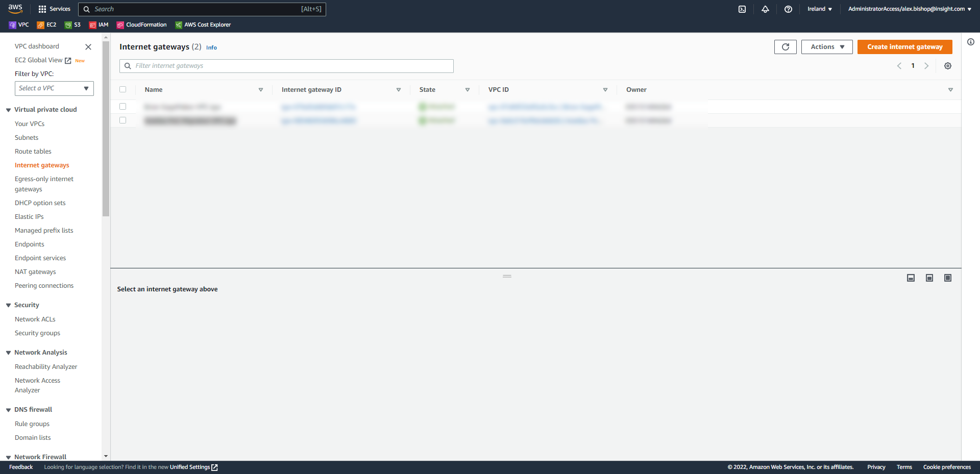

Name the gateway and click Create internet gateway.

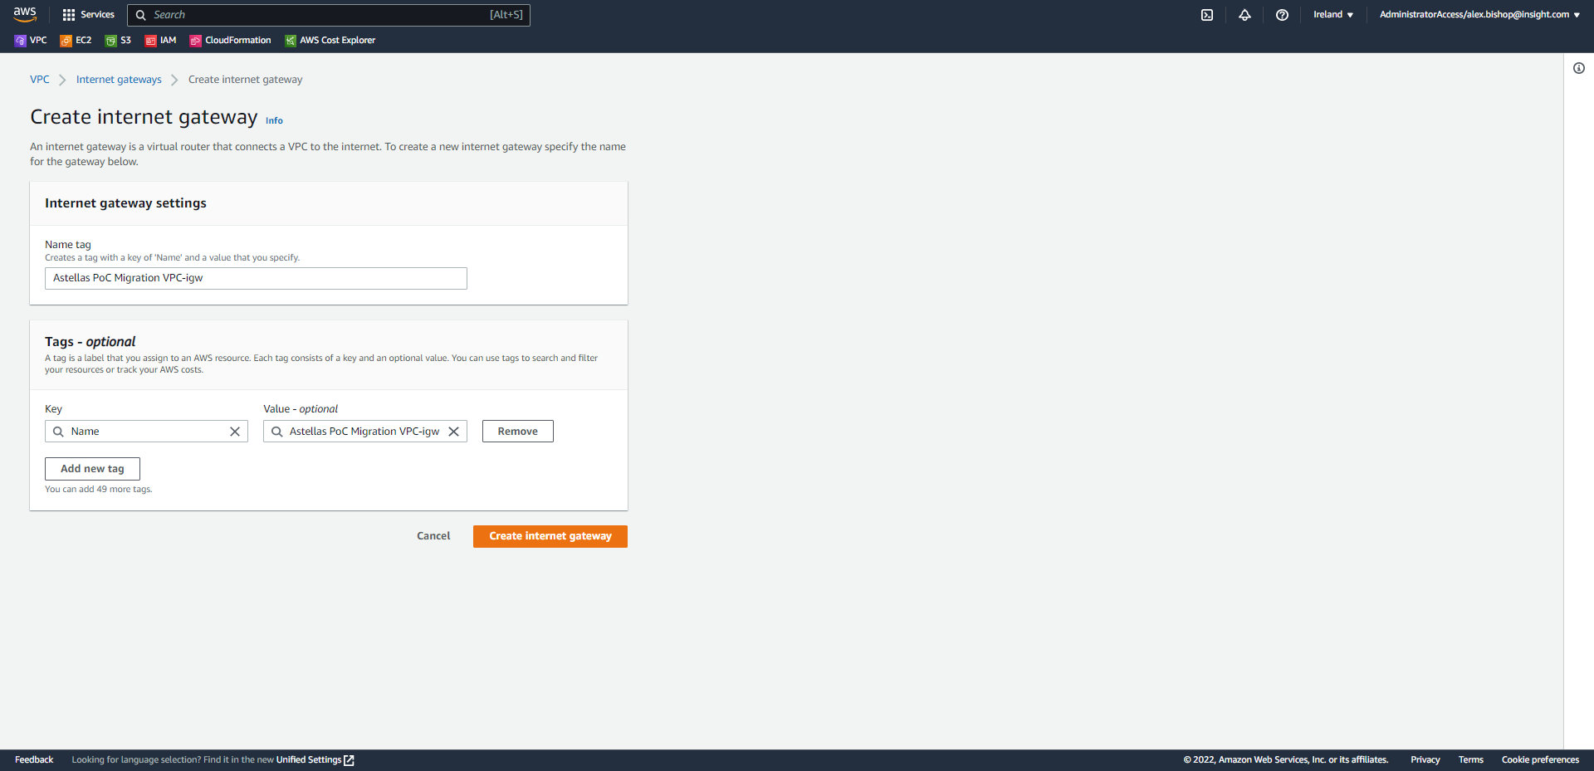

Now the internet gateway must be attached to the VPC. Select the new internet gateway and select *“Actions > Attach to VPC”*

Select the same VPC which hosts your EC2 instances and click Attach internet gateway.

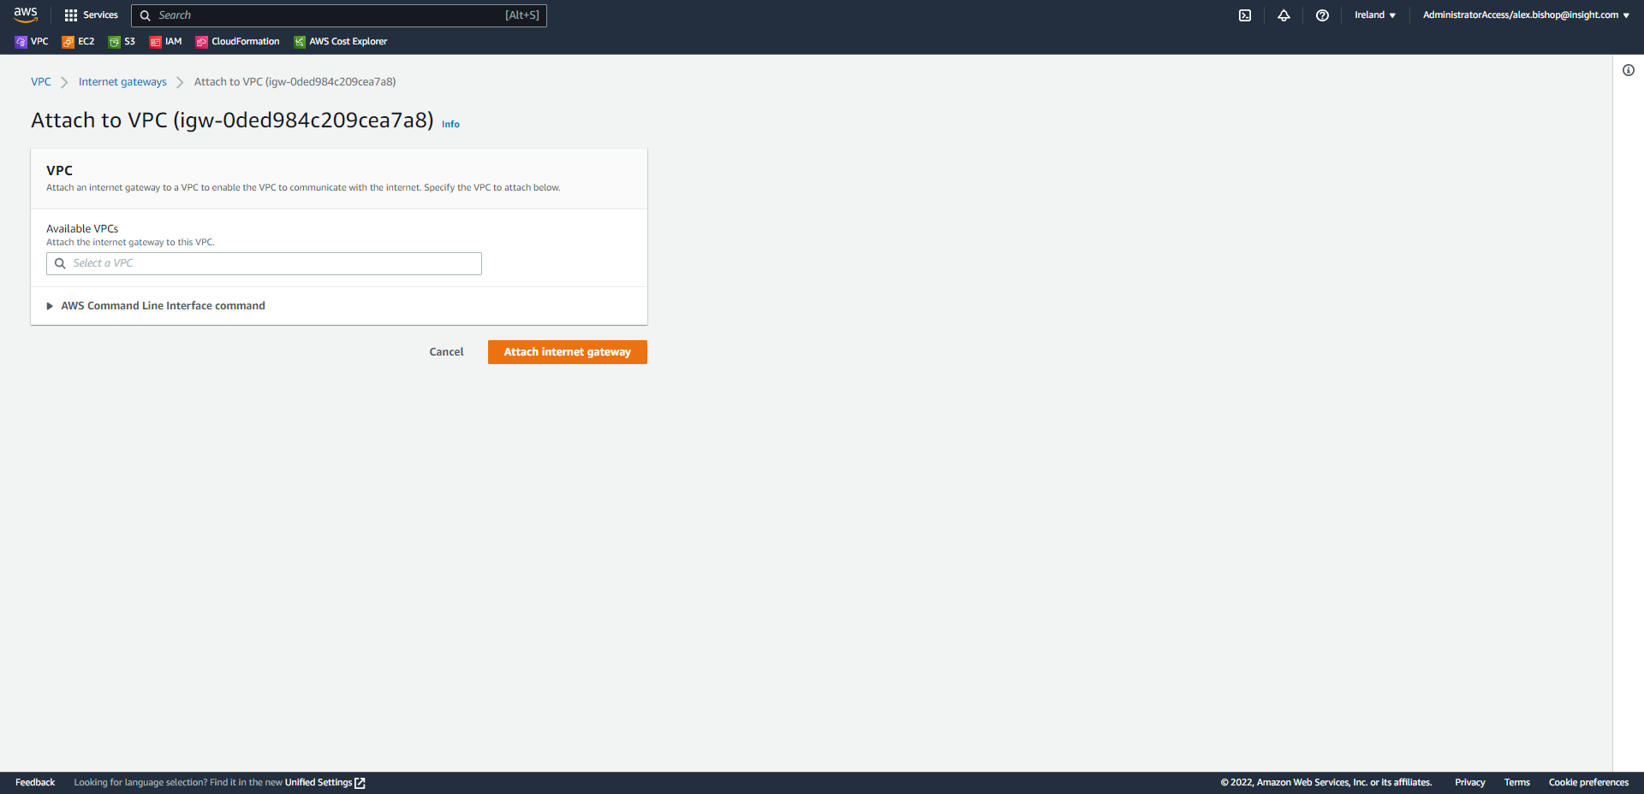

Your EC2 instances can now access the internet to retrieve the object in the S3 bucket.

1. Deploy the Packaged Application to EC2 (EUPMPPPLAP050 Migration Path)

This appendix covers deployment of the packaged web application on the migrated AWS Windows Server 2022 EC2 Instance. An example scenario of migrating the legacy application on EUPMPPPLAP050 (the process is the same regardless of OS version).

Open the Systems Manager console and select Fleet Manager in the left-hand navigation menu.

Select the Windows Server 2022 managed node and click *“Node actions > Connect with Remote Desktop”*

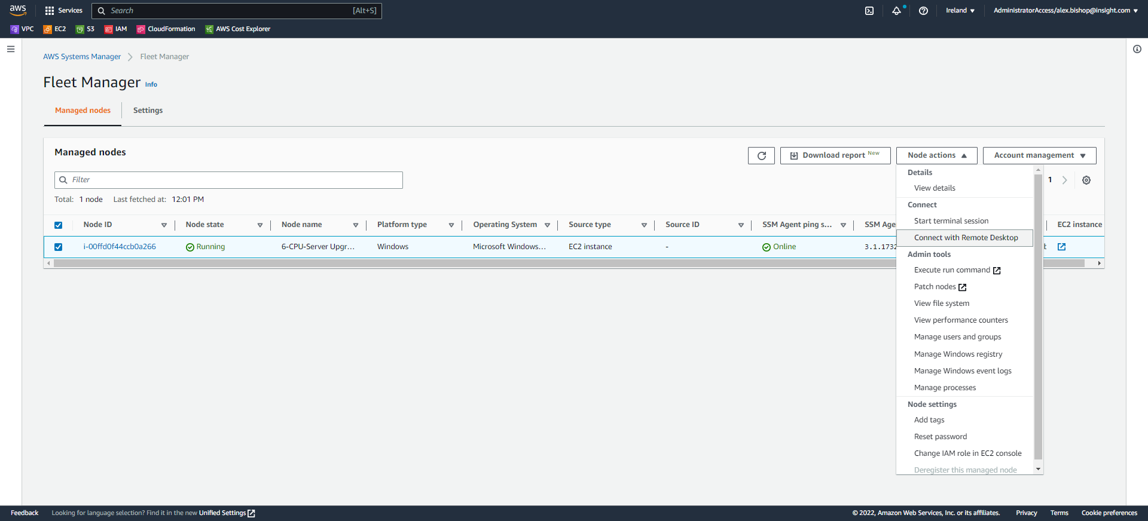

Choose the option of Key pair click Browse to select your key pair .pem file and click Connect.

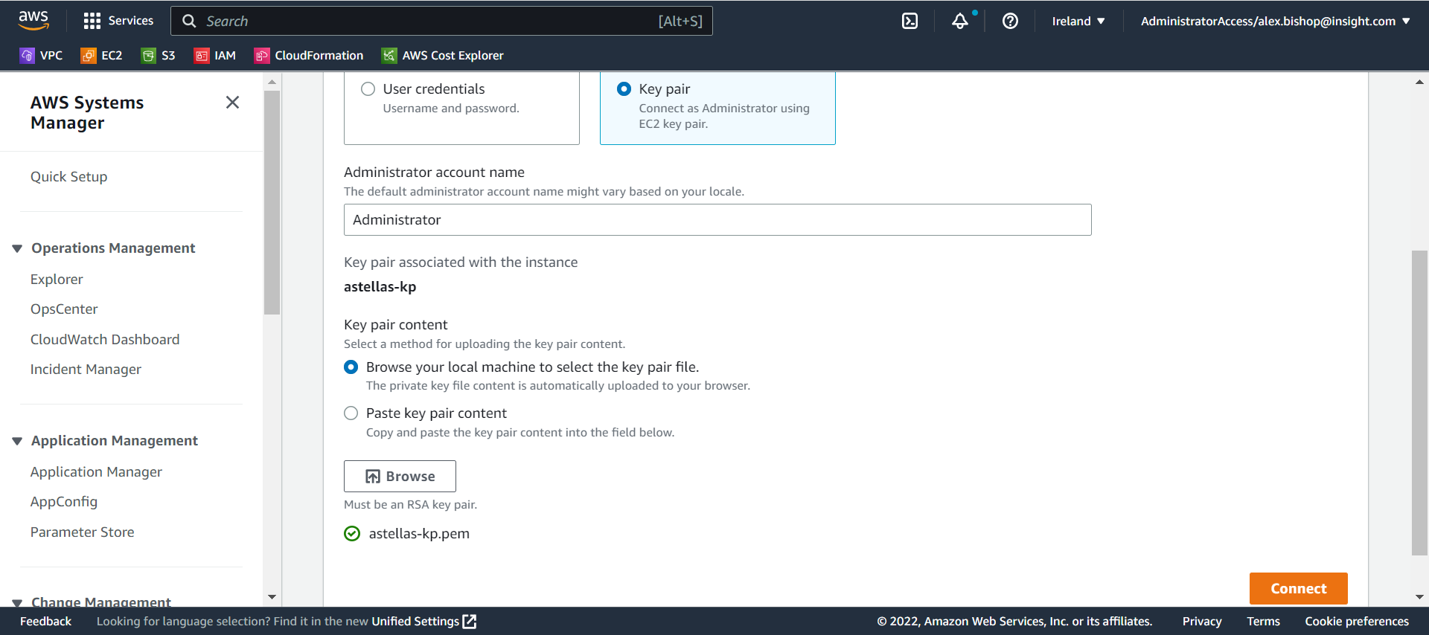

Once connected to the instance, use the AWS CLI to download the packaged files.

To install the AWS CLI open a web browser on the server and search for AWS CLI. Click the first URL.

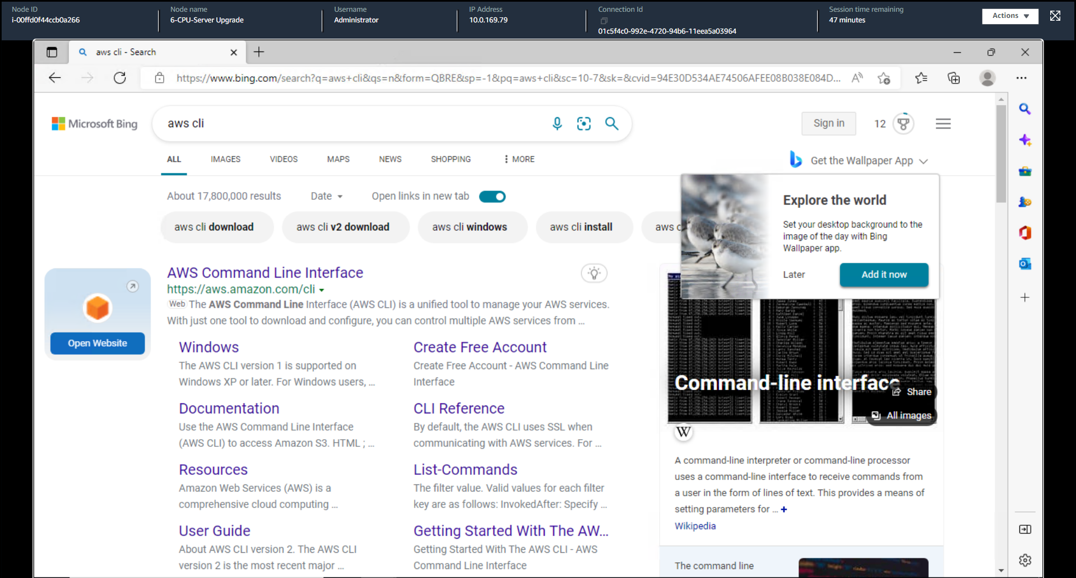

Download the 64-bit Windows installer from the right-hand side of the page.

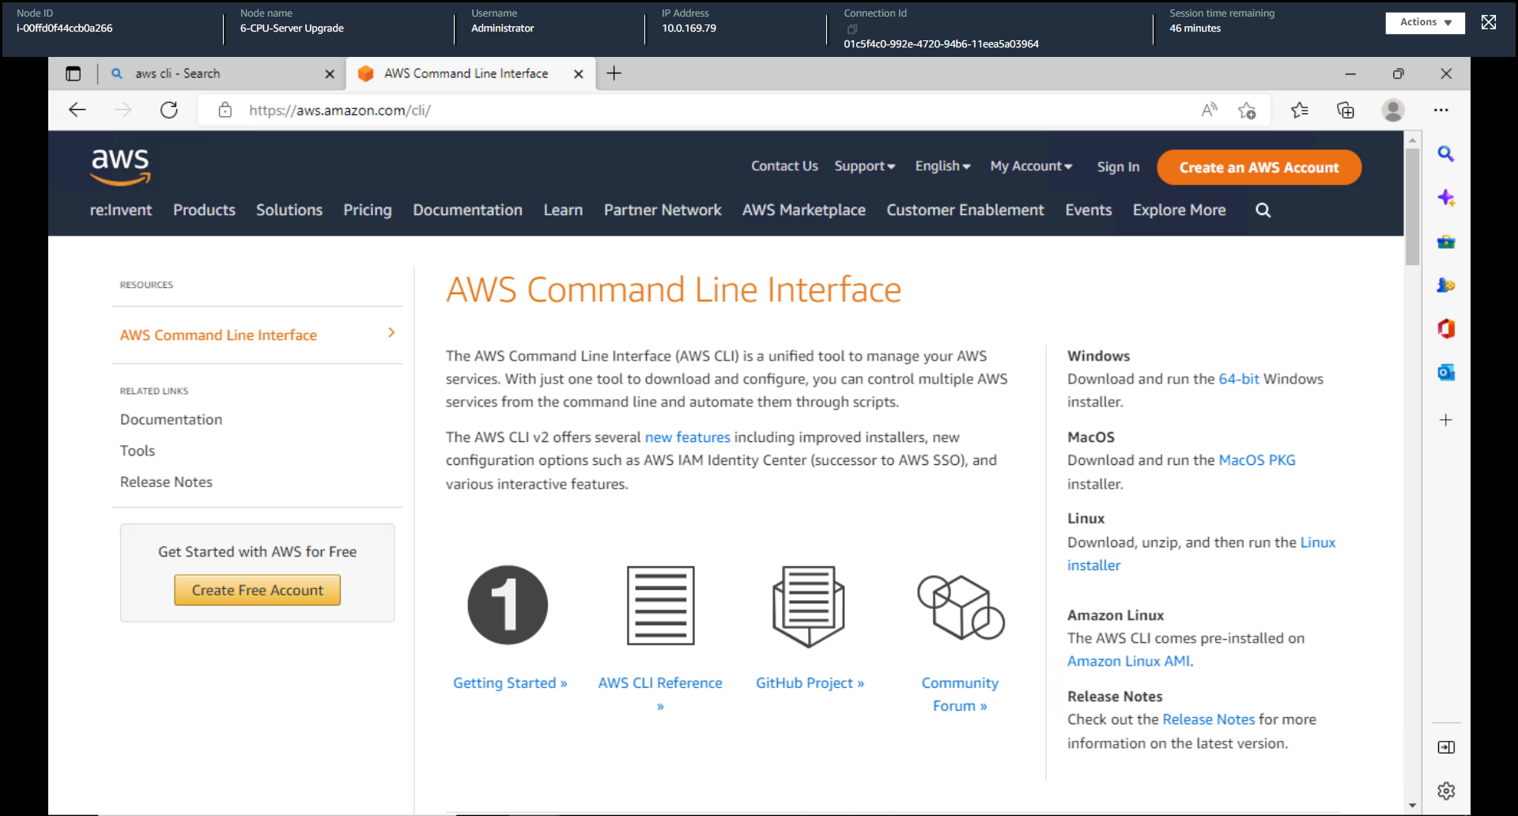

Open the downloaded.msi file and complete the installation wizard with the default options.

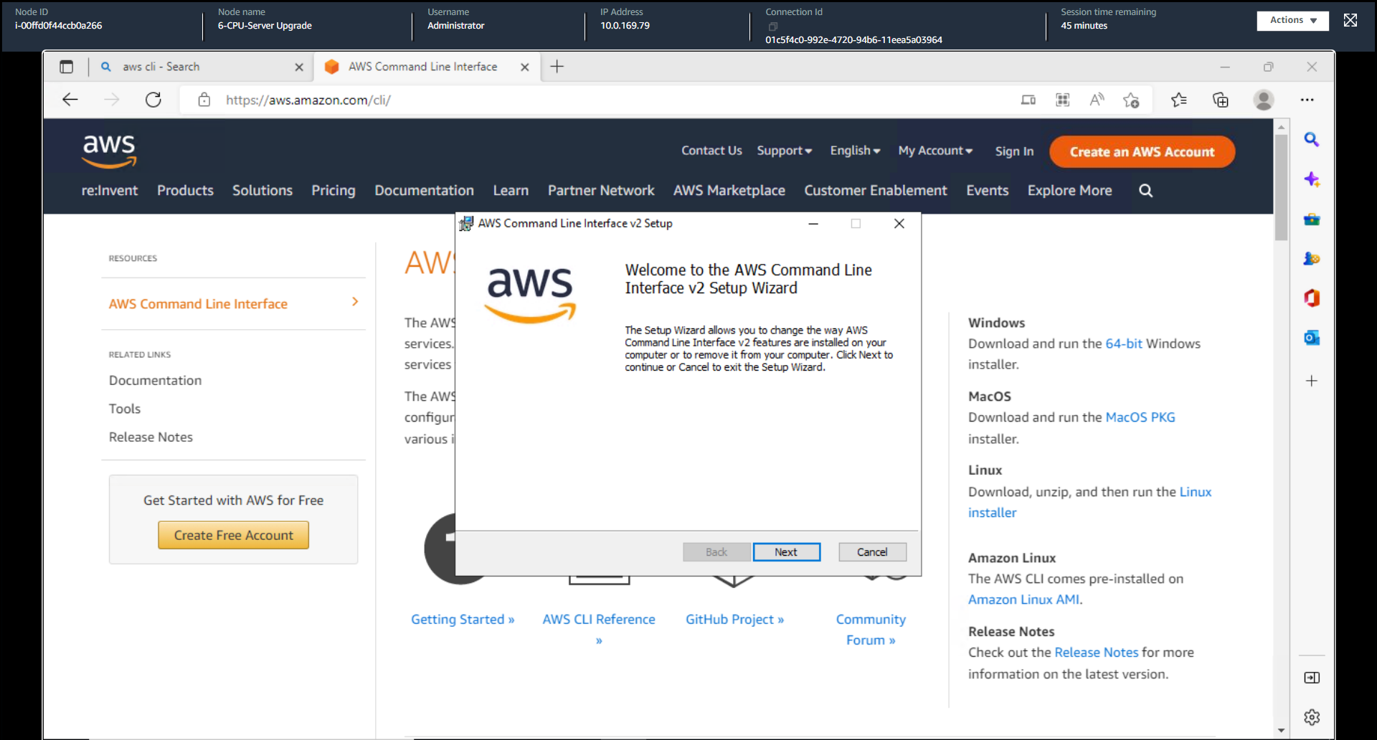

Once the wizard is finished open the command line and type the following commands into the terminal session:

1. “cd c:\”
2. “mkdir temp”
3. “cd c:\temp”
4. *“aws s3 cp s3://(name of bucket) . –recursive”*

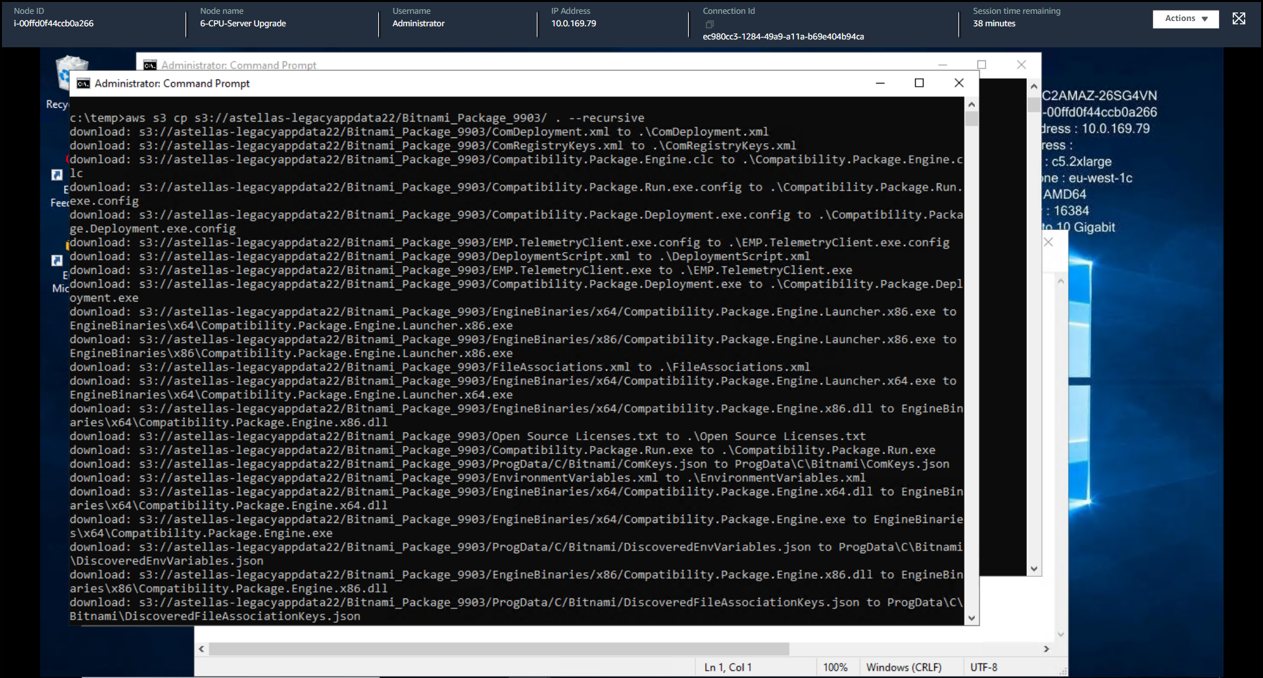

This will download the files to the c:/temp folder.

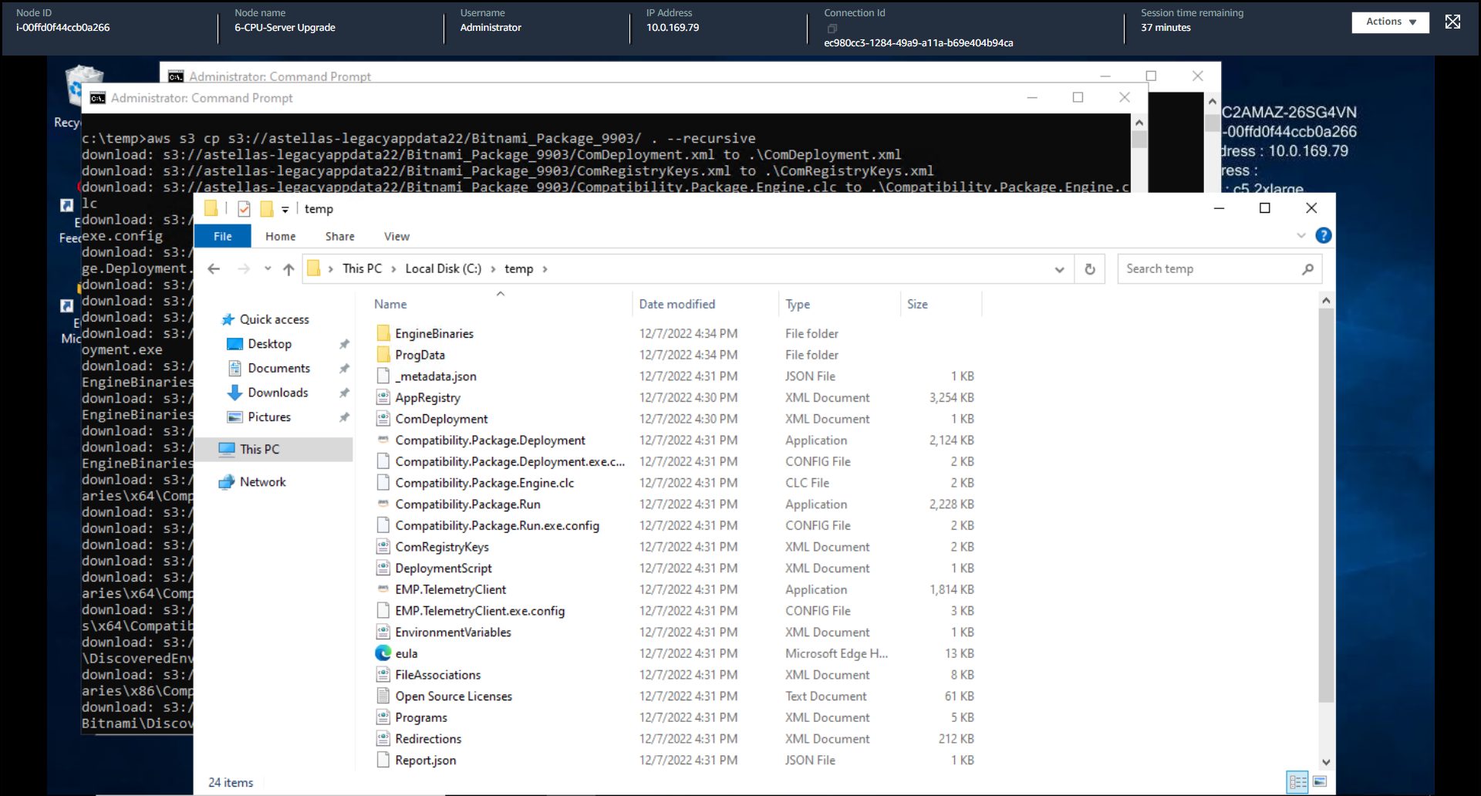

To deploy the package identify the location of the *“Compatibility.Package.Deployment.Exe”* file and run the following command:

*“C:\<path>\Compatibility.Package.Deployment.Exe /acceptEULA /deploydir "C:\<path>" /DeployAllRegistry”*

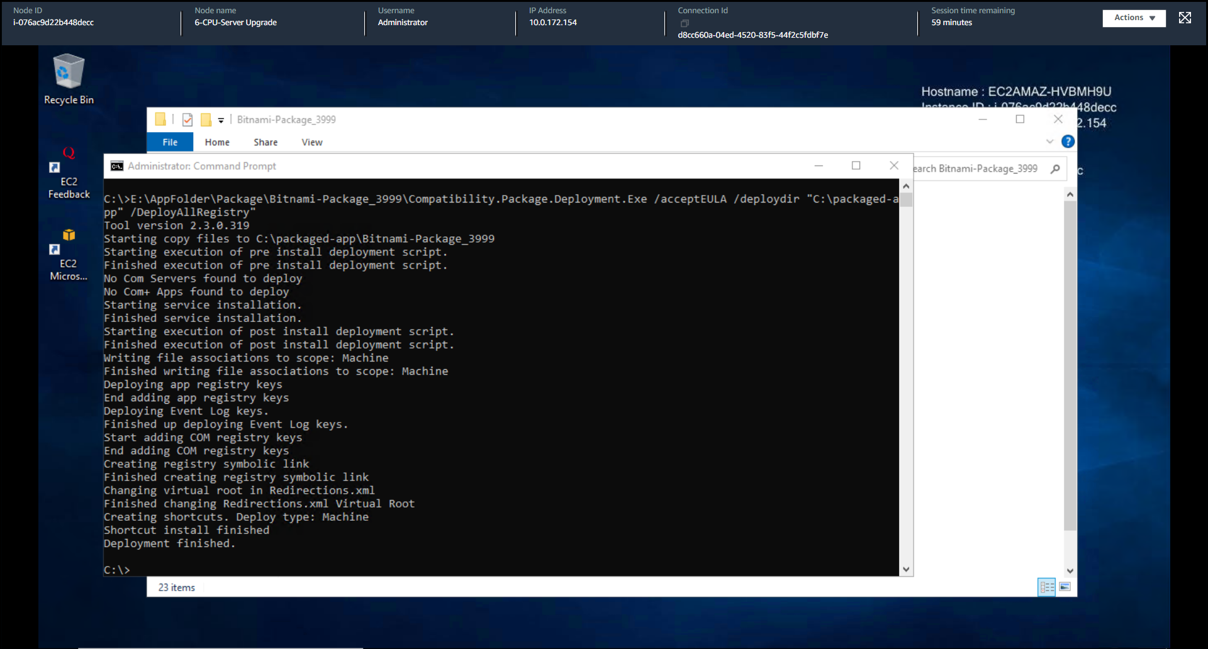

Once your deployment is finished you can browse to and open the application.

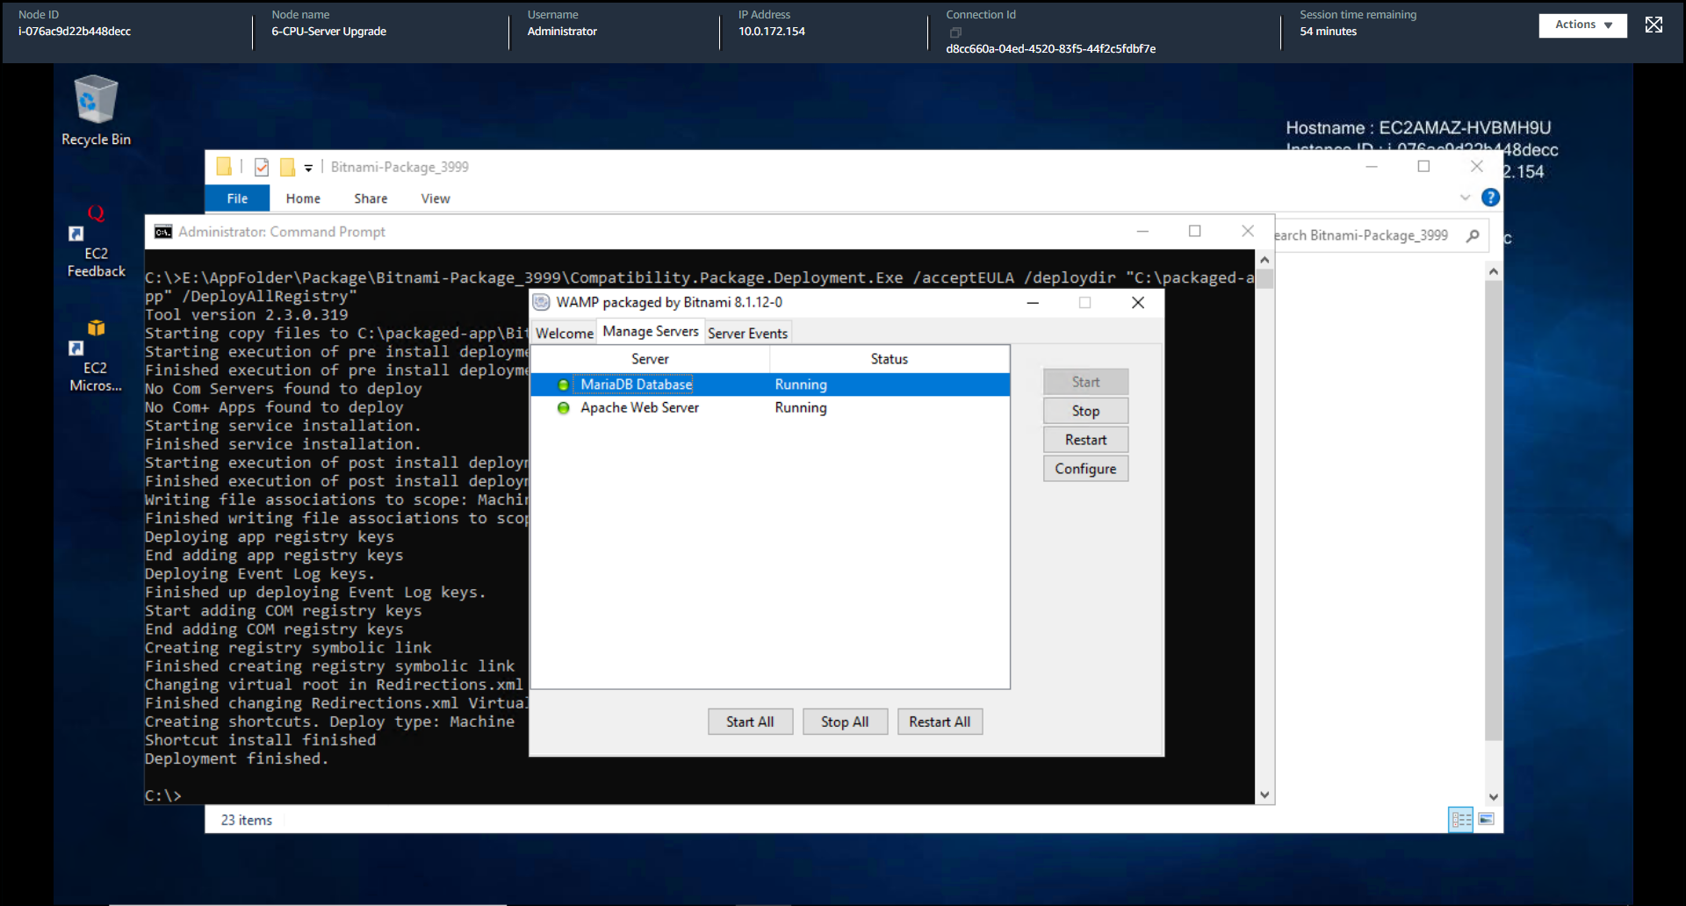

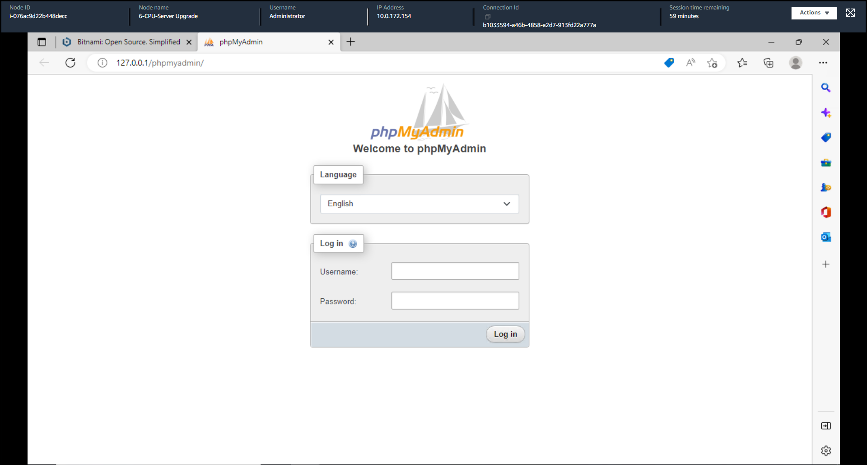

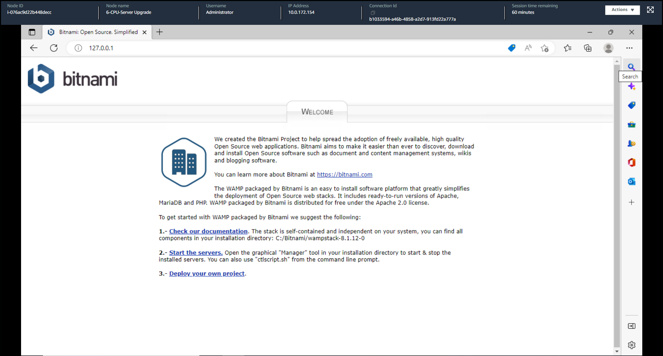

The application has been successfully migrated to the AWS EC2 instance.